Process Document of Change Management Process
Submitted to:
Kirloskar Oil Engine Limited(KOEL)
Date: 21 November 2019

Revision 1.0

Submitted By:
Kloudq Technologies Limited
Plot No.1,Yena,Adwaitnagar,
Paud Phate,Erandawana,
Pune-411038,Maharashtra,INDIA|

Table of Contents
Change Management Process 2
1. Proto BOM 2
1.1 Problem Report Proto BOM 3
1.1.1 Problem Report Proto BOM Creation 3
1.1.2 Problem Report Proto BOM Task 5
1.2 Engineering Change Request Proto BOM 9
1.2.1 Engineering Change Request Proto BOM Creation 10
1.2.2 Engineering Change Request Proto BOM Task 11
1.3 Engineering Change Notice Proto BOM 16
1.3.1 Engineering Change Notice Proto Creation 16
1.3.2 Engineering Change Notice Proto Task 18
2. Production BOM 19
2.1 Problem Report Production BOM 19
2.1.1 Problem Report Production BOM Creation 19
2.1.2 Problem Report Production BOM Task 21
2.2 Engineering Change Request Production BOM 22
2.2.1 Engineering Change Request Production BOM Creation 22
2.2.2 Engineering Change Request Production BOM Task 24
2.3 Engineering Change Request Production BOM 30
2.3.1 Engineering Change Request Production BOM Creation 30
2.3.2 Engineering Change Request Production BOM Task 32
4. Proto Iteration 49

Change Management Process

Proto BOM
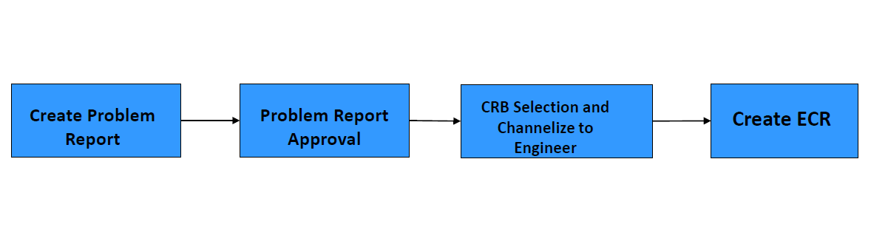

Problem Report Proto BOM

Problem Report Proto BOM Creation
Action – New Problem Report
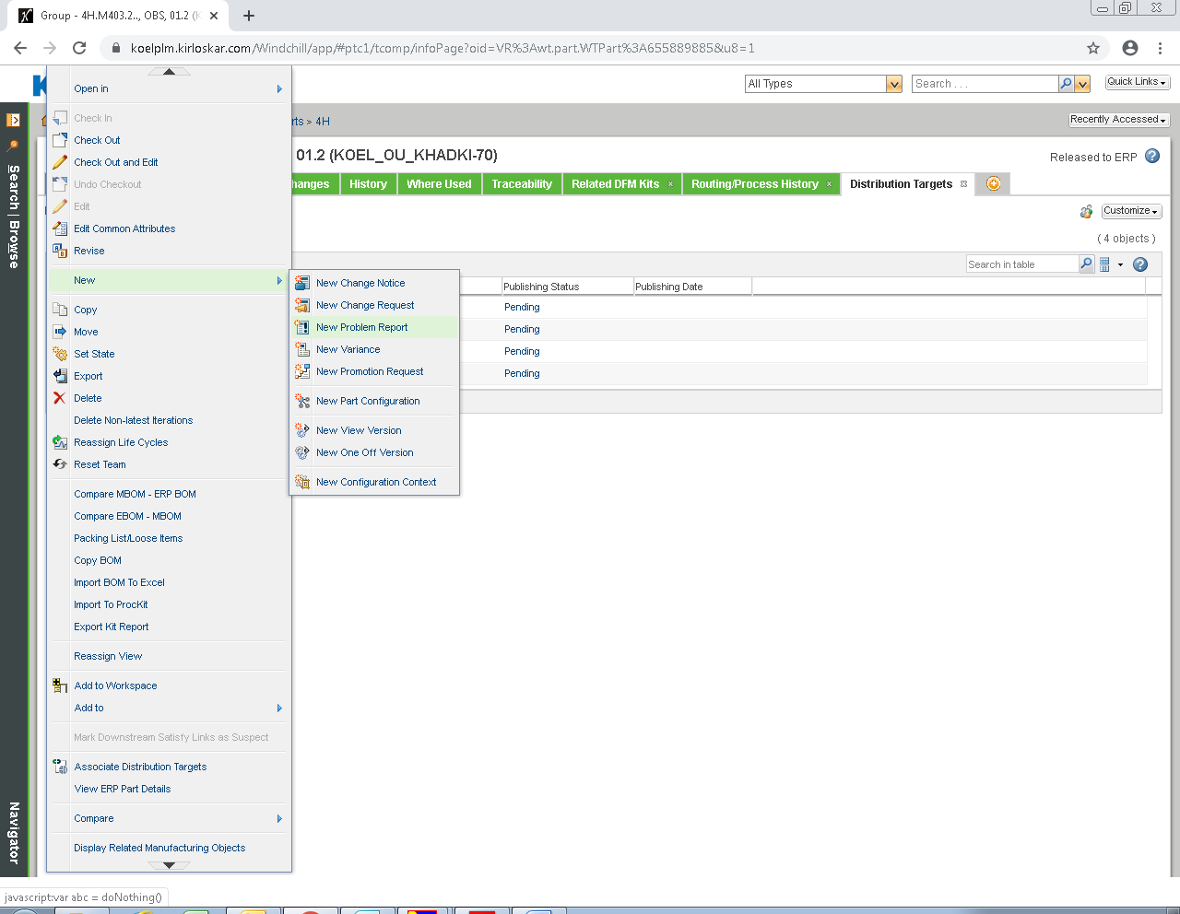
Select Attributes – Select Problem Report Proto BOM in Type and fill the below details
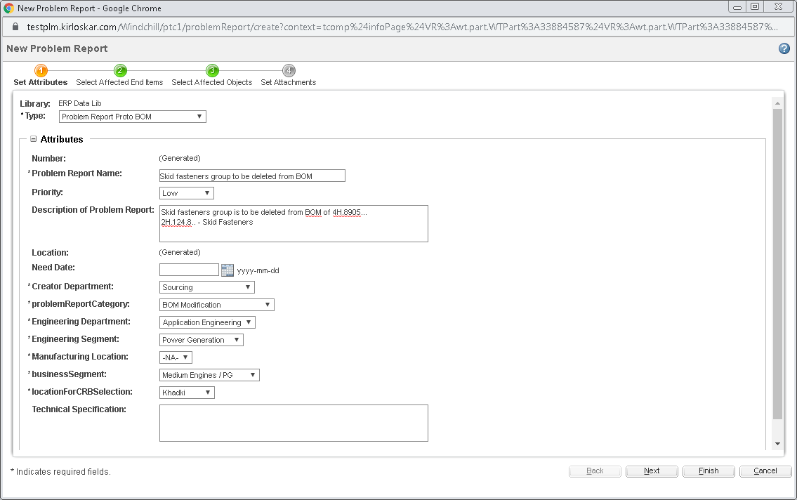

Select Affected End Items
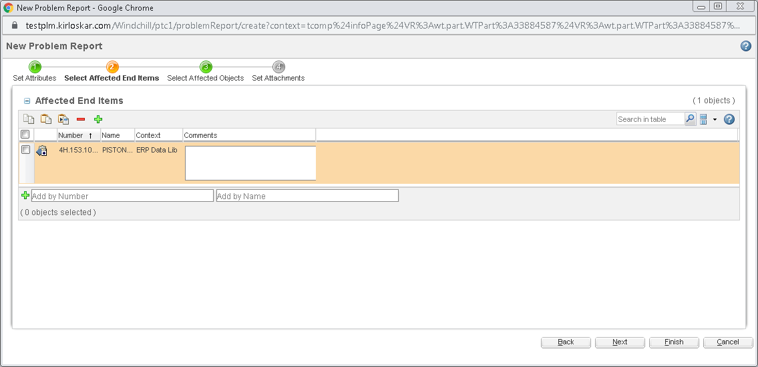
Select Affected Objects
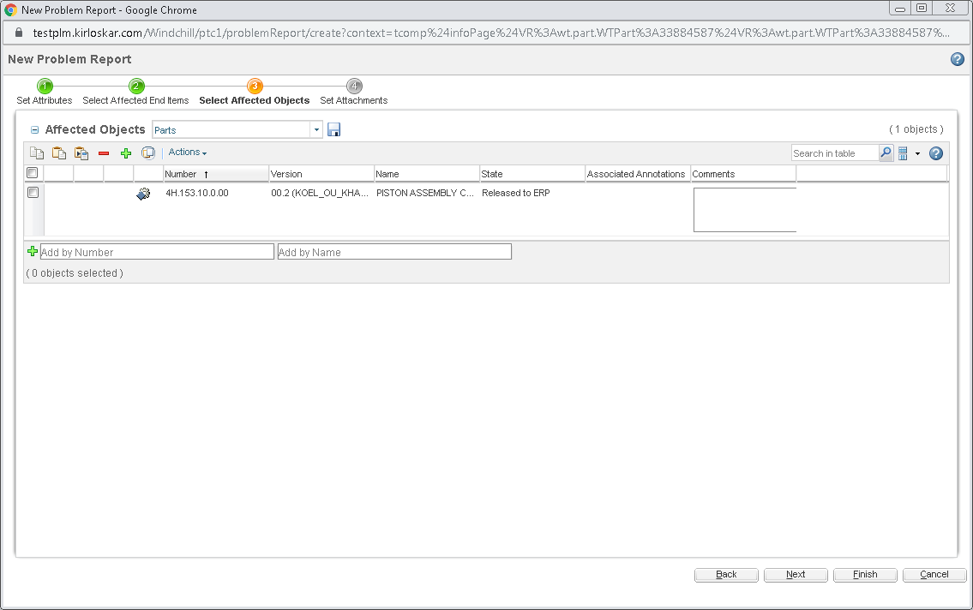
Set Attachments
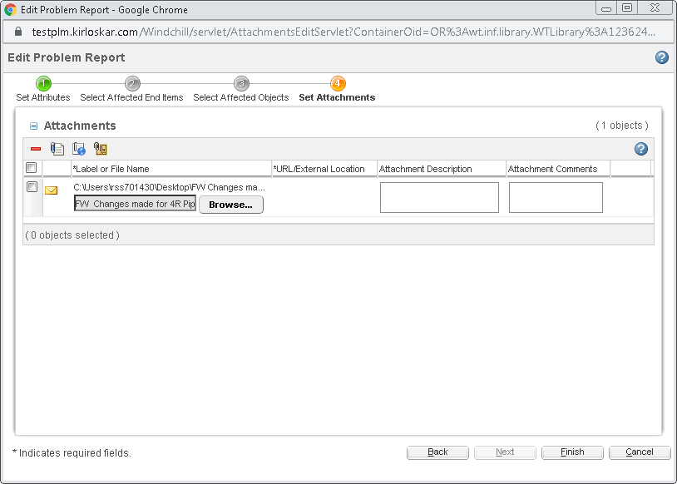

Click on Issues.
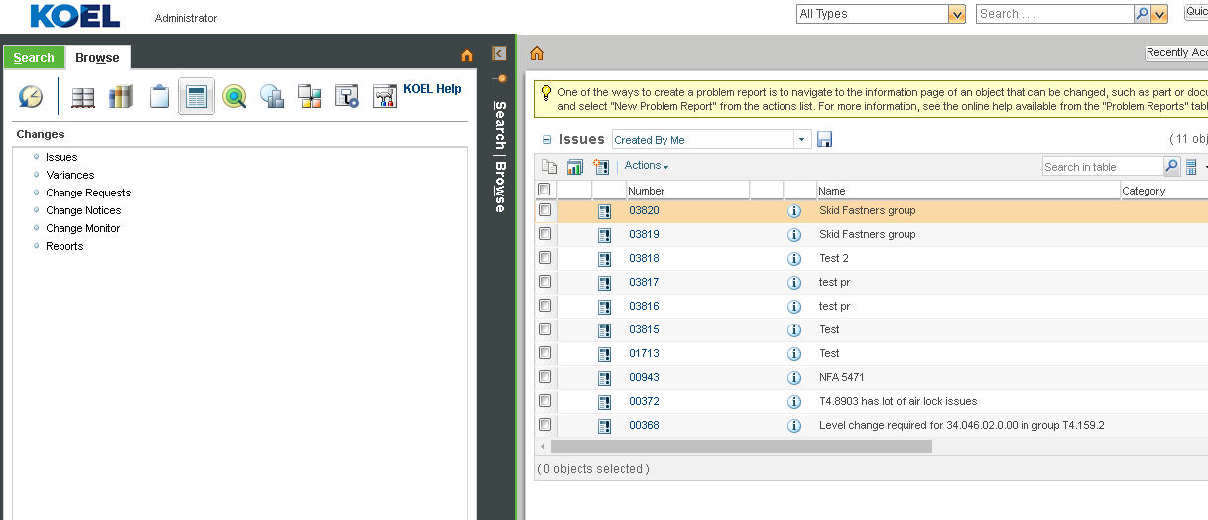

Login through Problem Report creator
Click on Home
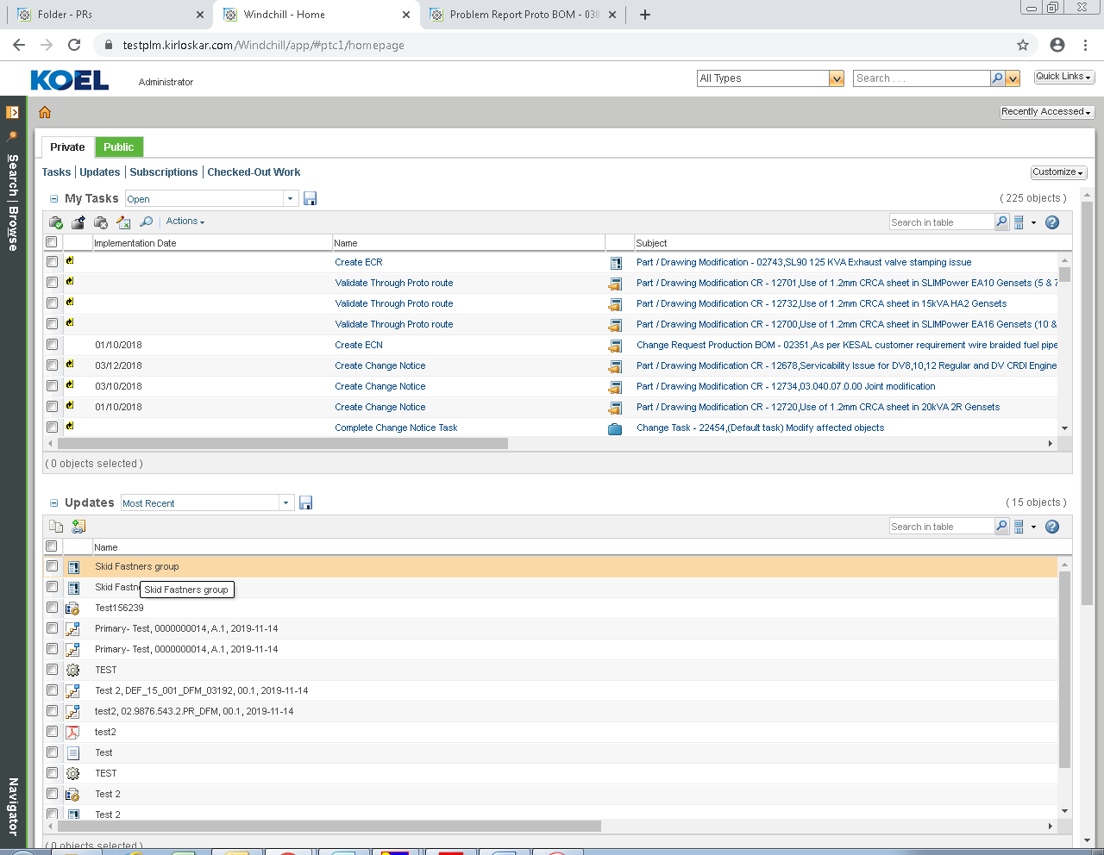

Problem Report Proto BOM Task
Select Approver for department raising PR activity from the list.

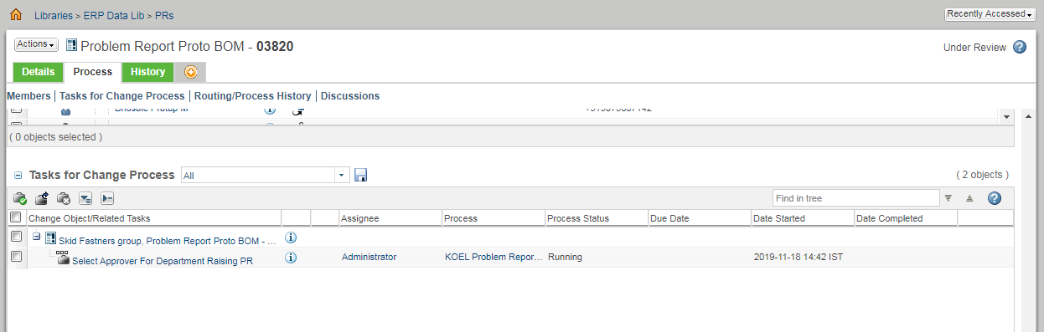
Select Setup Participants
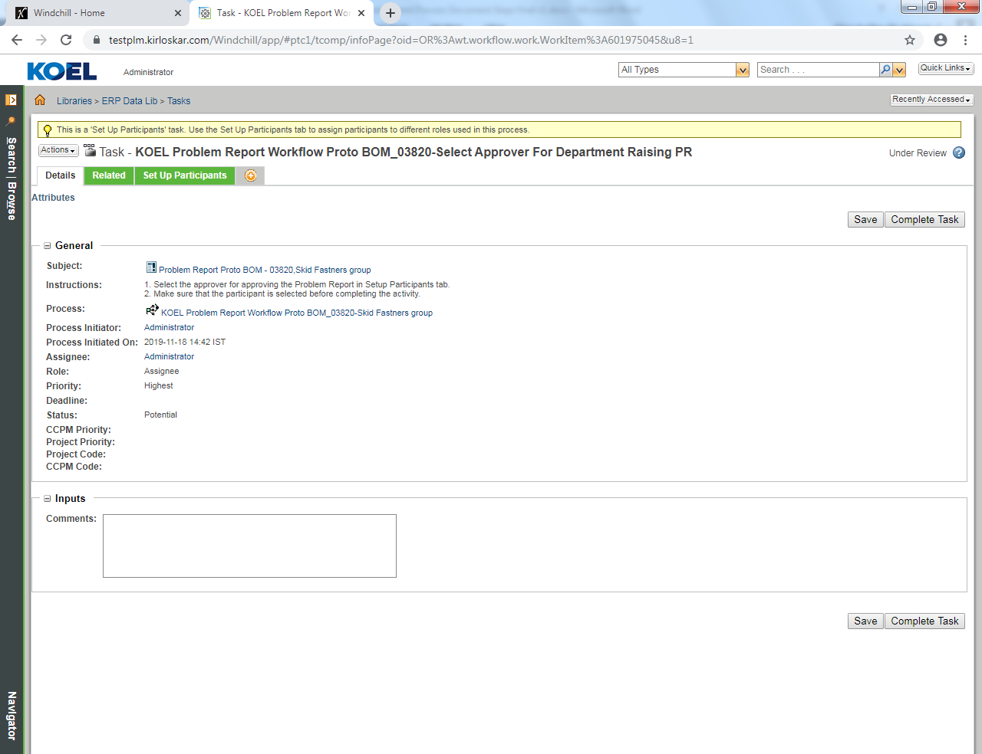

Select respective department head user
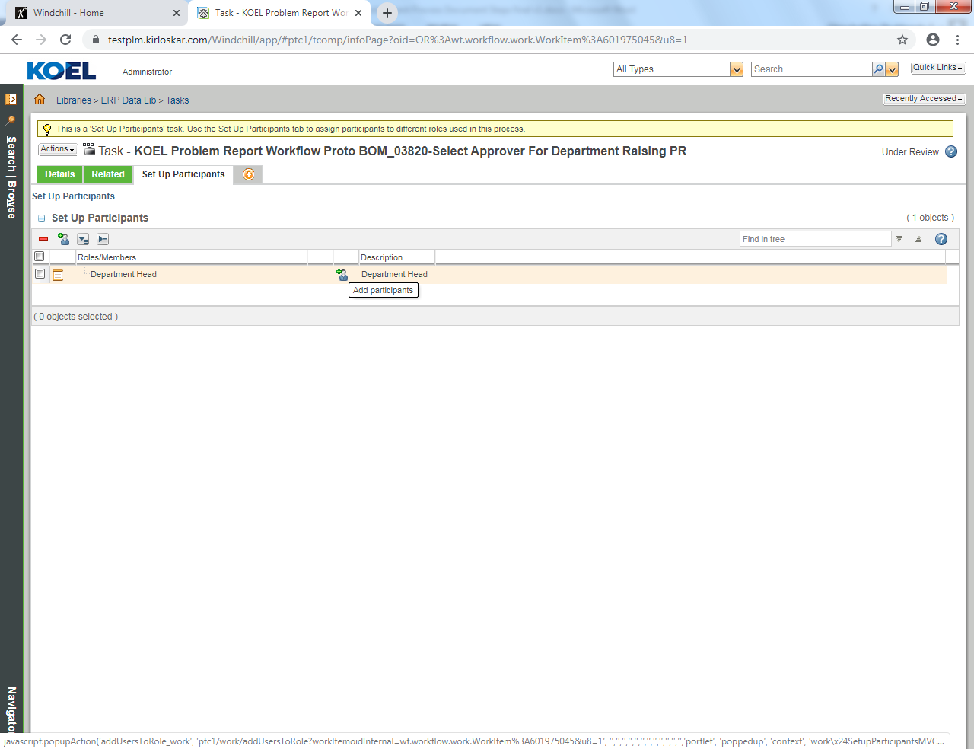
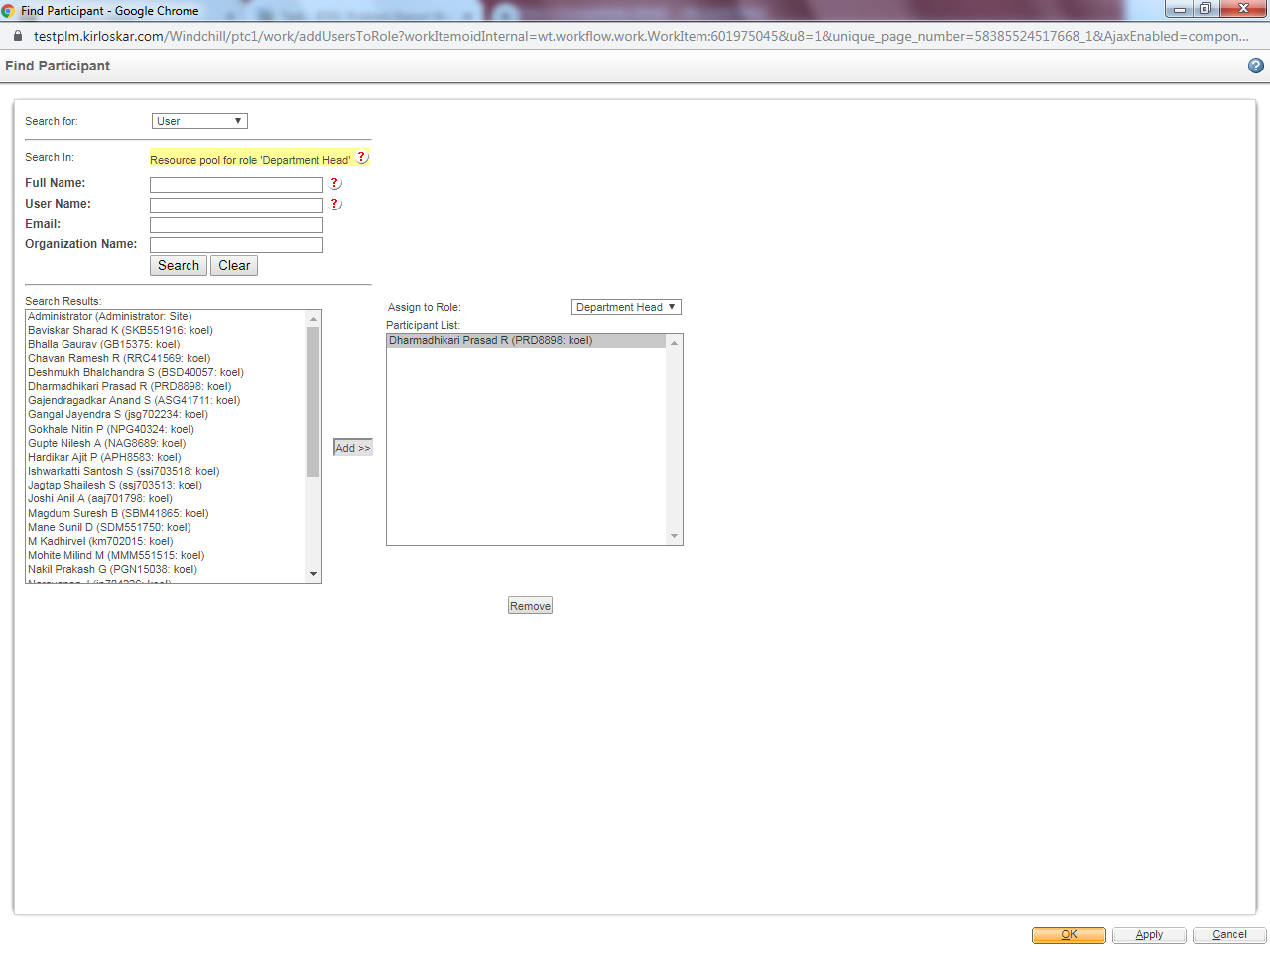
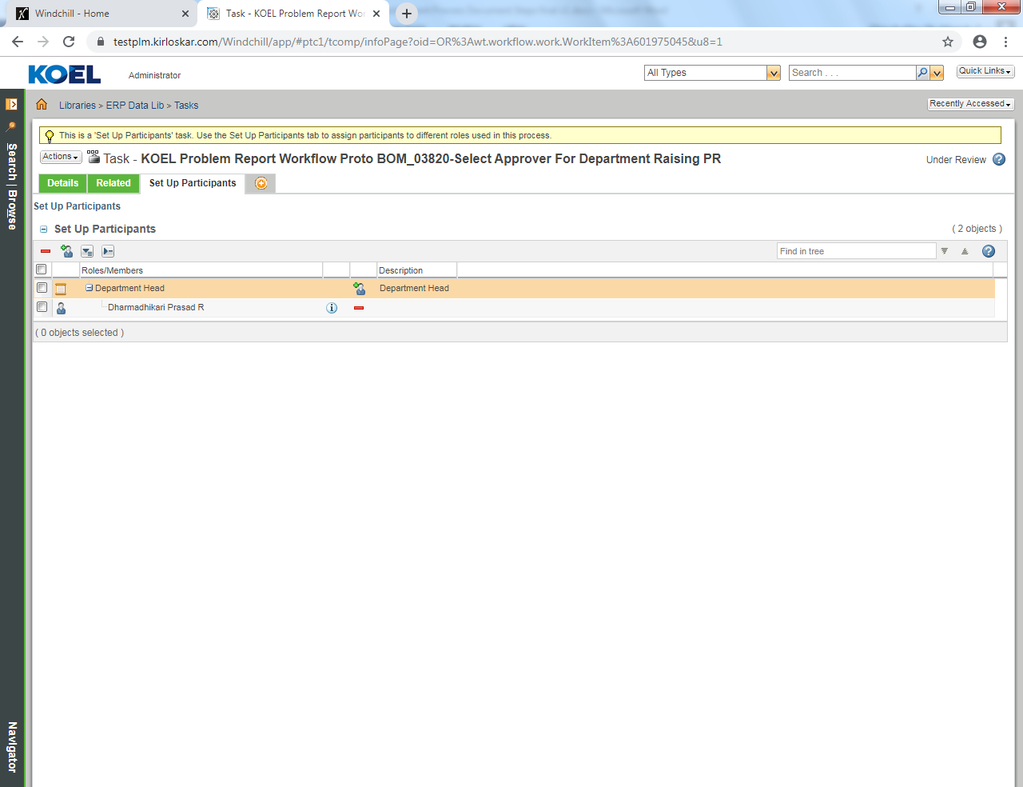
Click to Complete Task

Review Problem Report
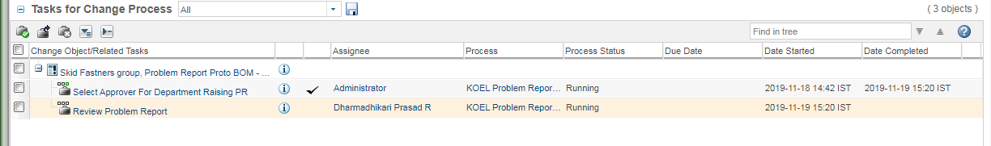
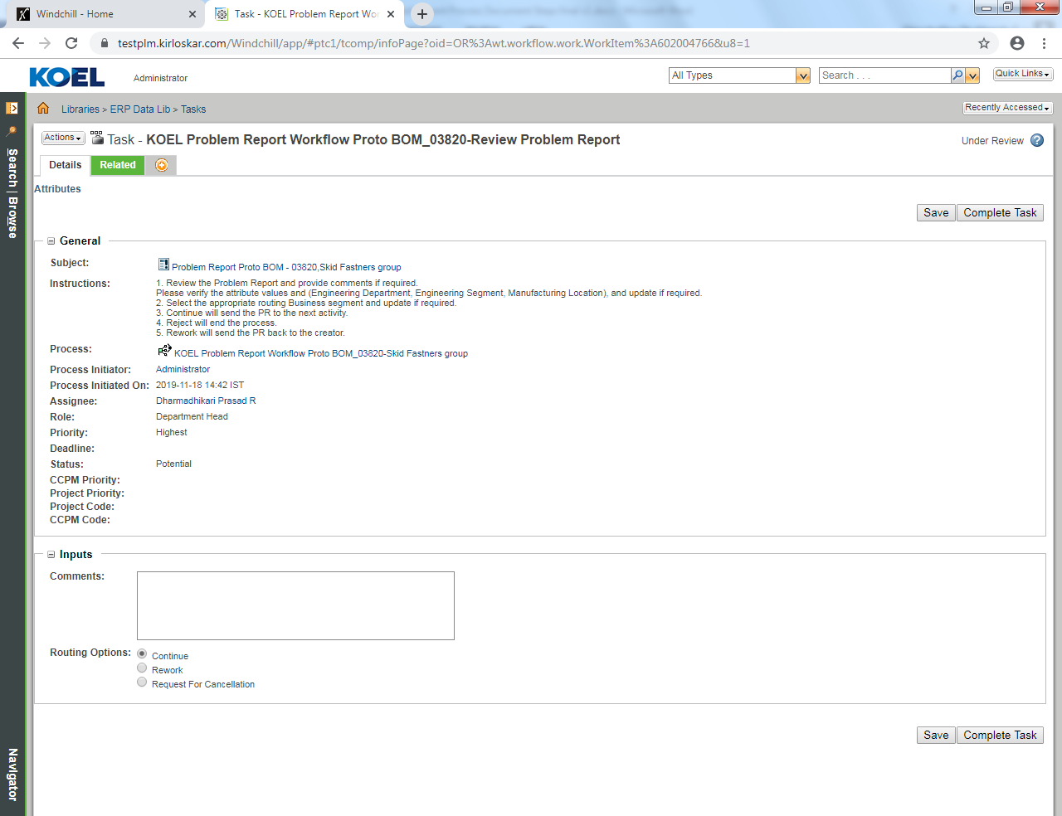

Select continue and click to Complete Task
Select rework and complete the activity by giving the comments.
If comments are not provided an error message pop out.
The same is applicable if Reject routing is selected.

Assign Engineer and Department for comments
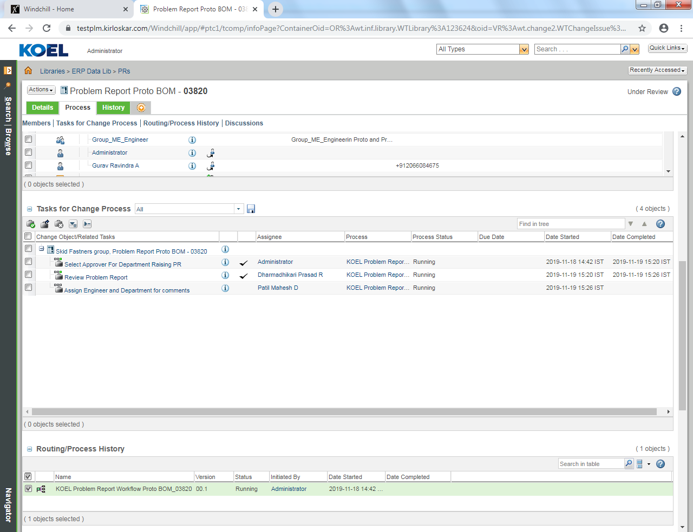
Select Setup Participant.
Select Engineer by clicking search button.
Add it to Participant list.
Click ok
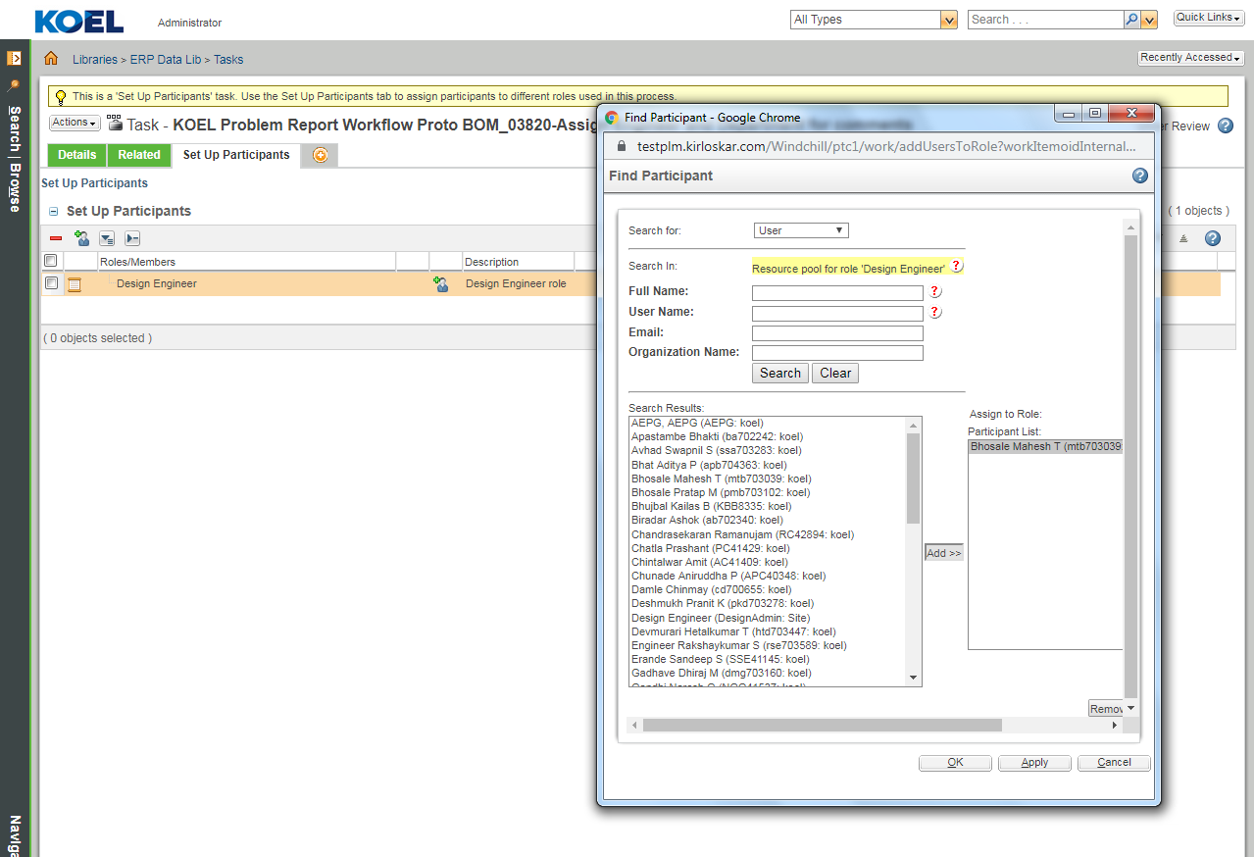

Select Review Departments and click on Complete Task

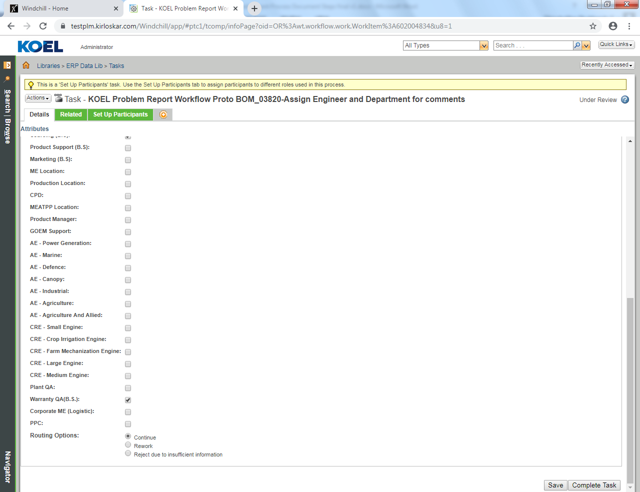
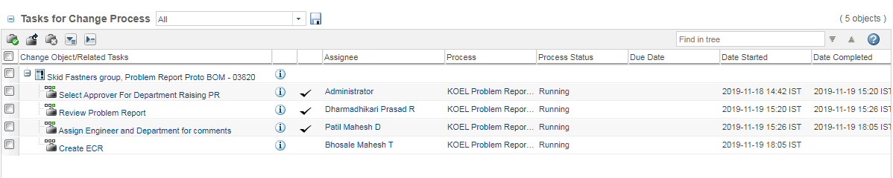

Engineering Change Request Proto BOM
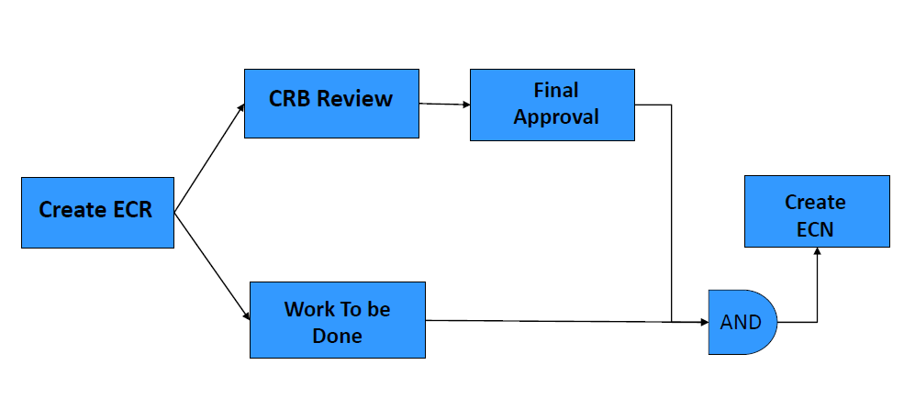

Engineering Change Request Proto BOM Creation
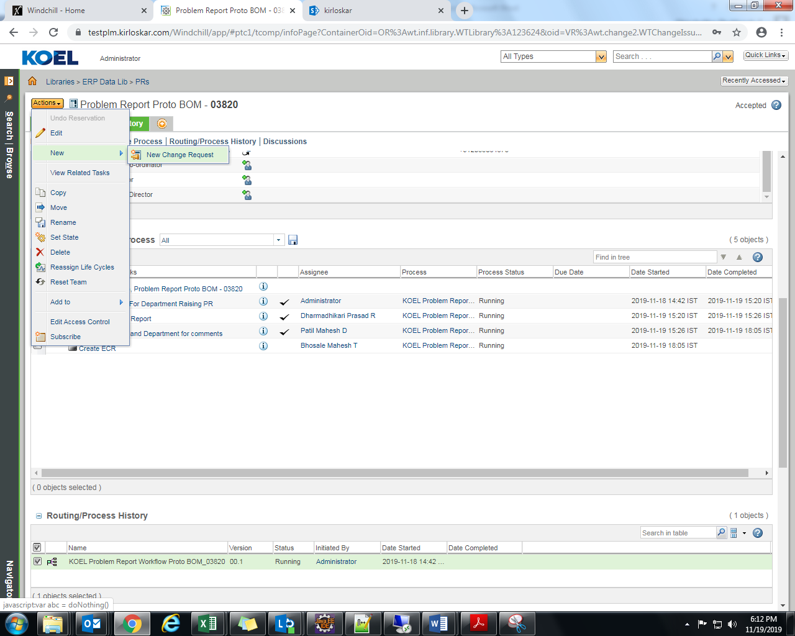
Set Attributes
Create New Change Request.
Attributes are Auto populated and none of the IBAs are editable if CR is created against PR

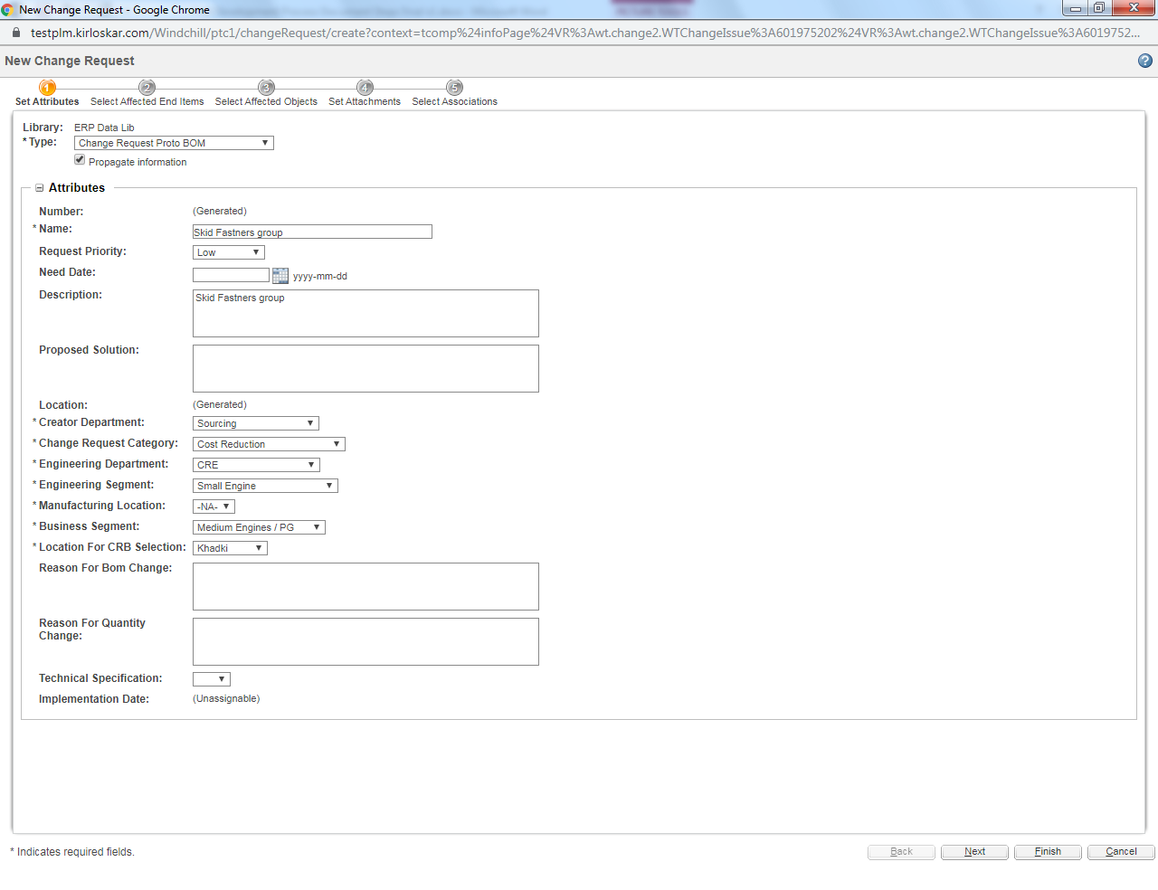
Select Affected End Items
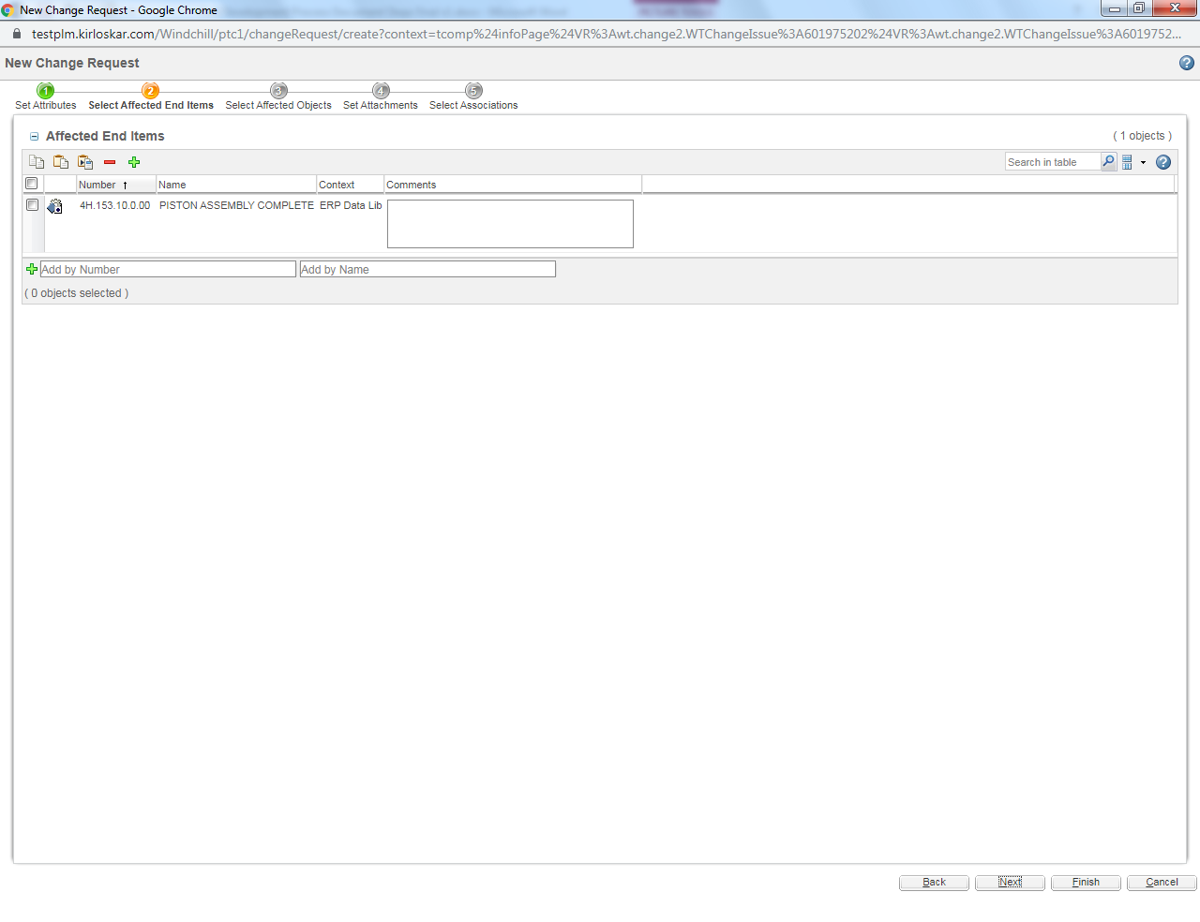

Select Affected Objects
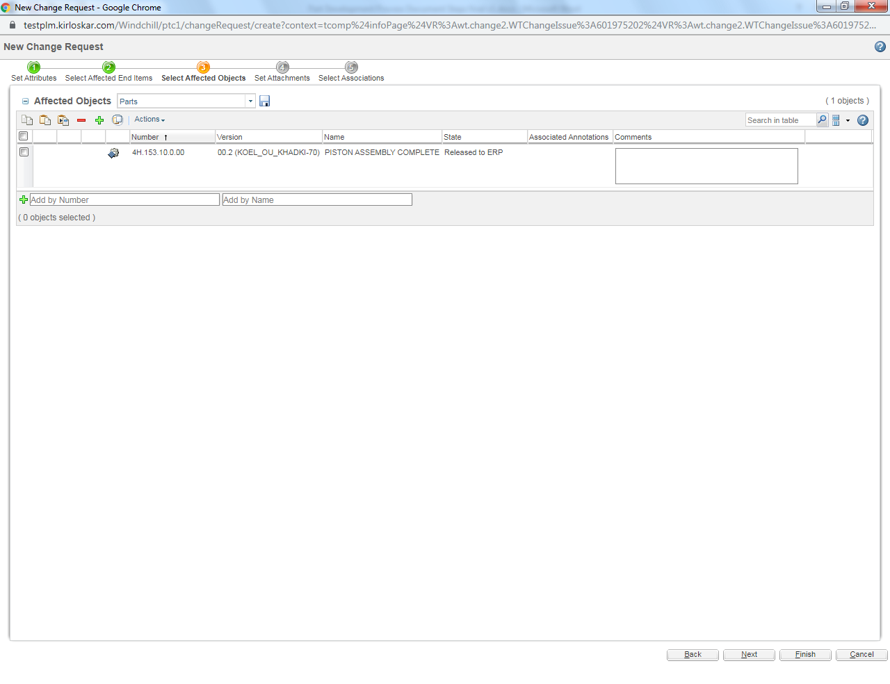
Set Attachments
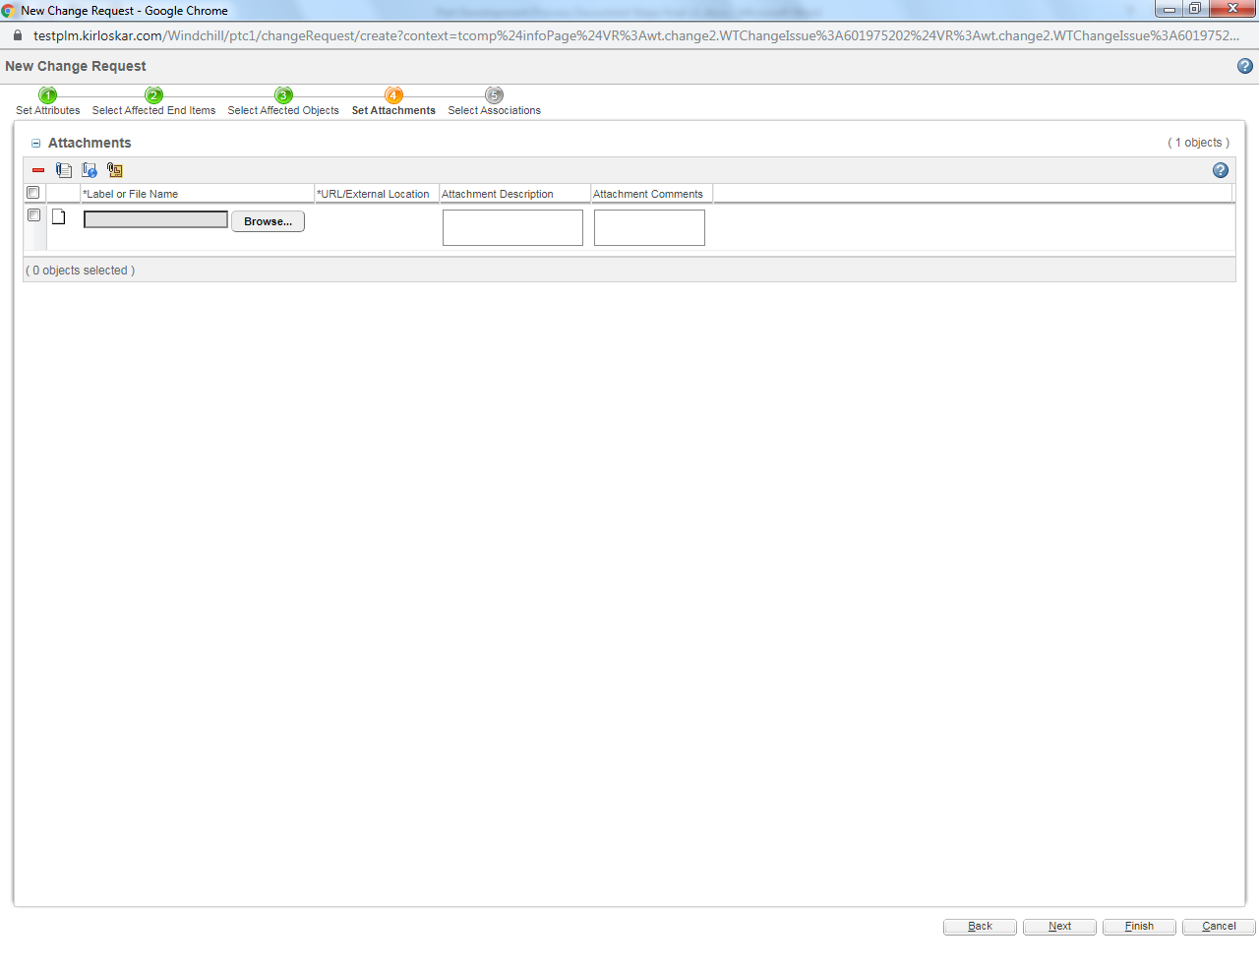
Set Associations
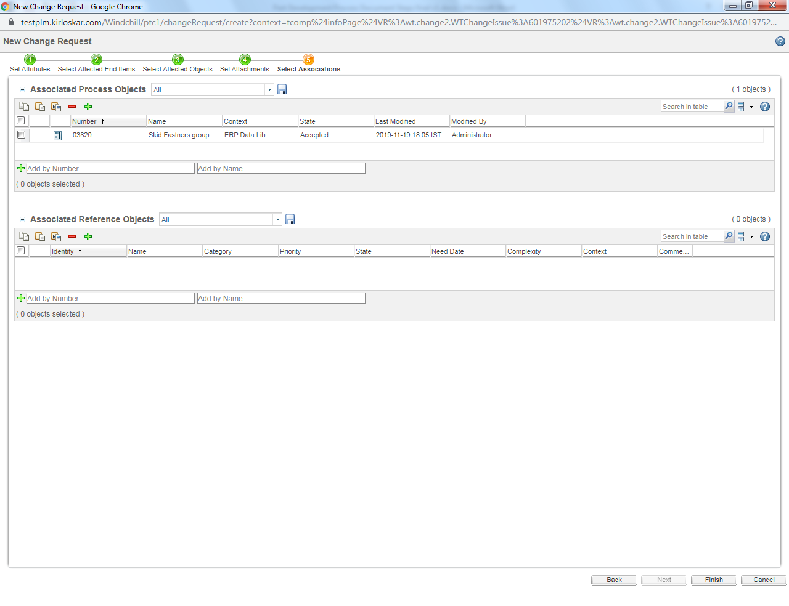

Engineering Change Request Proto BOM Task
Login as respective department reviewer according to selected category fields
Click on Home.
Select CRB Department Review from the list & fill the comment as required.
Click on Complete Task

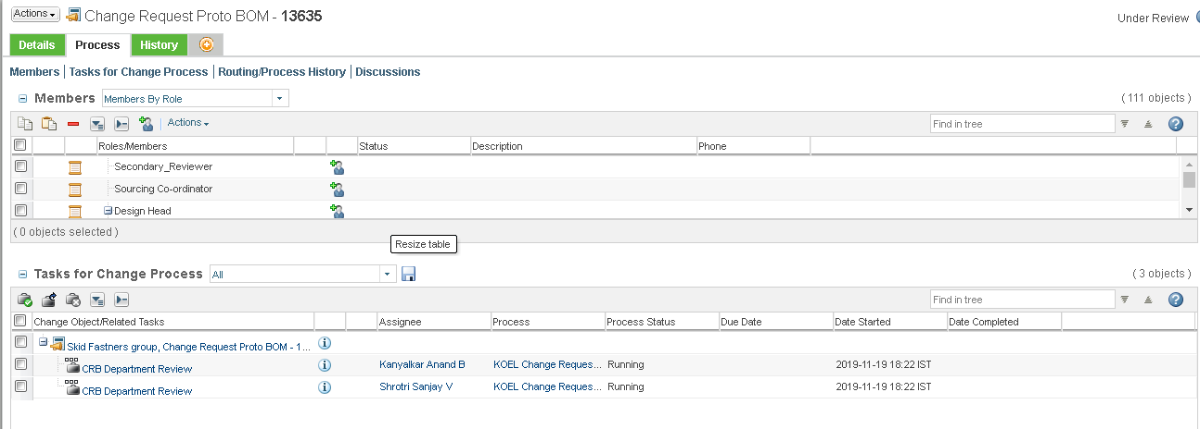

Select Setup Participant.
Select Engineer by clicking search button.
Add it to Participant list.
Click ok
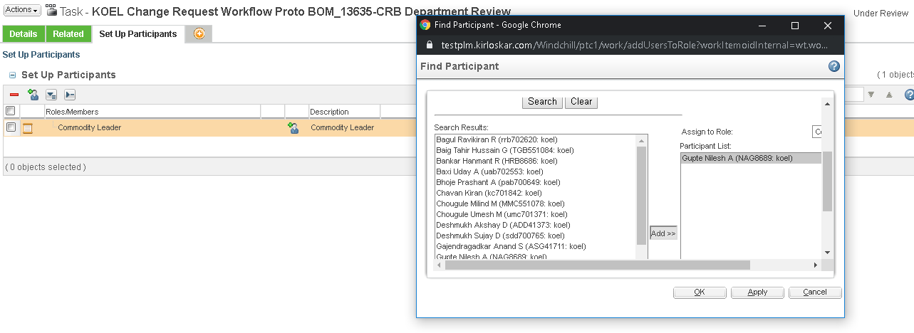

Final Approval Call Login as respective Design Head.
Click on Home.
Select Final Approval Call from the list.
Click on Complete Task

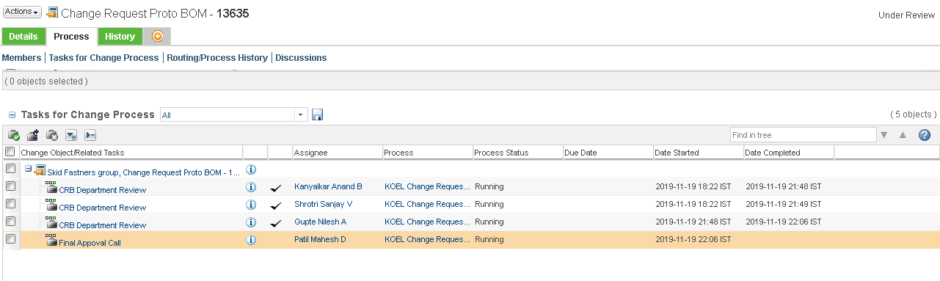
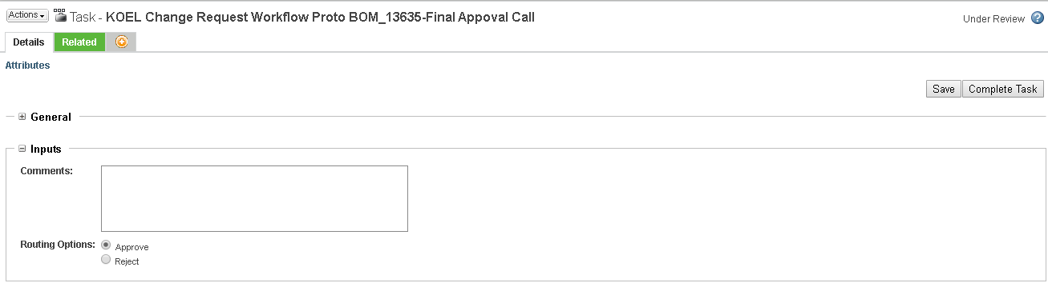

Select ECR for Implementation Date Block
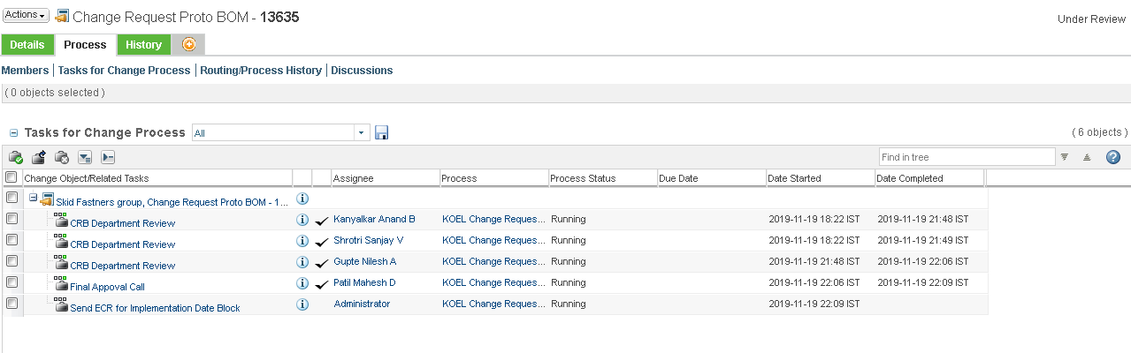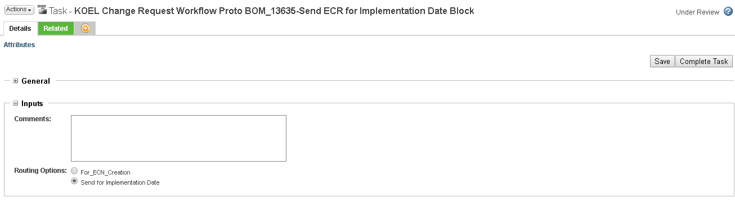
CPD Change Request Review
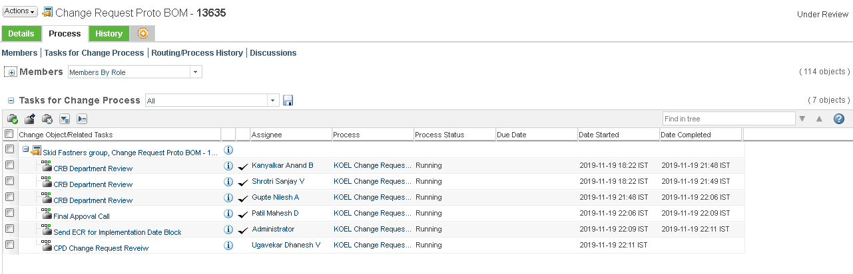
Select appropriate option e.g. select Source Selection
Click on Complete Task
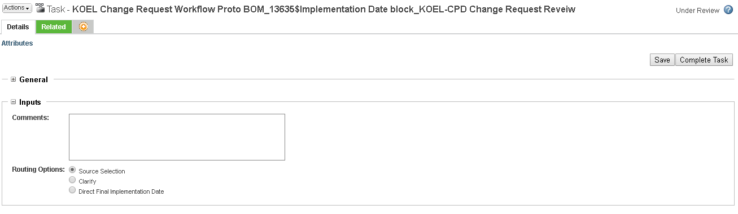

Select the source
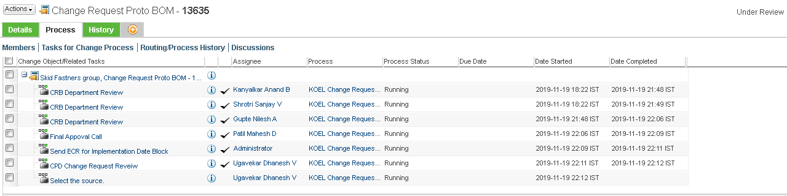
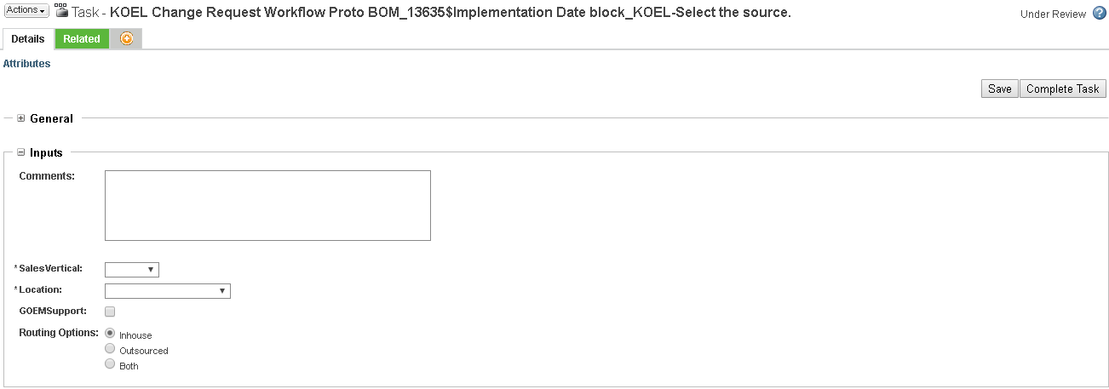
Provide the date required for implementation
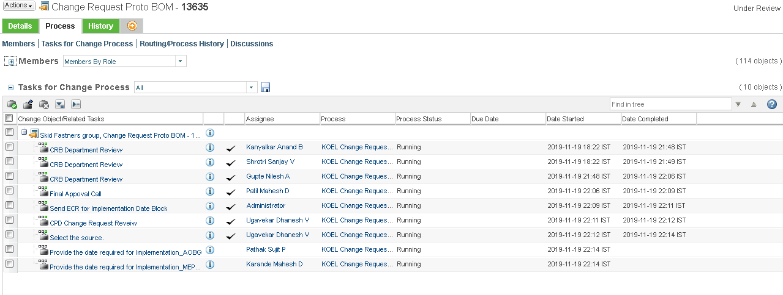
Provide the date
Click on Complete Task
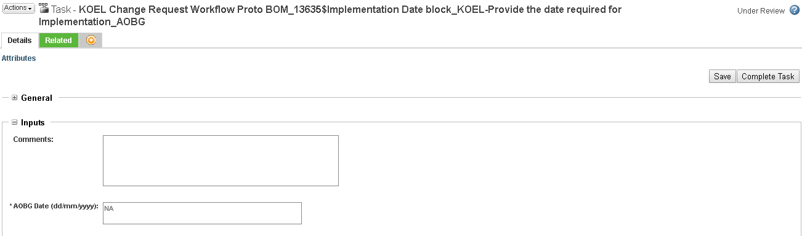

CPD Planned development date
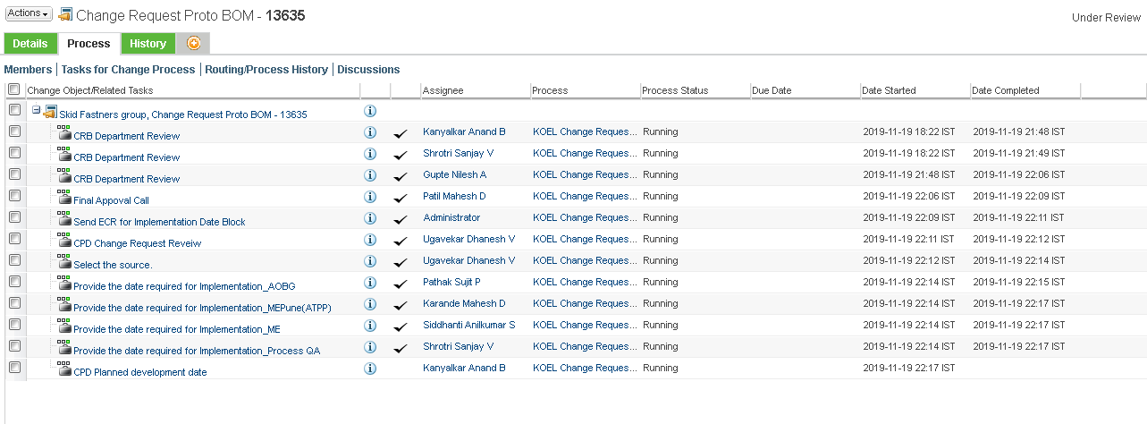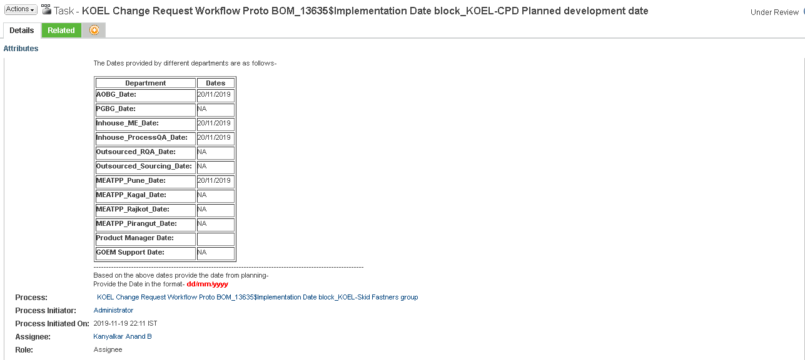
Provide CPD date
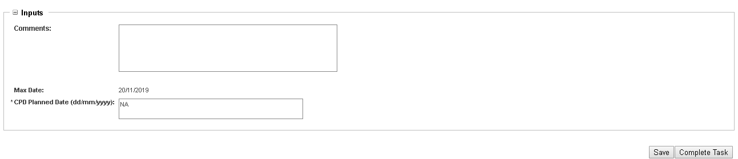
CPD date should be greater than Max date
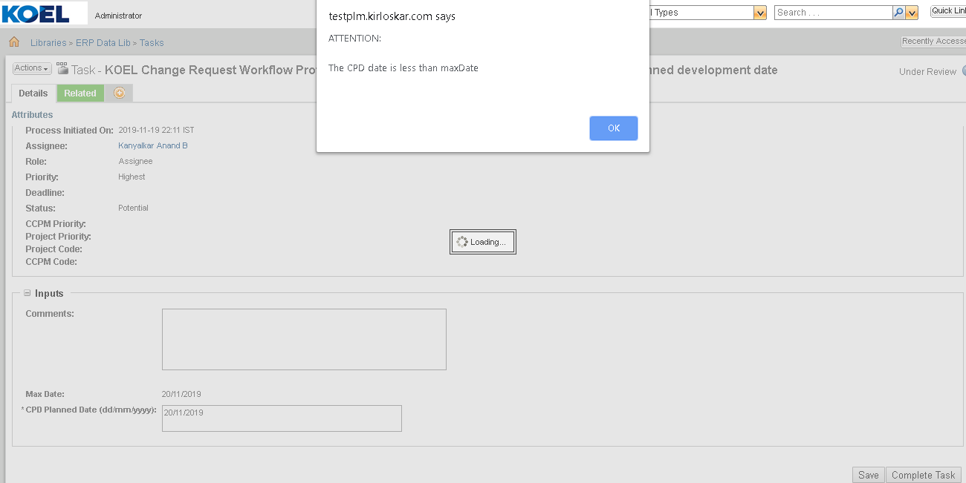

Engineering Change Notice Proto BOM
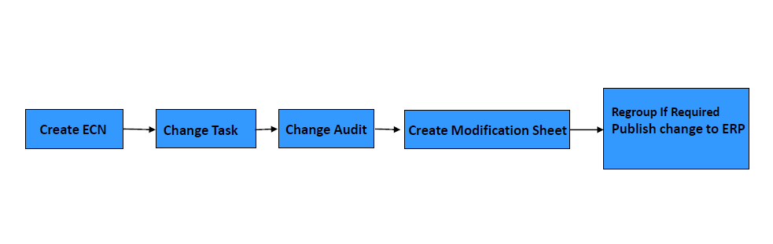

Engineering Change Notice Proto Creation
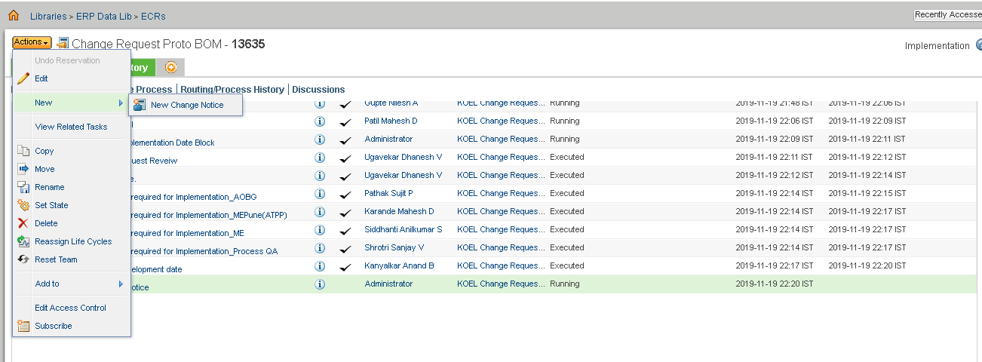
Set Attributes
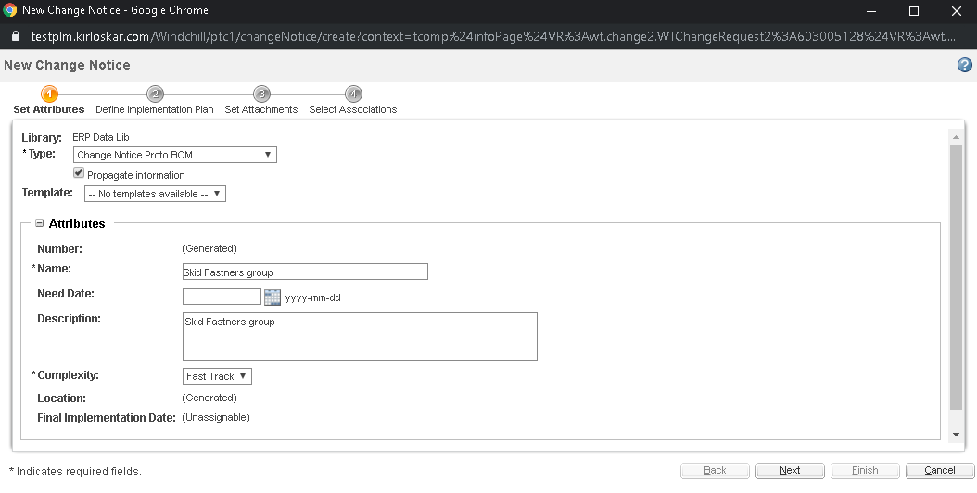

Define Implementation Plan
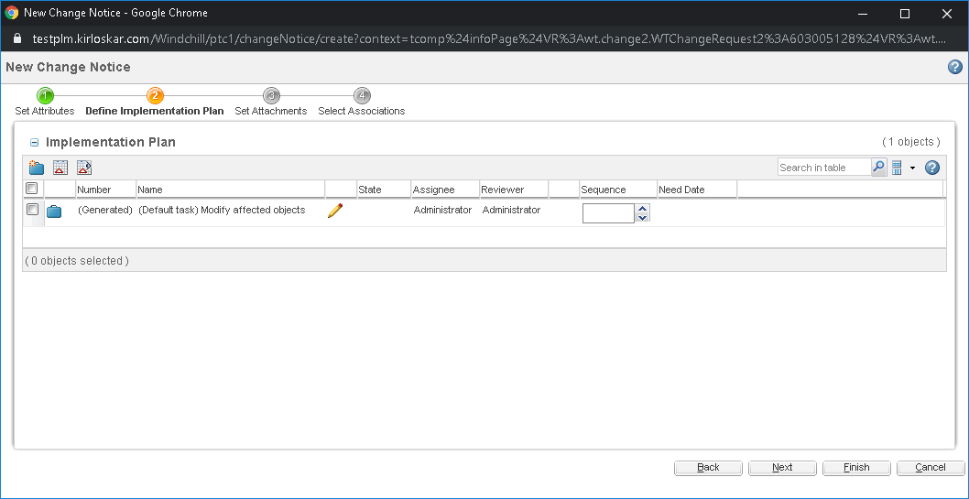
Set Attachments
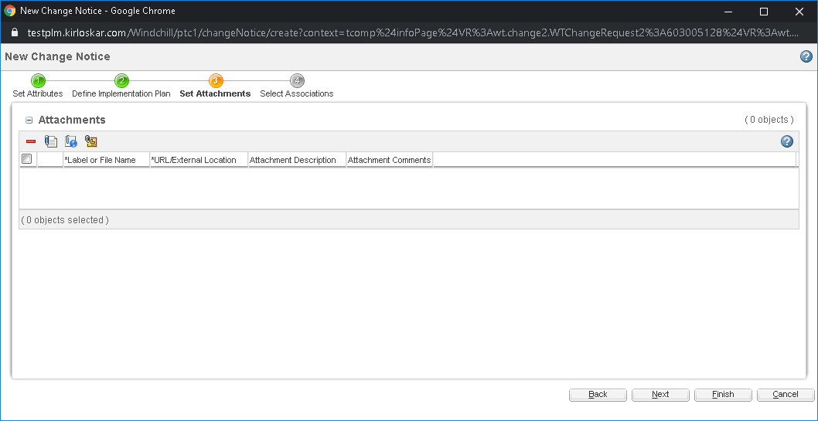
Select Associations
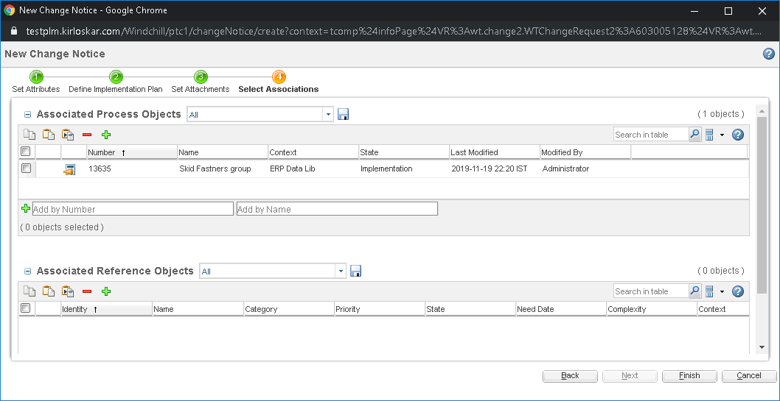
Click on Submit Now
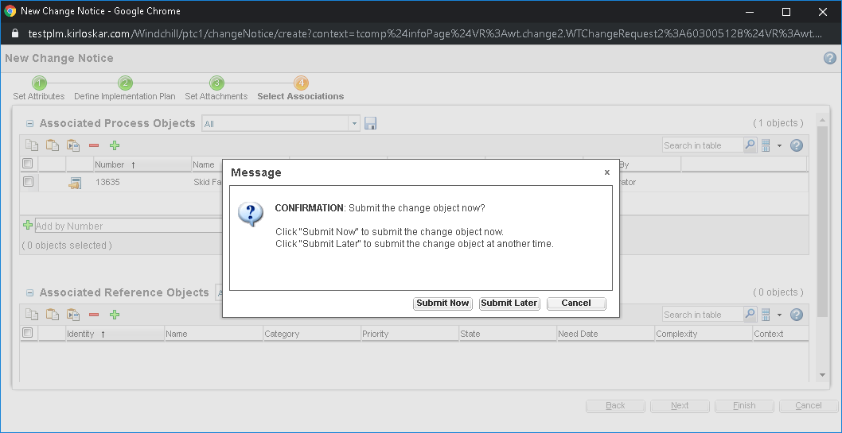

Engineering Change Notice Proto Task

Select complete change notice task from list.
Select complete task.
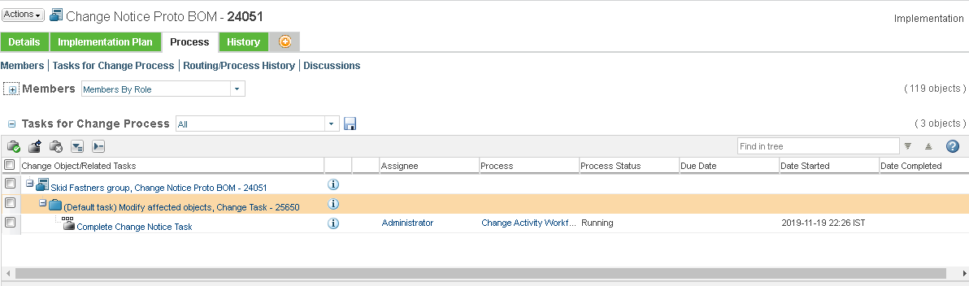
Release Modification Sheet
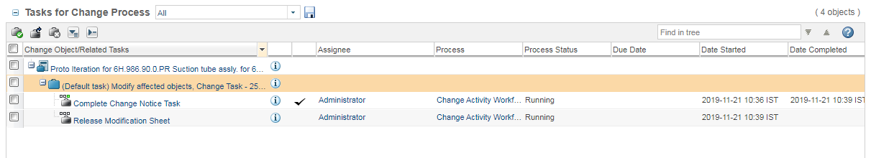
Set Attachments
Click on Complete Task

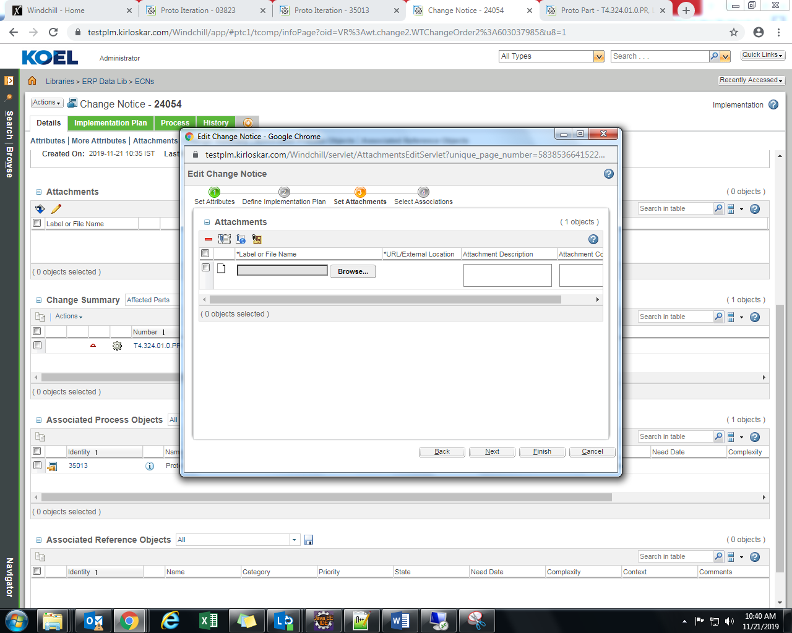

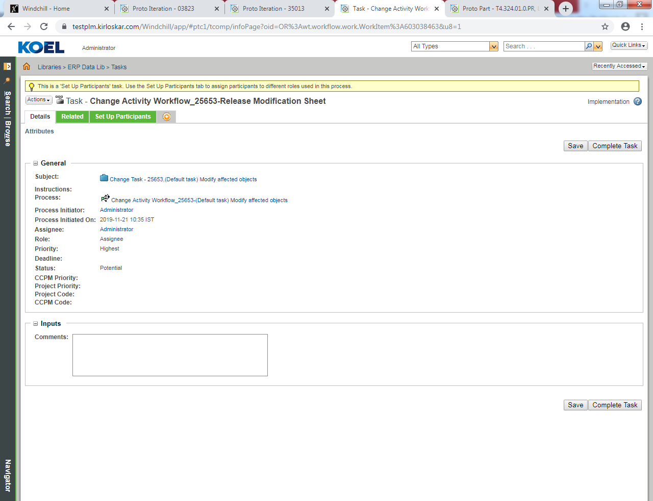

Production BOM

Problem Report Production BOM

Problem Report Production BOM Creation

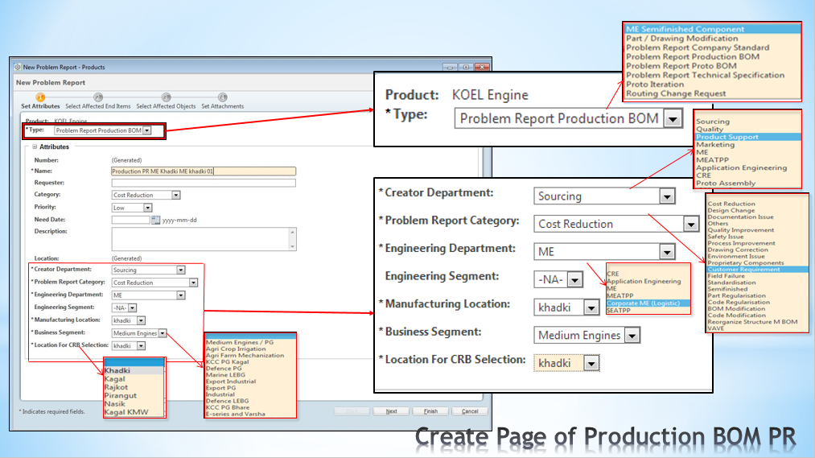

Select Affected End Items
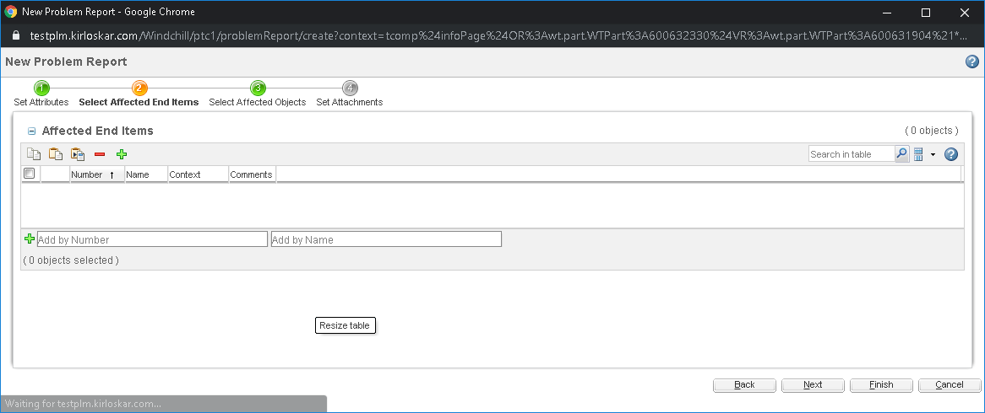
Select Affected Objects
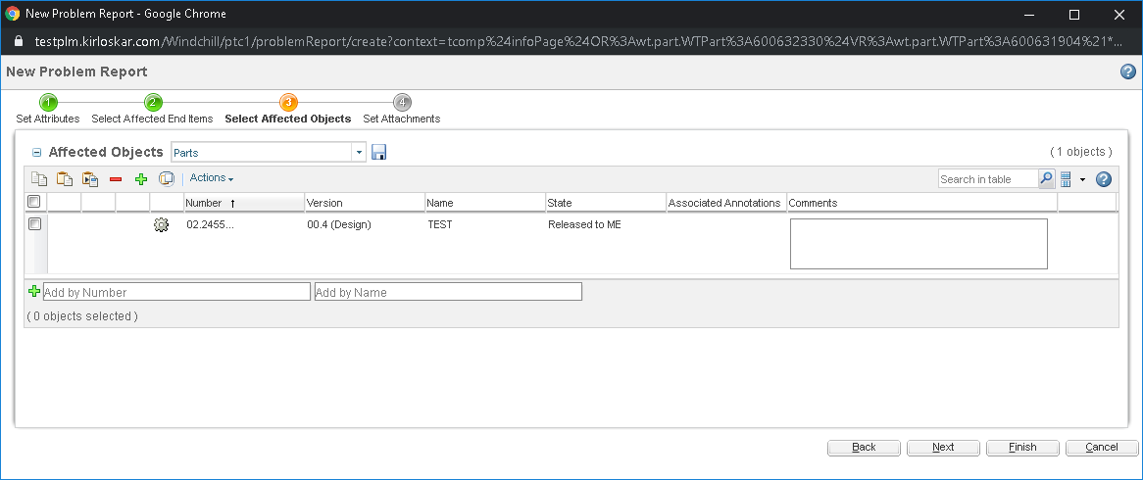
Set Attachments
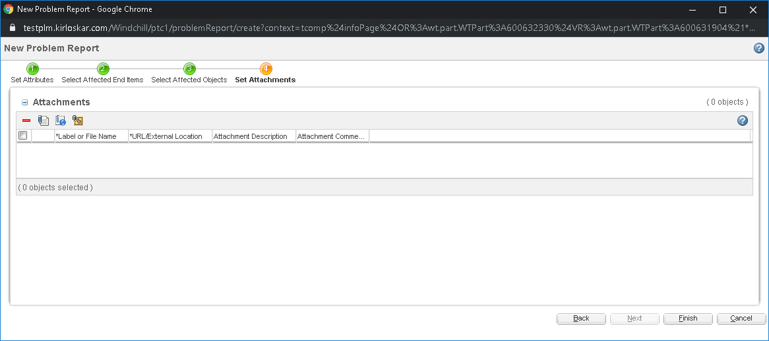
Select Submit Now
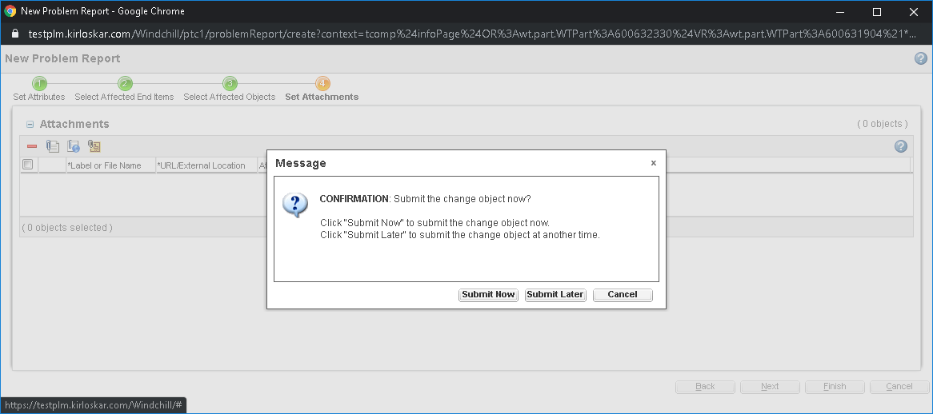

Problem Report Production BOM Task
Channelize to CRE engineer & Select Review Departments
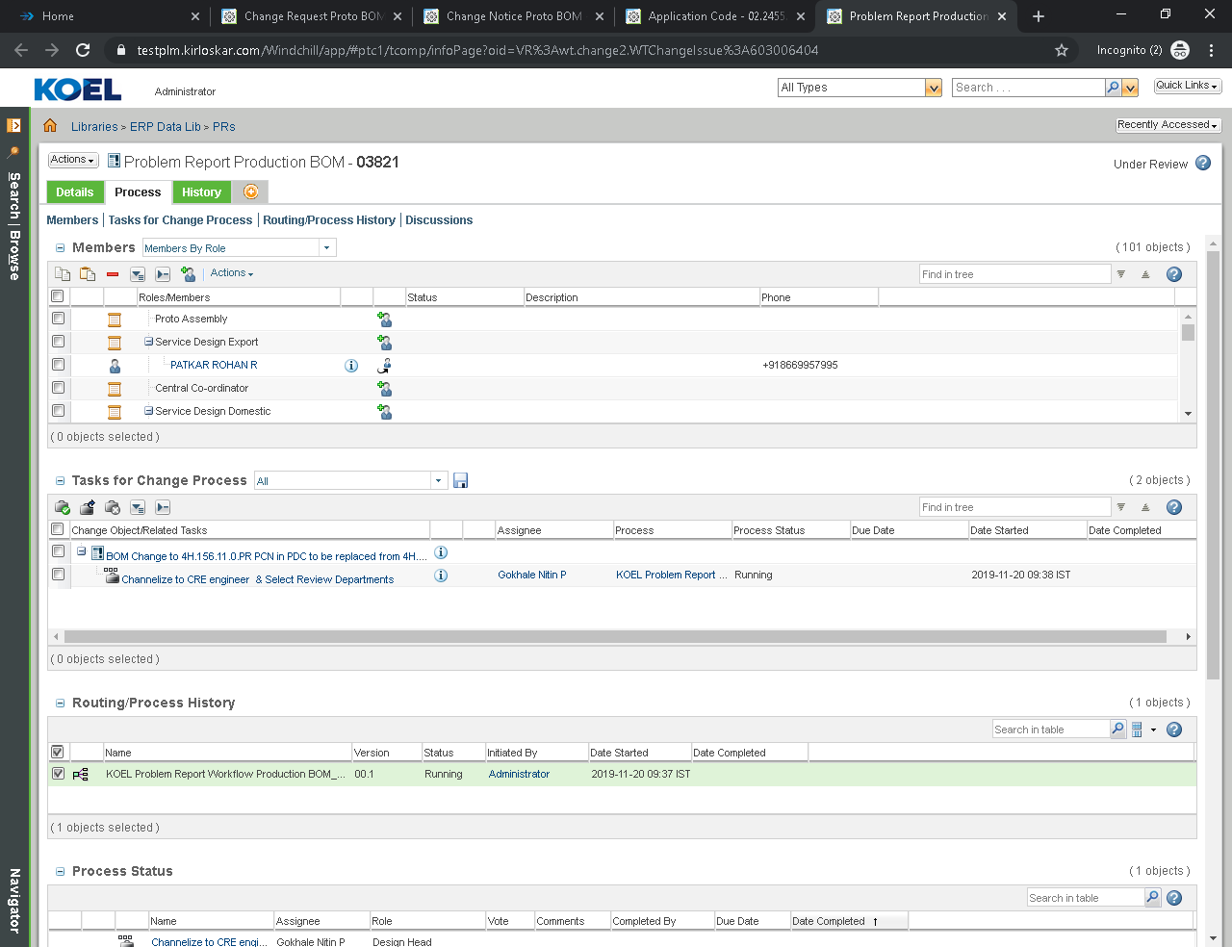
Setup Participants
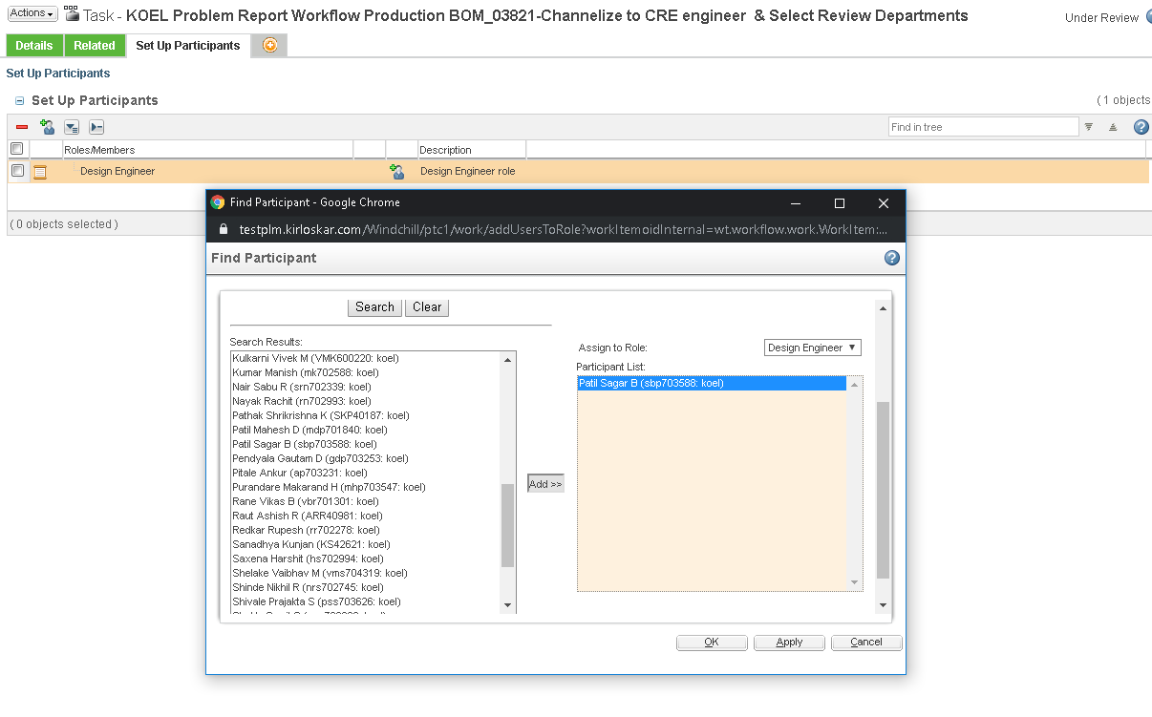

Select Review Departments and click on Complete Task

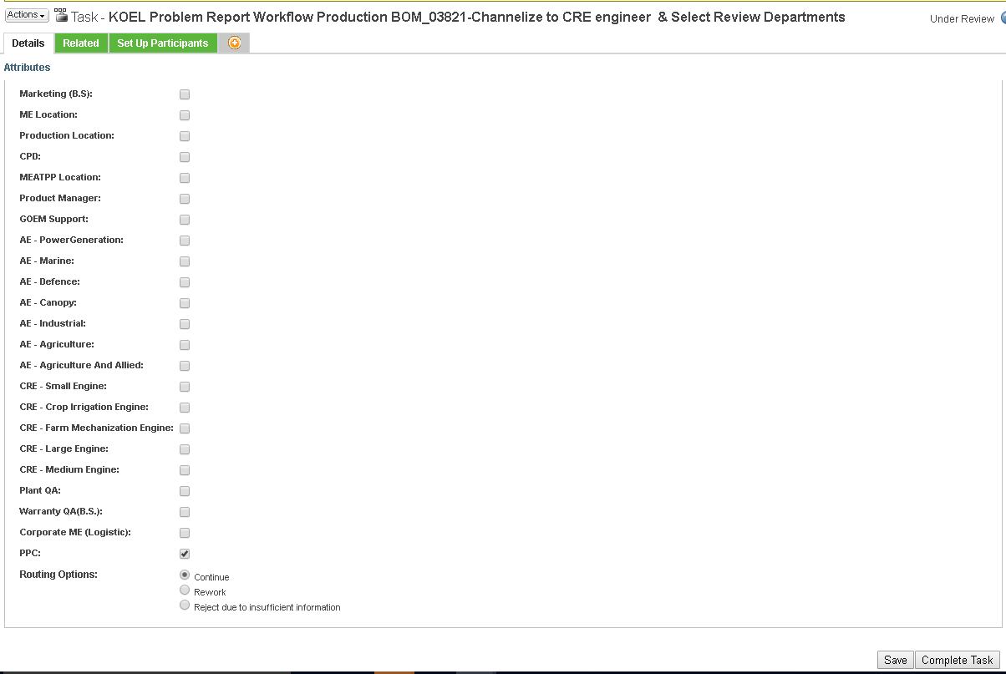

Engineering Change Request Production BOM

Engineering Change Request Production BOM Creation
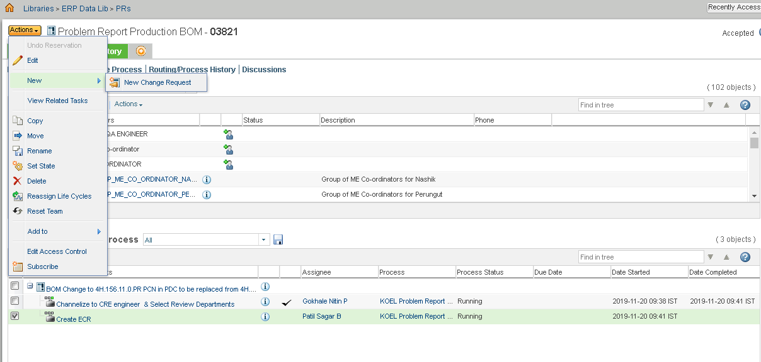

Create New Change Request.
Attributes are Auto populated and none of the Attribute are editable if CR is created against PR
Select Attributes

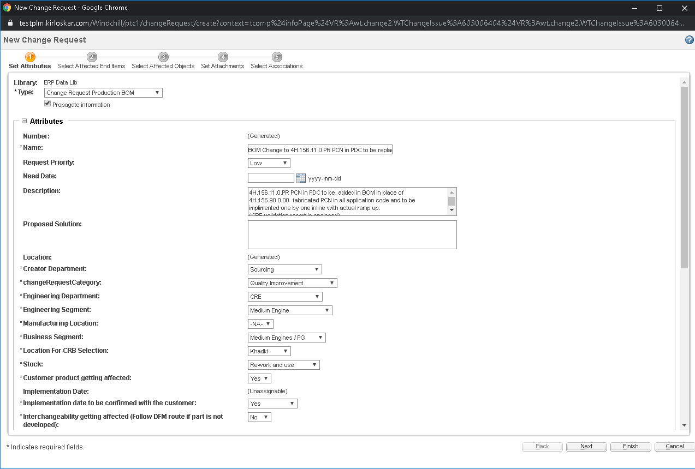
Select Affected End Items
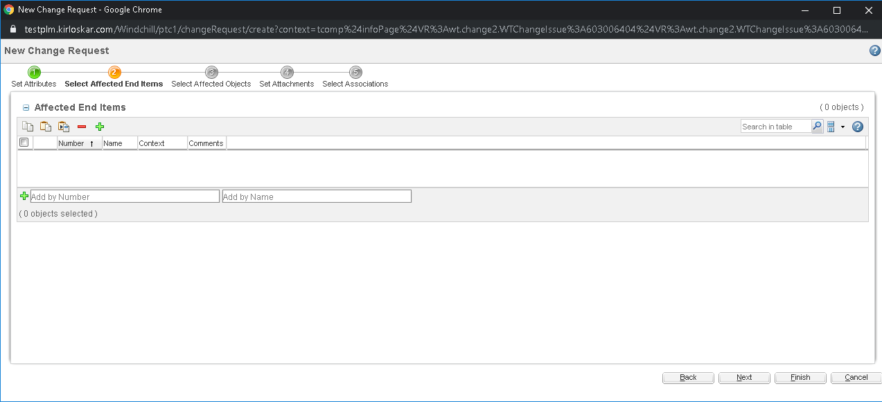
Select Affected Objects
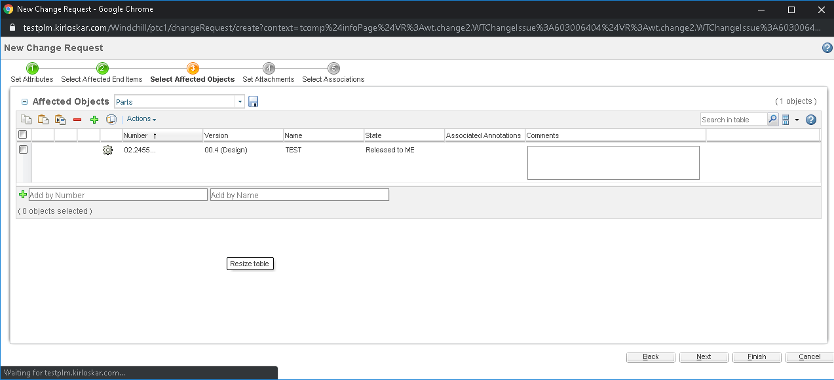
Set Attachments
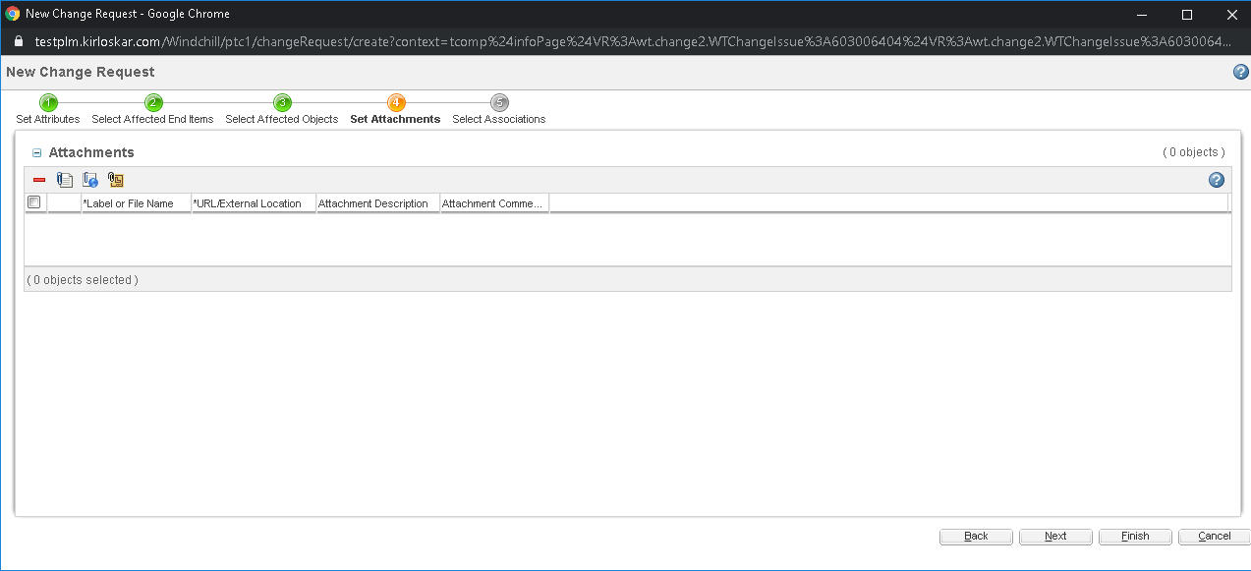

Select Associations
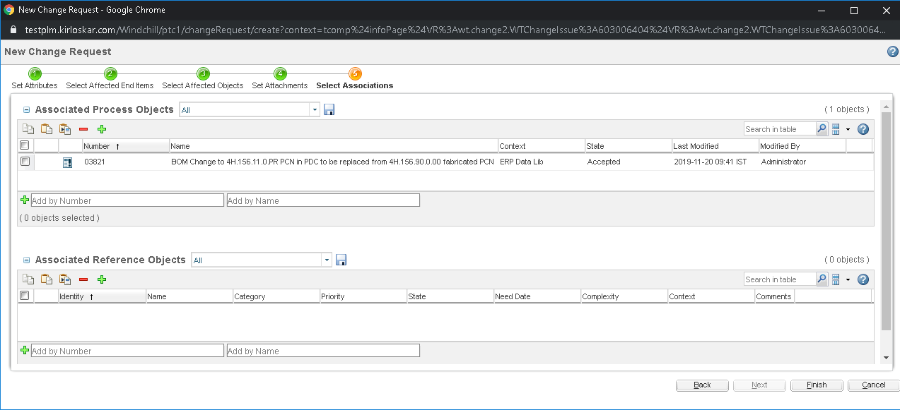
Click on Submit Now
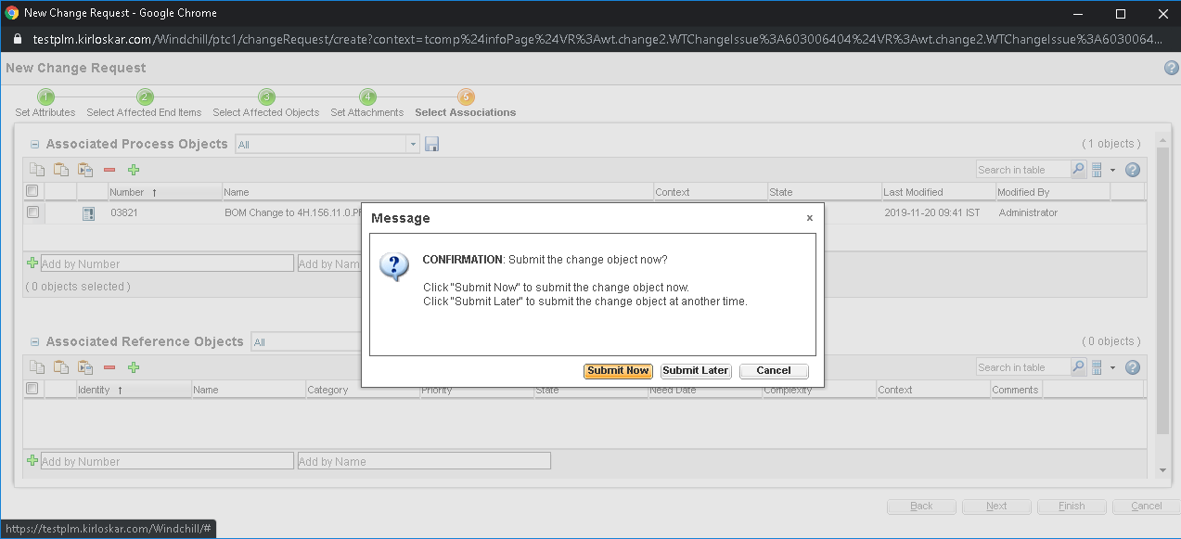

Engineering Change Request Production BOM Task

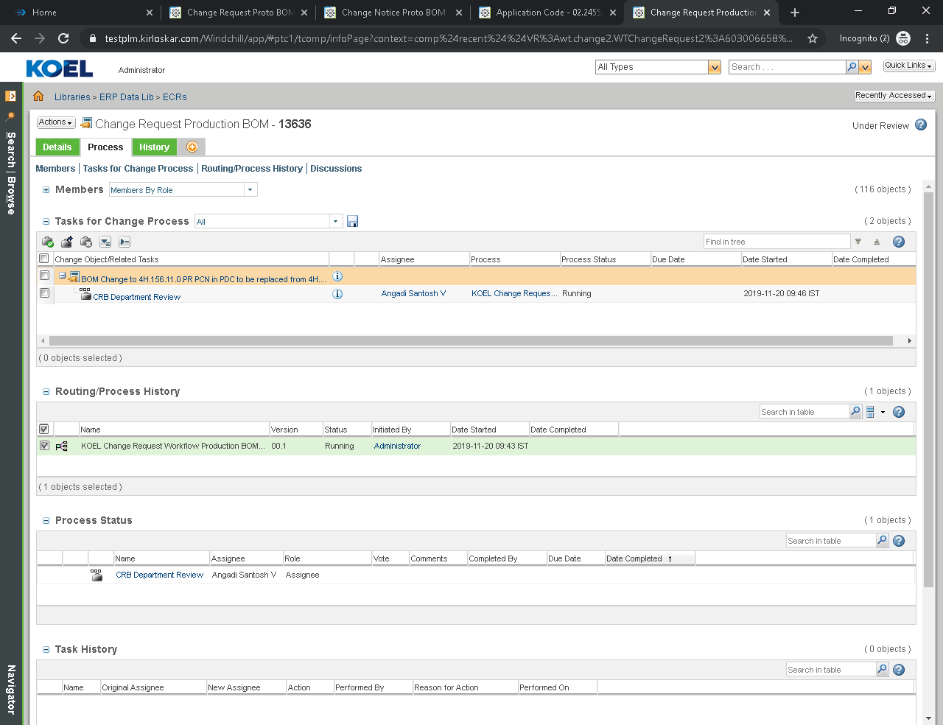

Login as respective department reviewer according to selected category fields
Click on Home.
Select CRB Department Review from the list & fill the comment as required.
Click on Complete Task

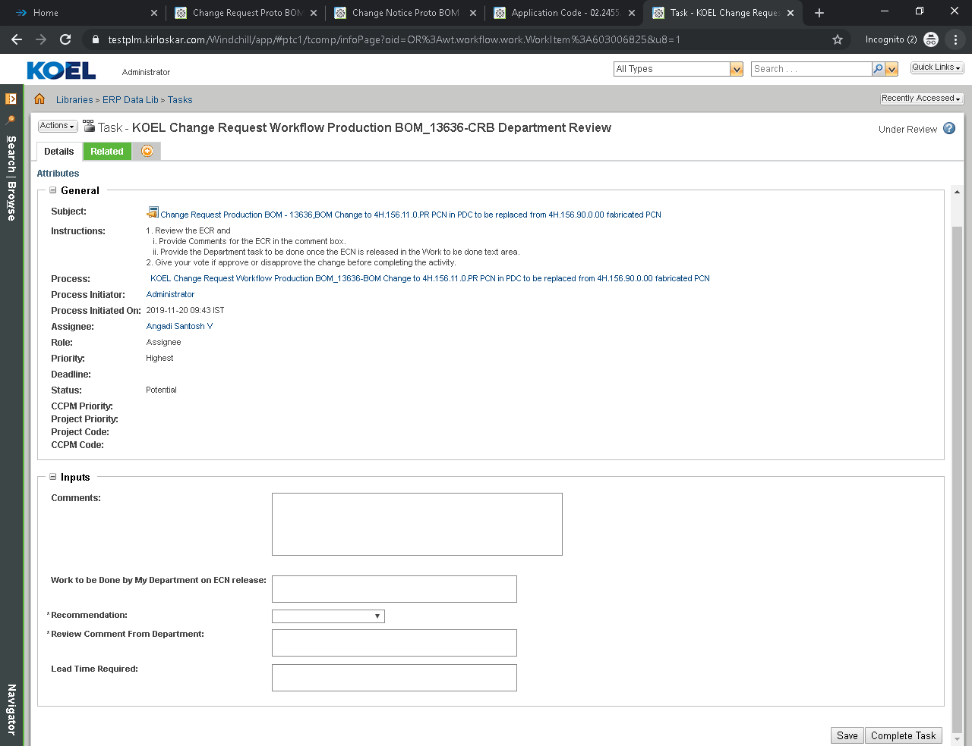
Review Approval Final
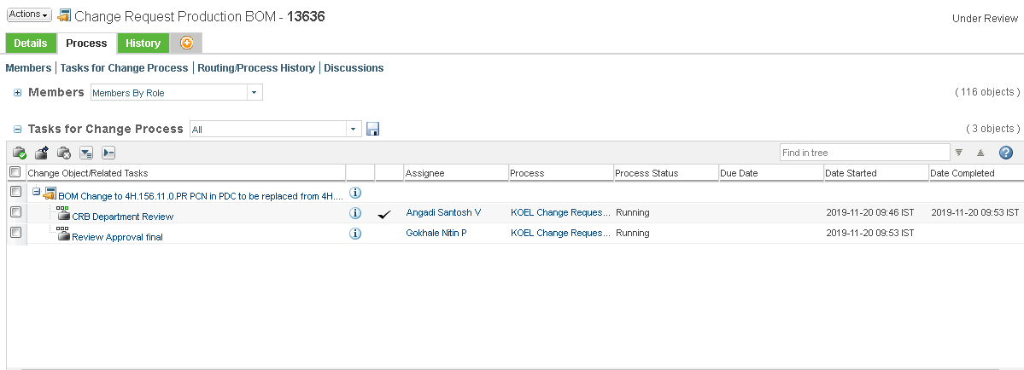

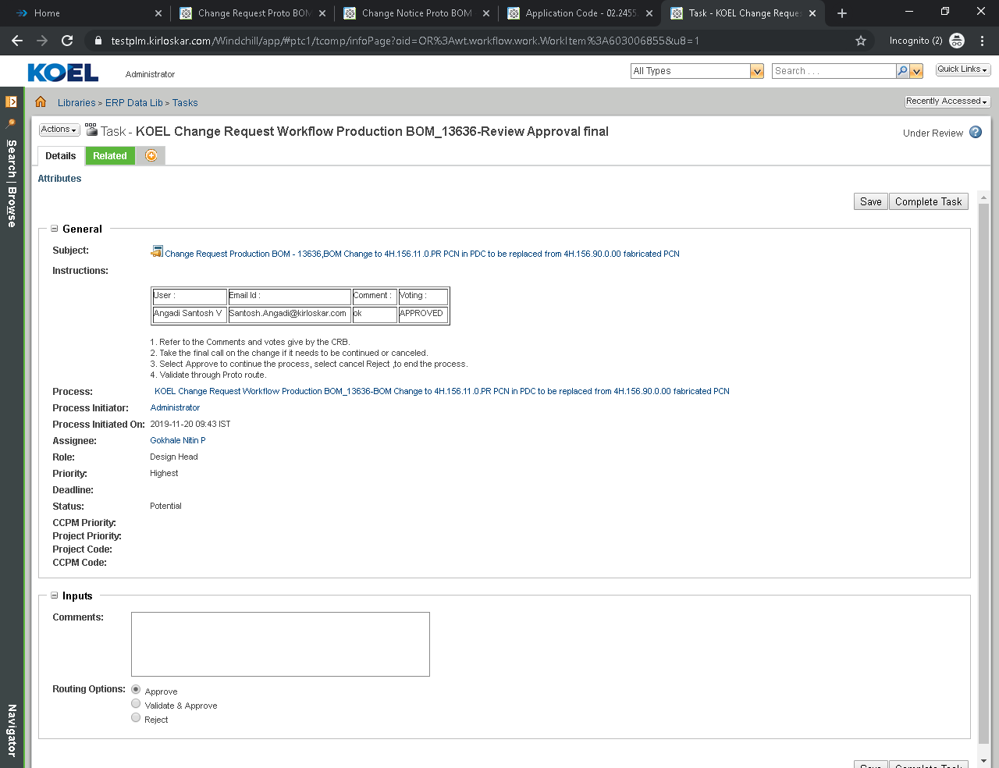
CPD Review & Impact Analysis
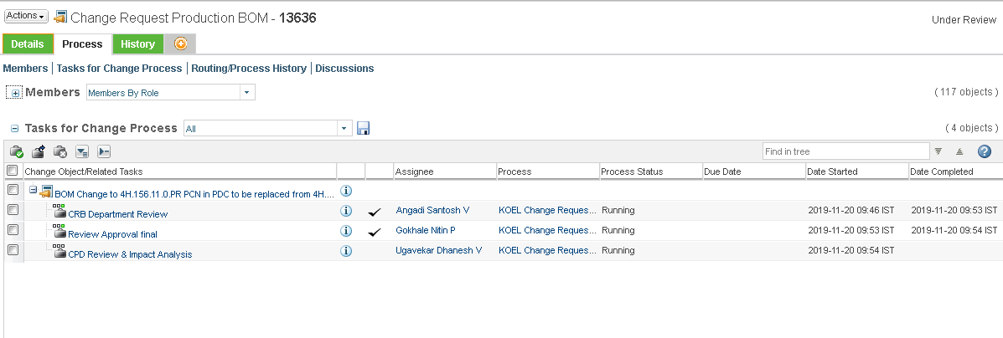
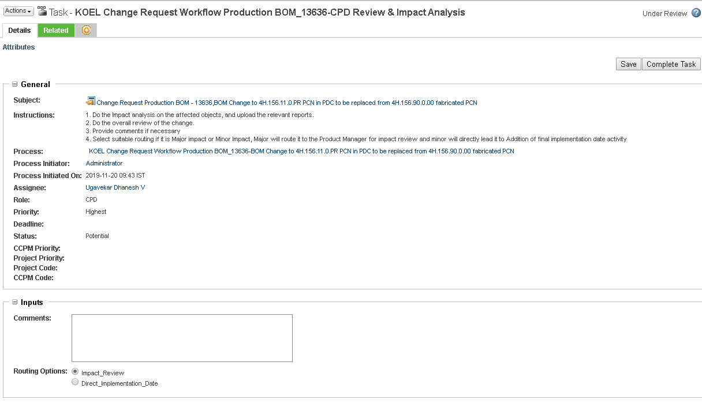

Impact Review
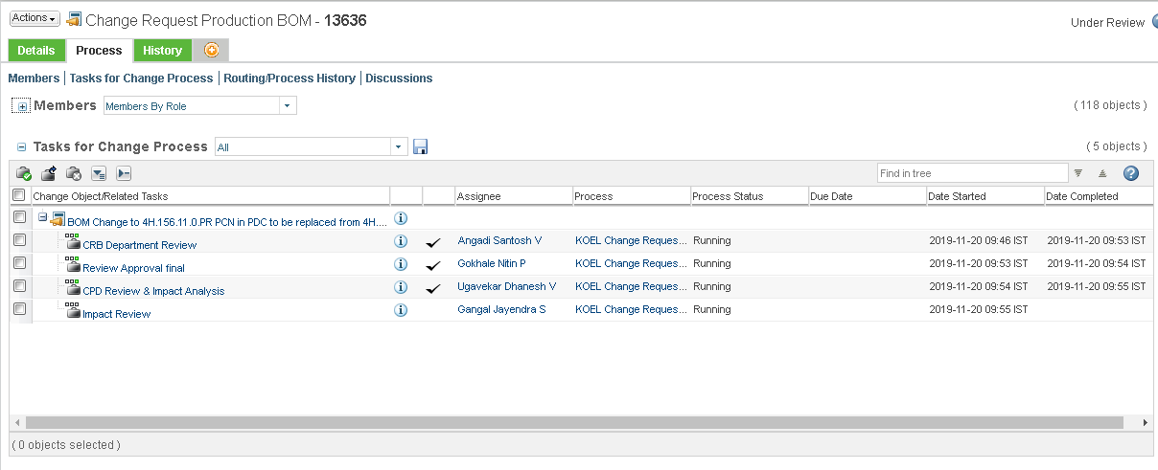
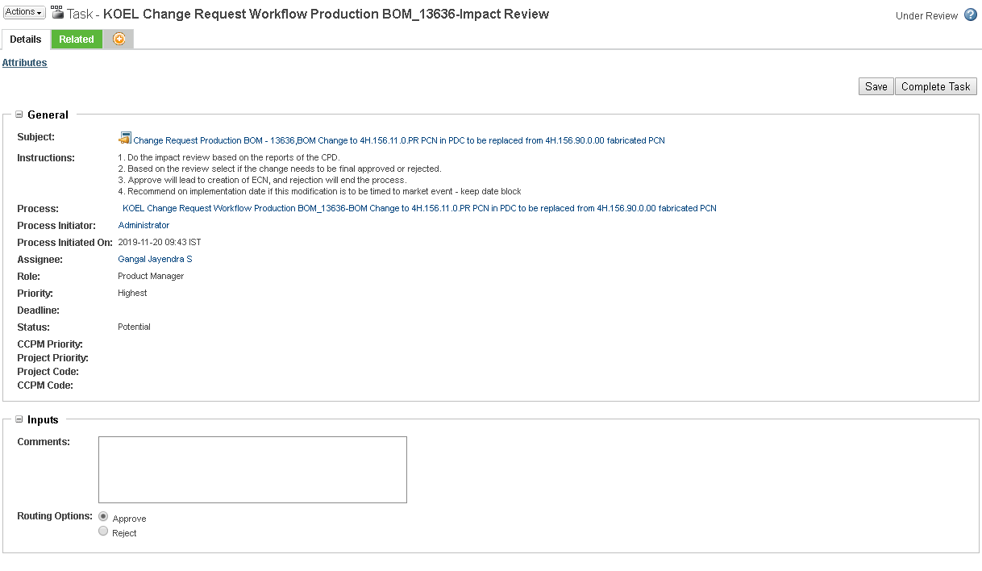
CPD Change Request Review
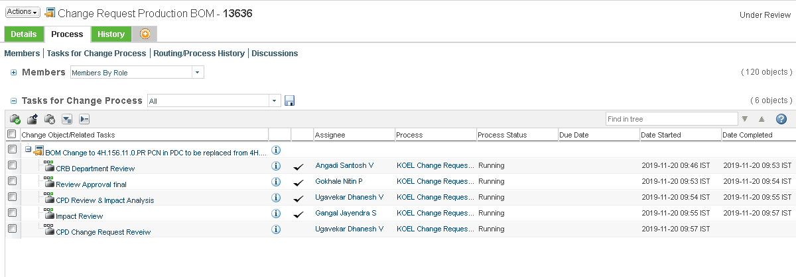

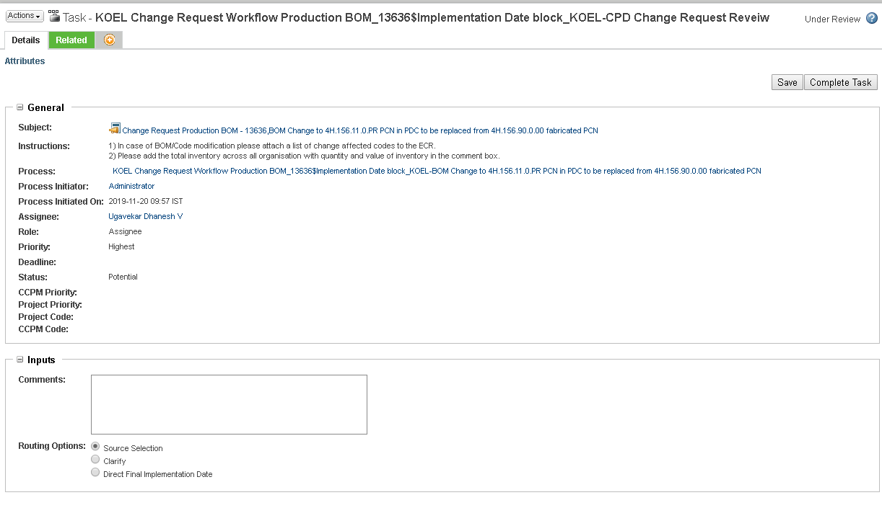
Select the source
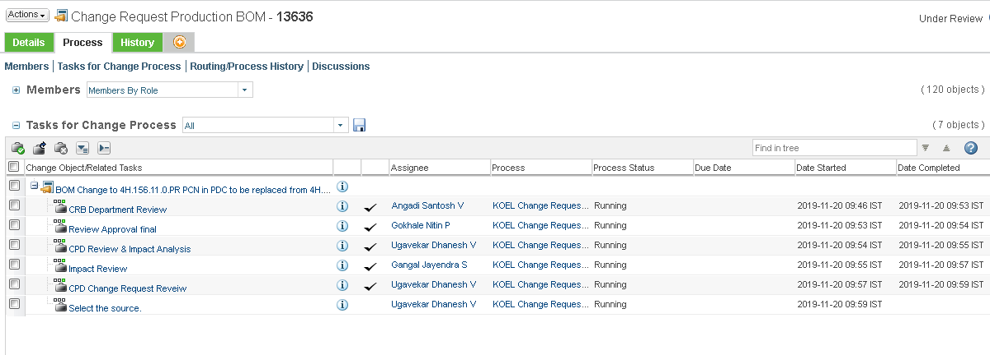
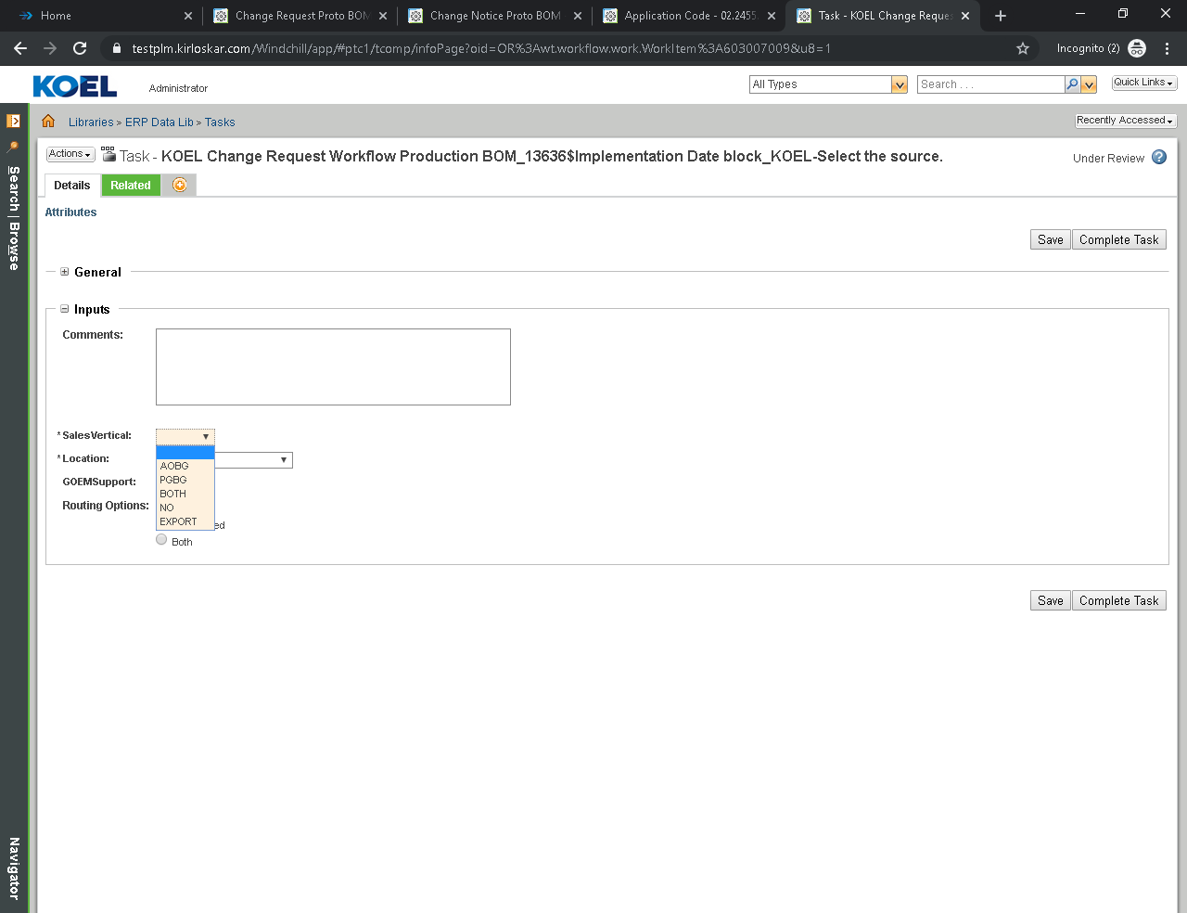

Provide the date required for Implementation
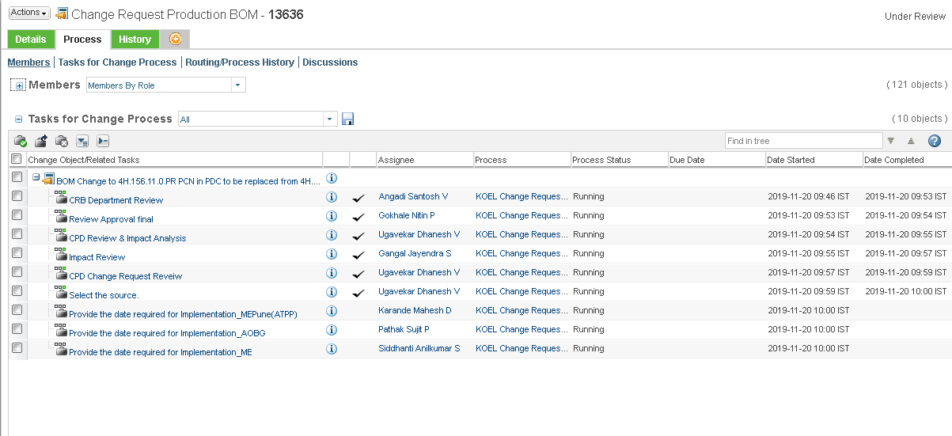
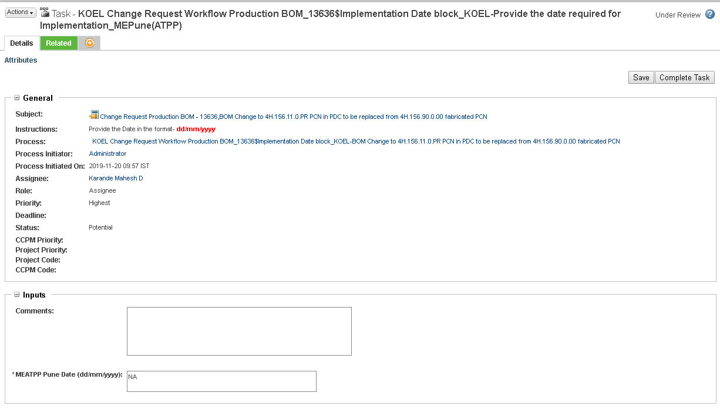
CPD Planned development date
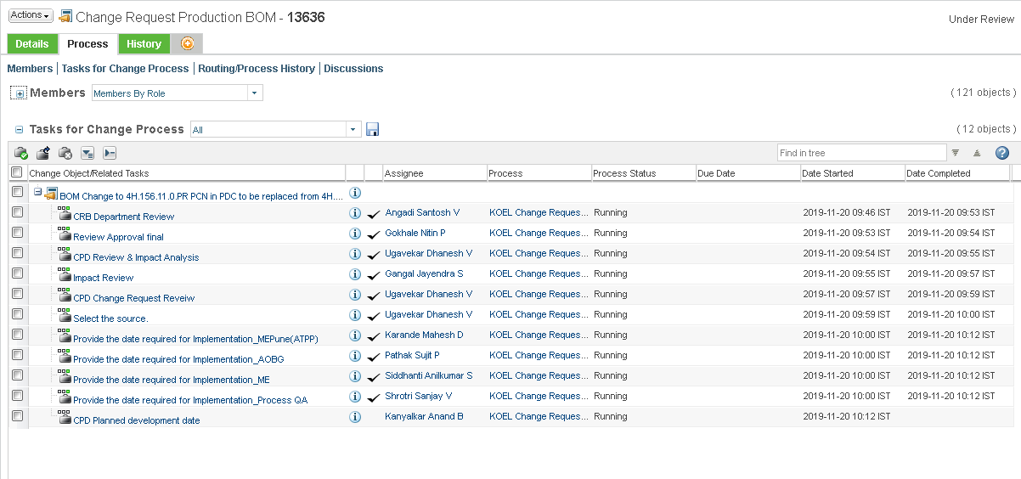

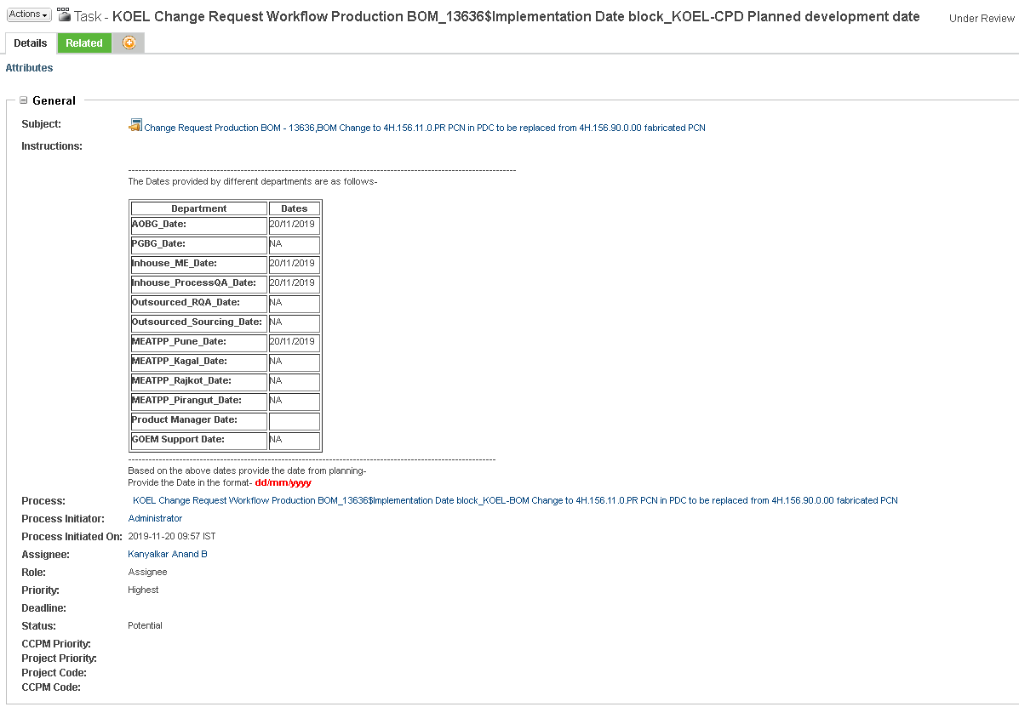
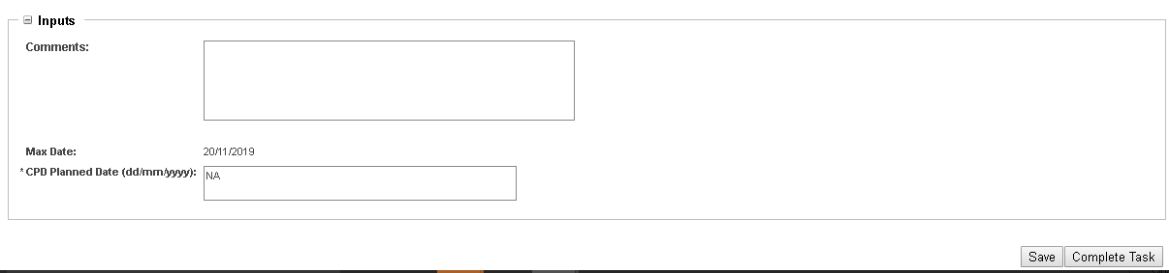

Engineering Change Request Production BOM

2.3.1 Engineering Change Request Production BOM Creation
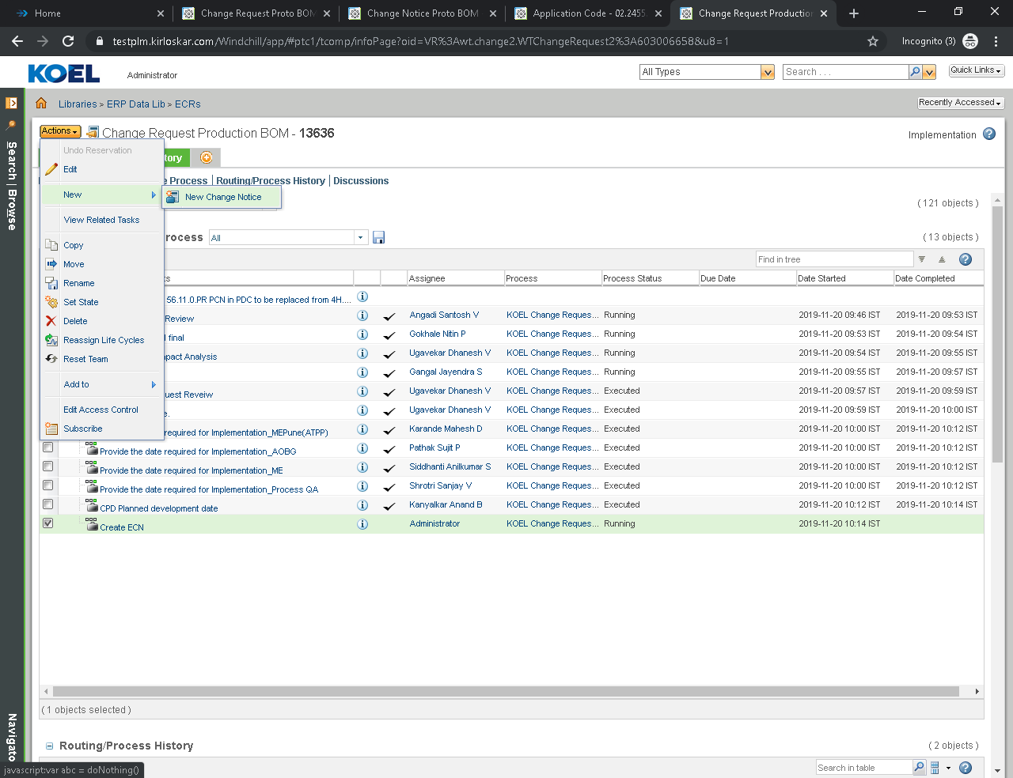

Set Attributes
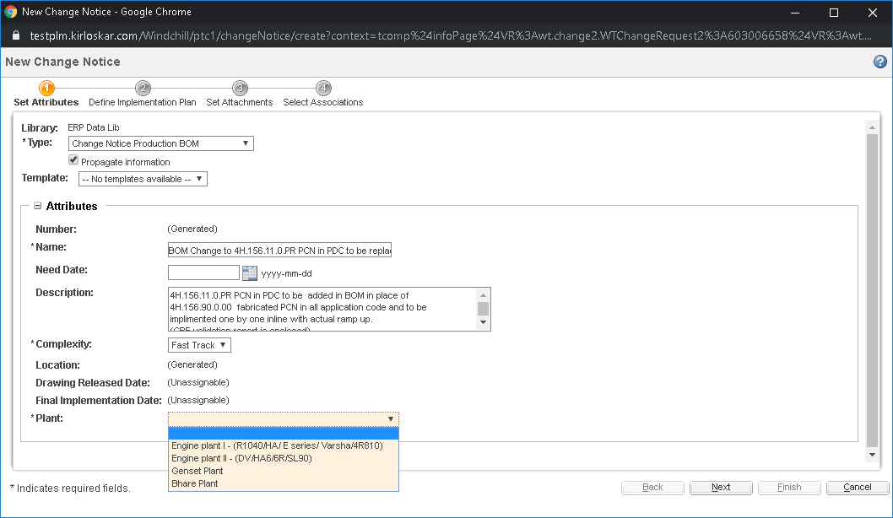
Define Implementation Plan
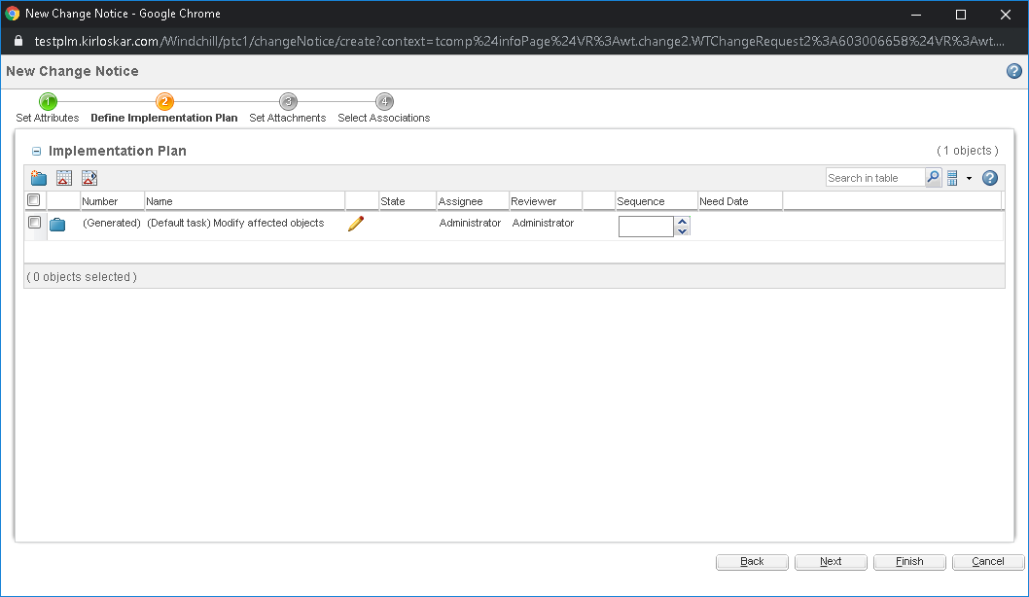
Set Attachments
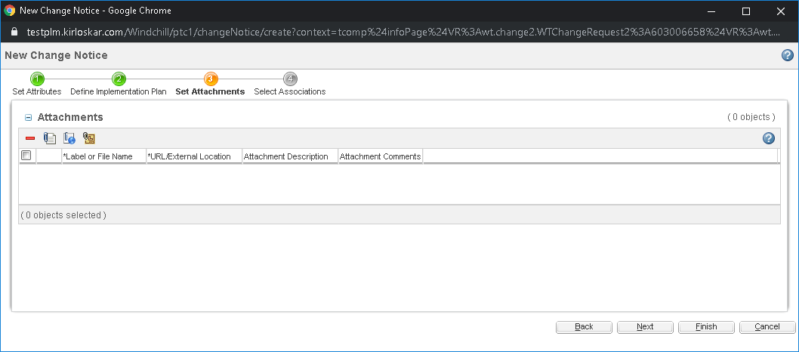
Select Associations
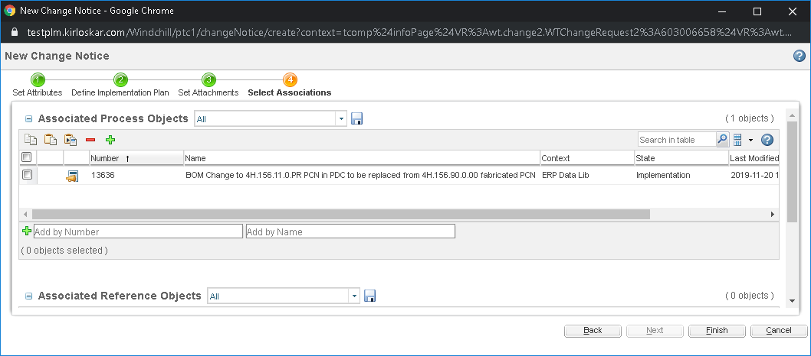

Click on Submit Now
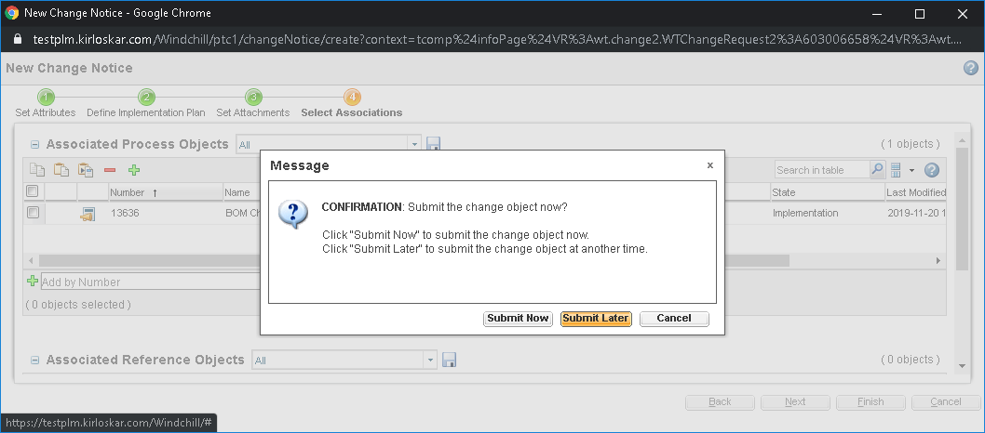

2.3.2 Engineering Change Request Production BOM Task
Complete Change Notice Task
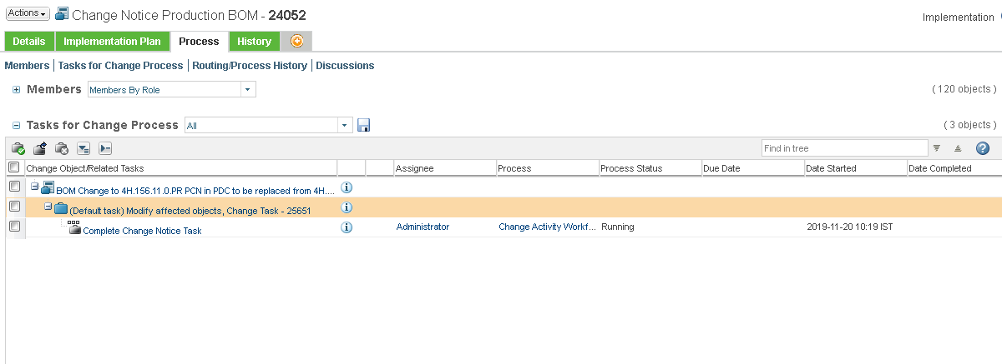

  - Part/Drawing Modification
  - Problem Report Part/Drawing Modification
    - Problem Report Part/Drawing Modification Creation
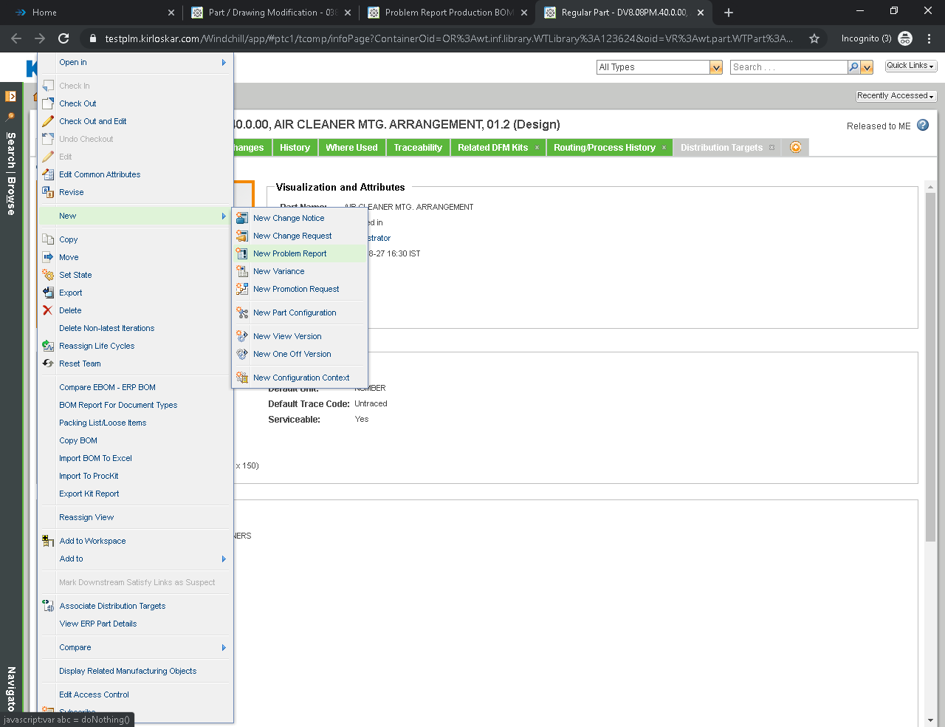

Set Attributes
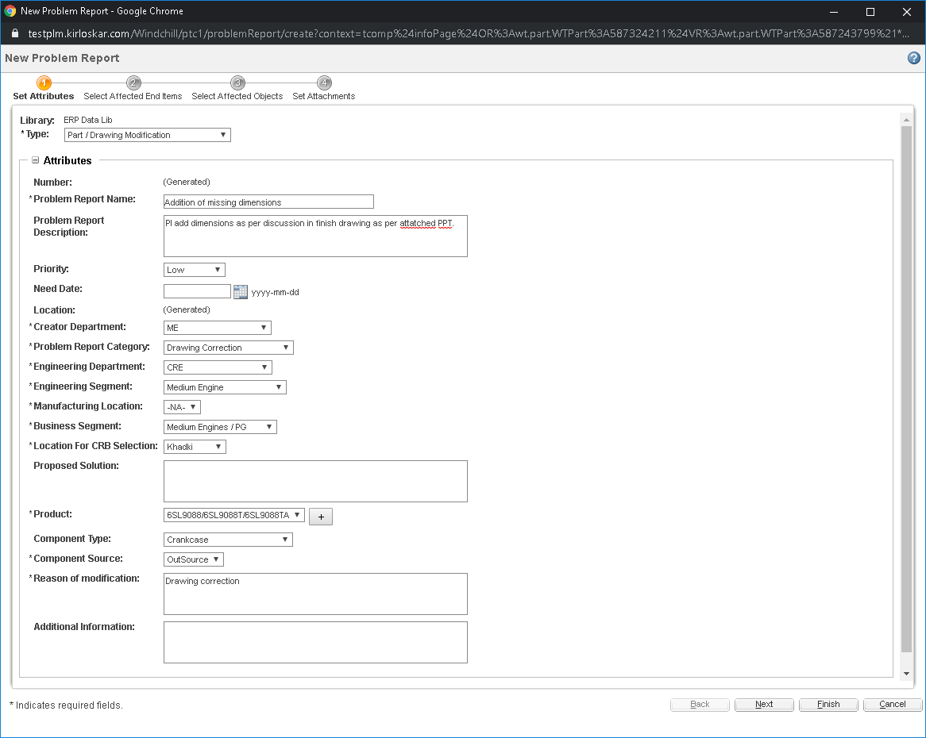
Select Affected End Items
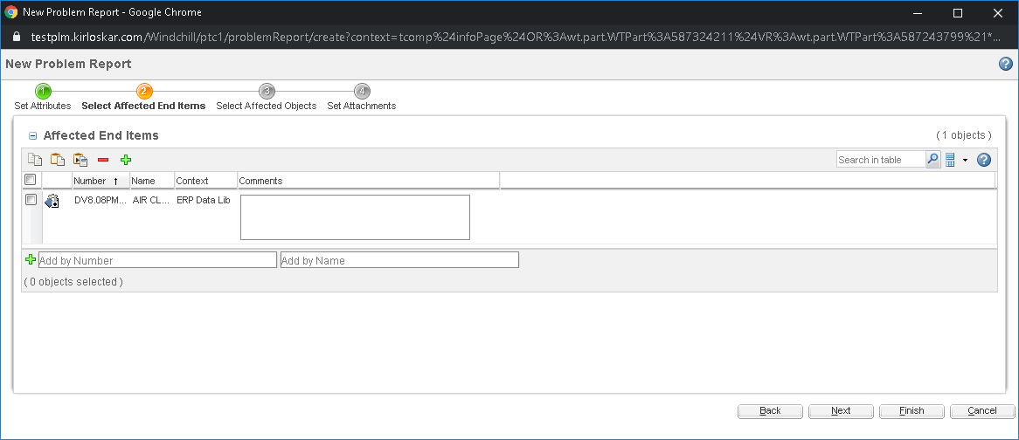
Select Affected Objects
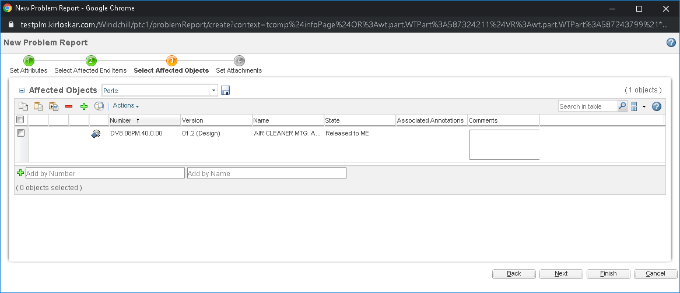
Set Attachments
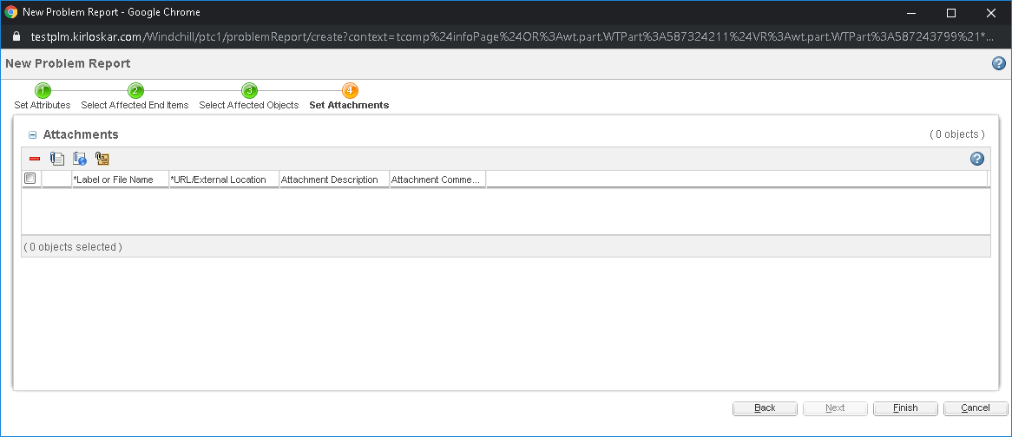
Select Submit Now
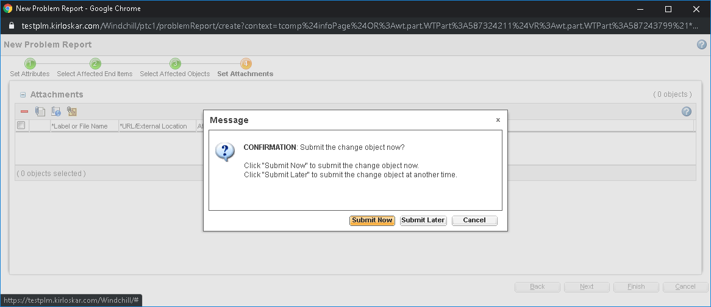

    - Problem Report Part/Drawing Modification Creation
Management Filter
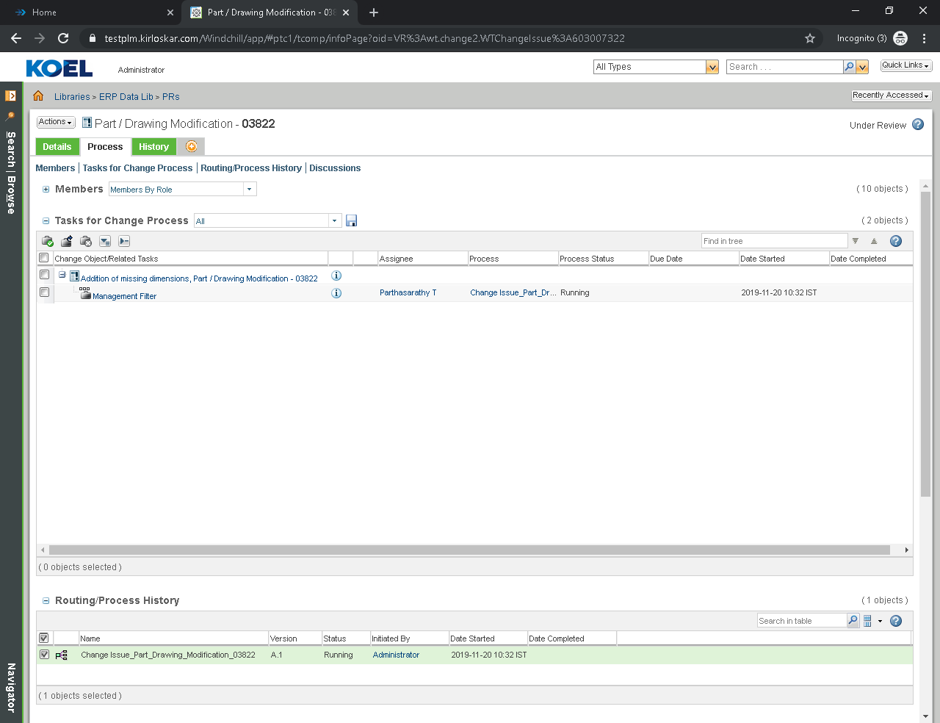
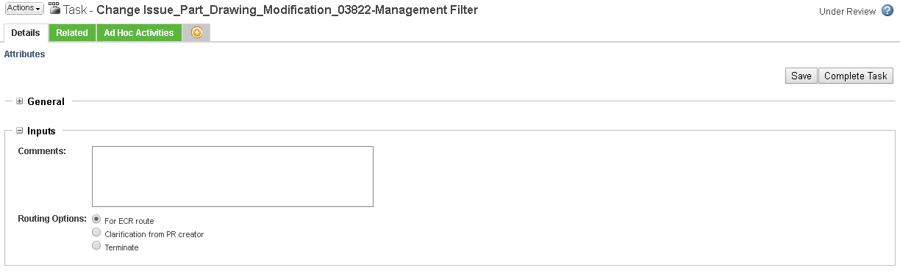
Assign Engineer and Development for comments
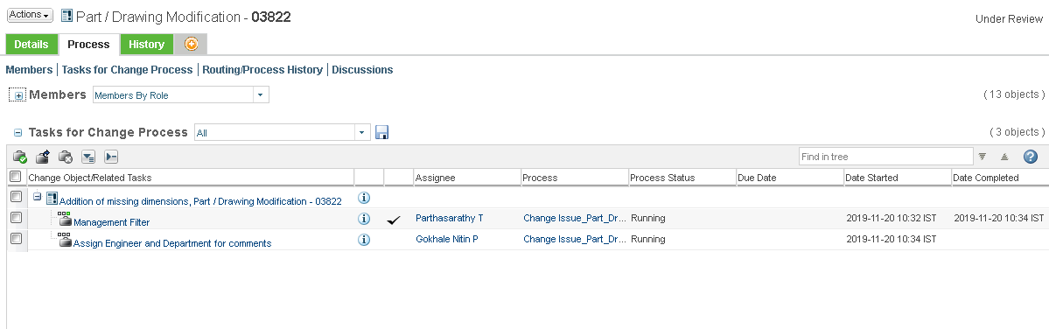

Assign Engineer and Department for comments
Select Review Departments and click on Complete Task
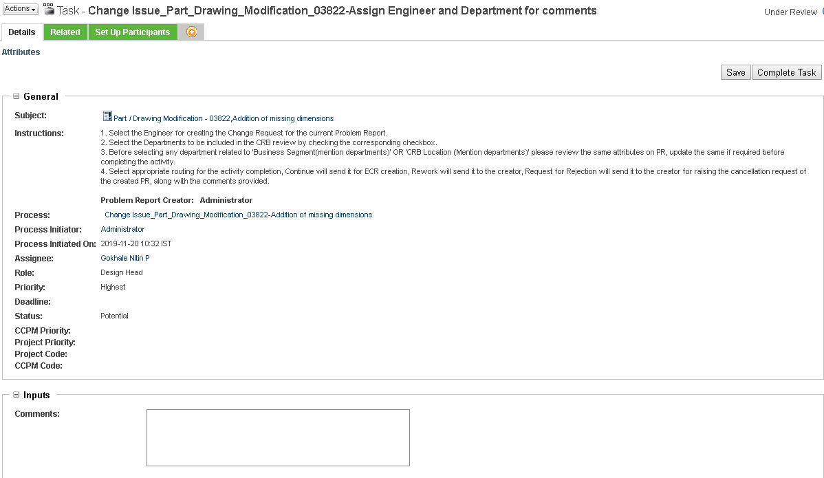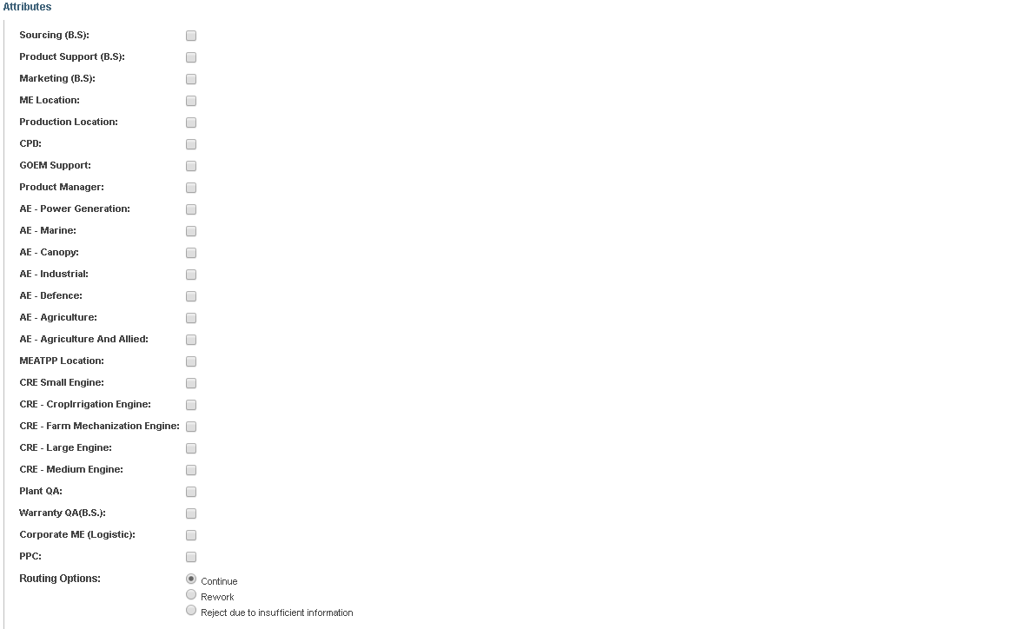

Setup Participants
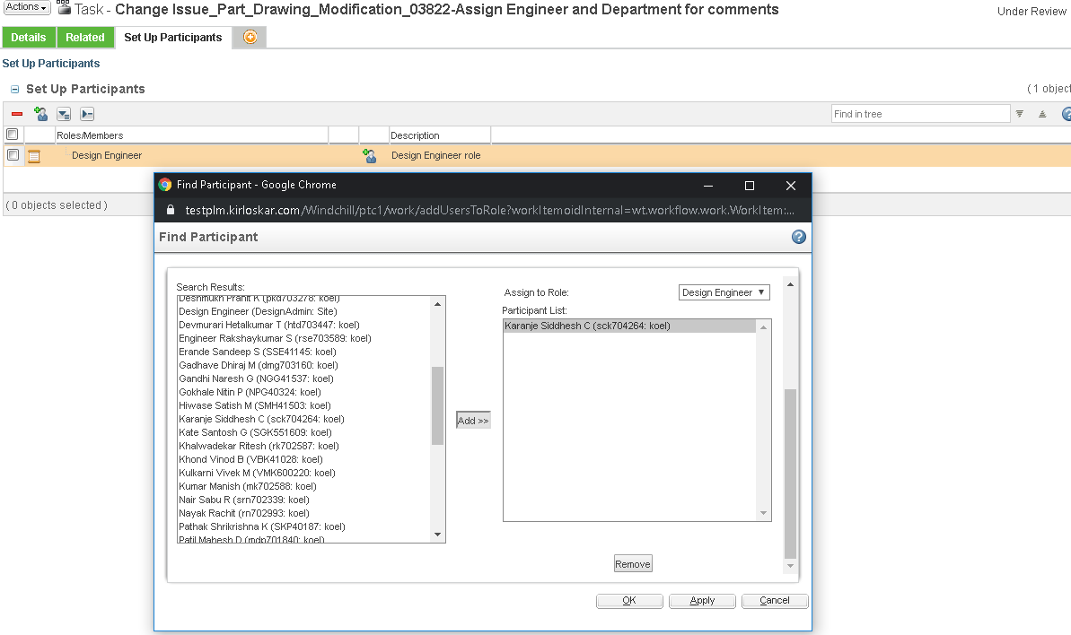
  - Engineering Change Request Part/Drawing Modification
3.2.1 Engineering Change Request Part/Drawing Modification Creation
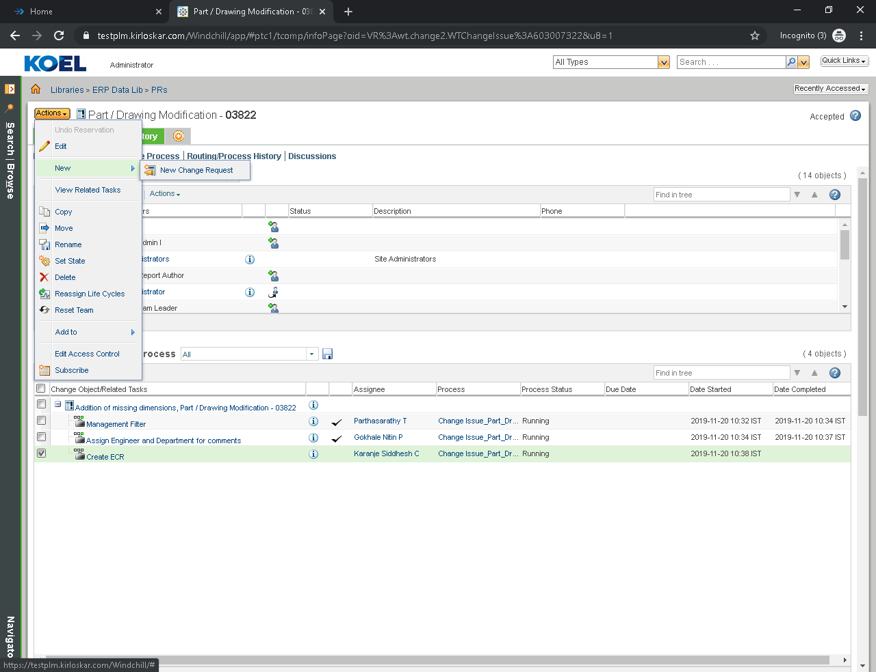

Set Attributes
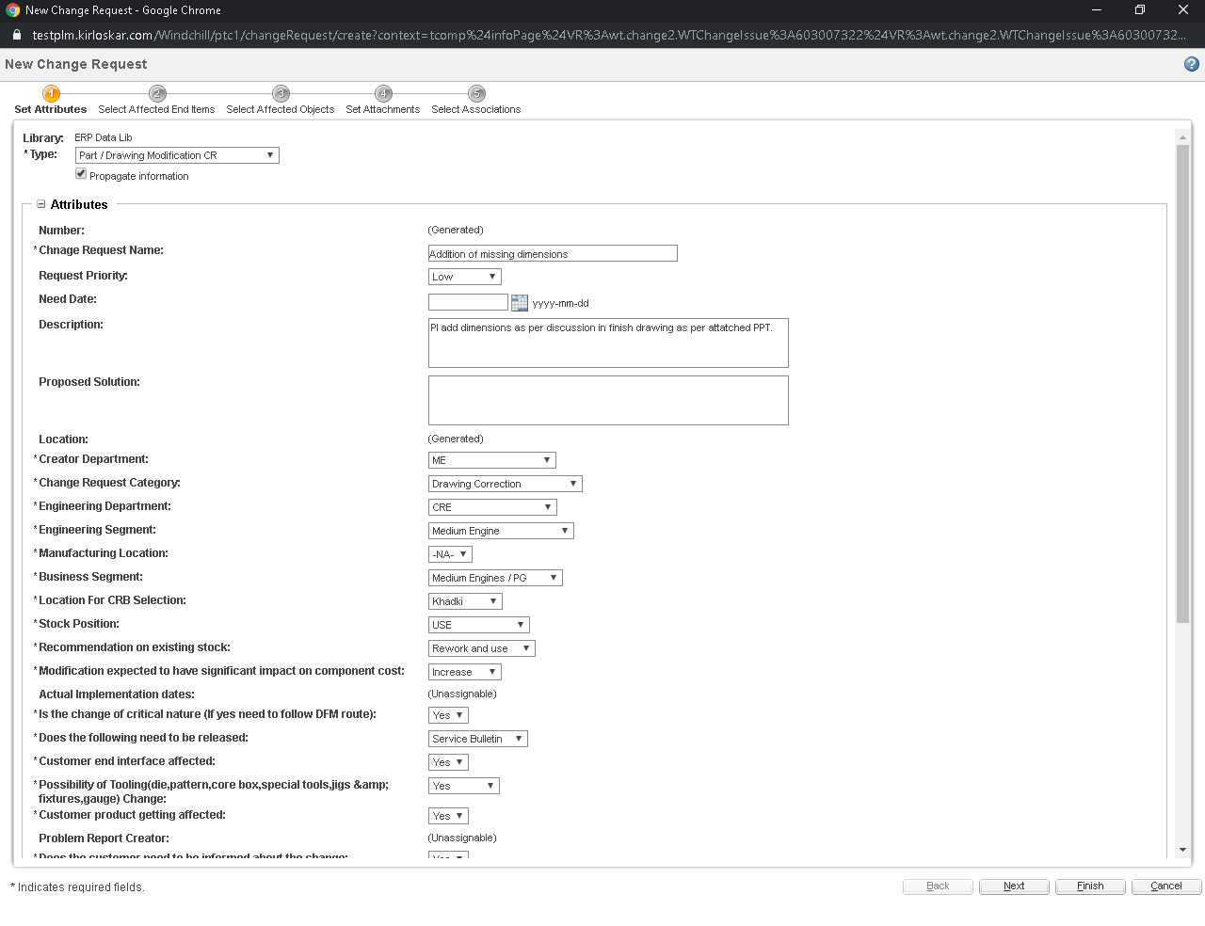
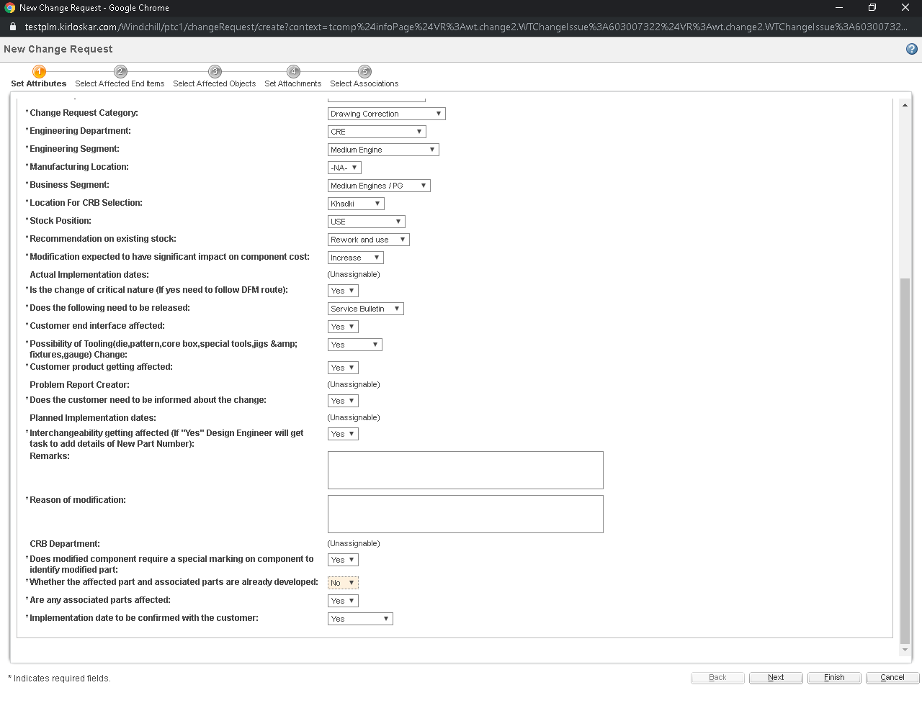

Select Affected End Items
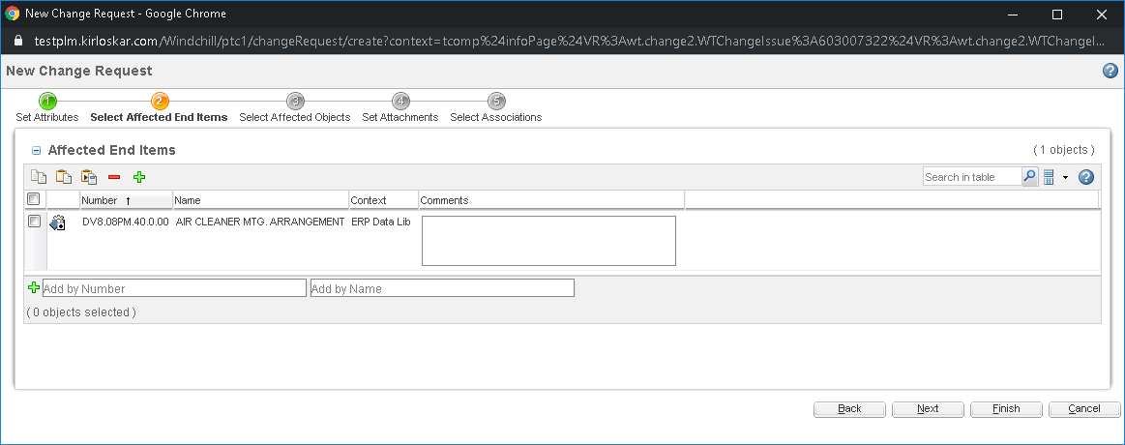
Select Affected Objects
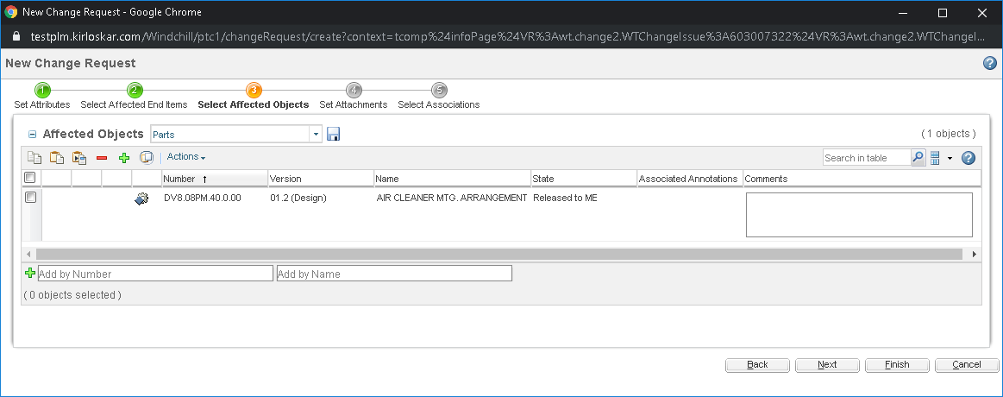
Set Attachments
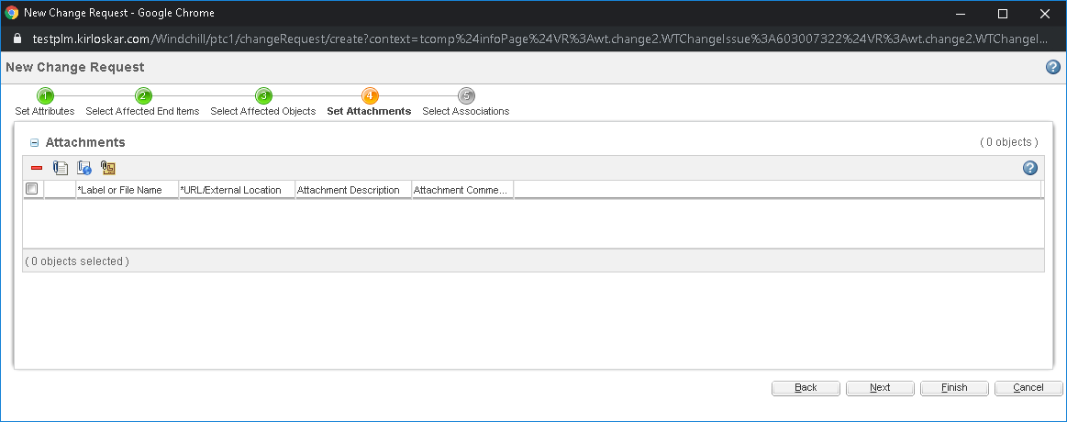
Select Associations
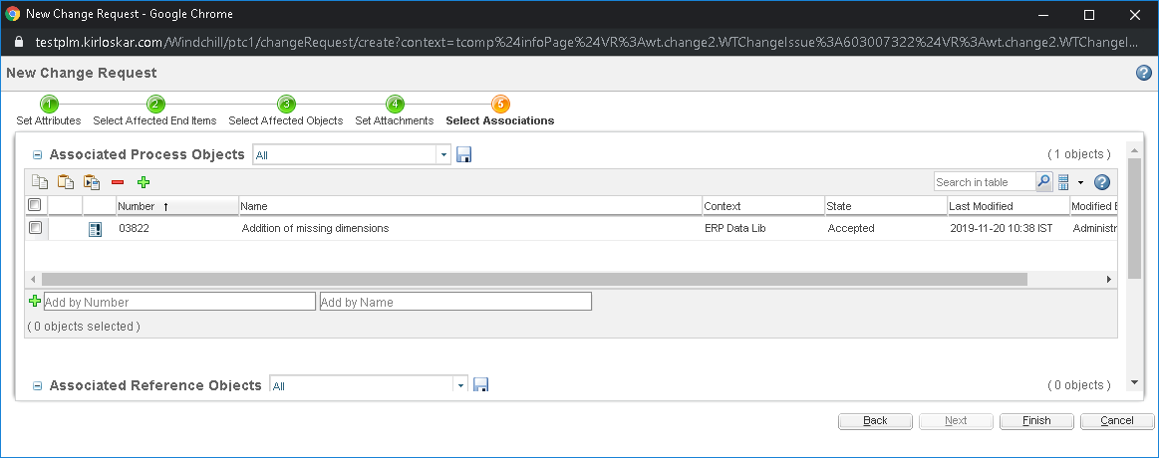

3.2.2 Engineering Change Request Part/Drawing Modification Task
CRB Department Review
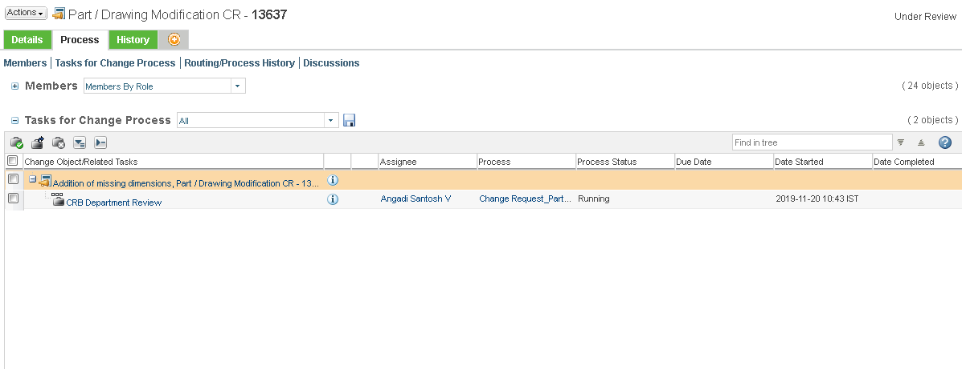
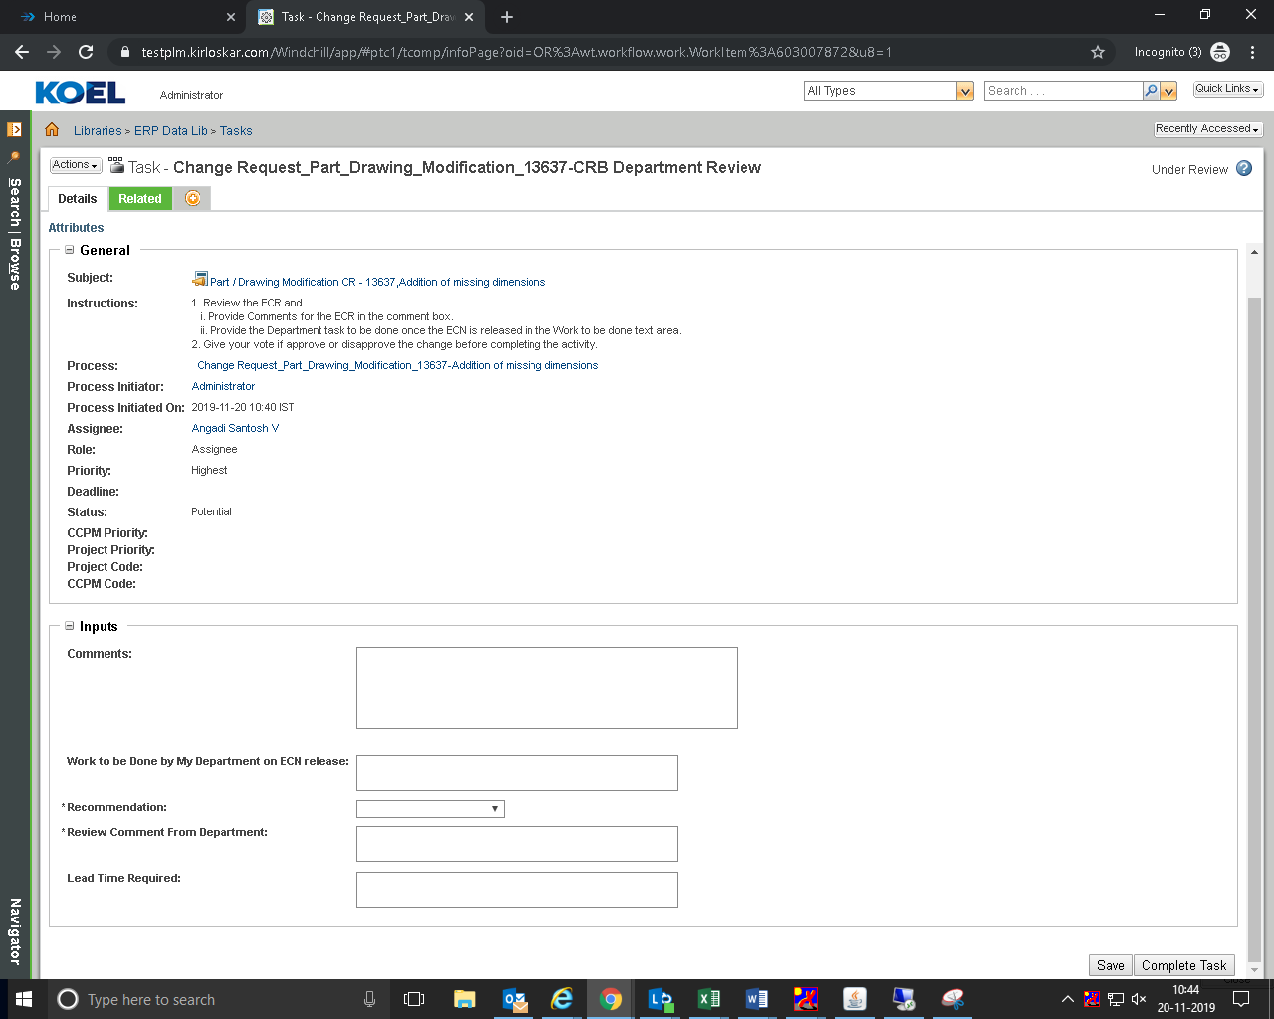
Final Decision CRE/AE Stakeholders
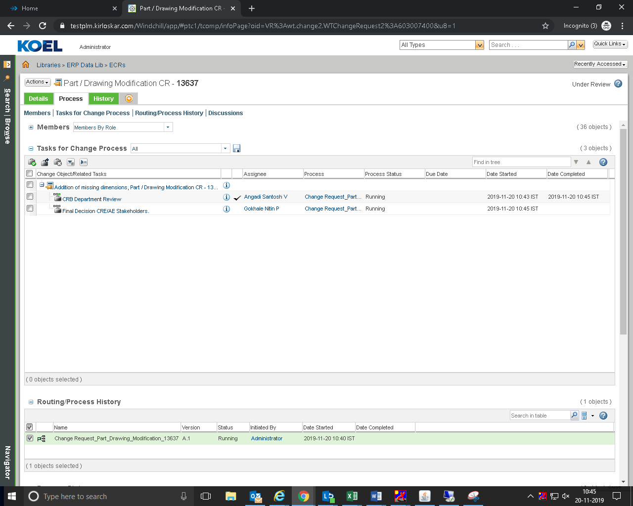

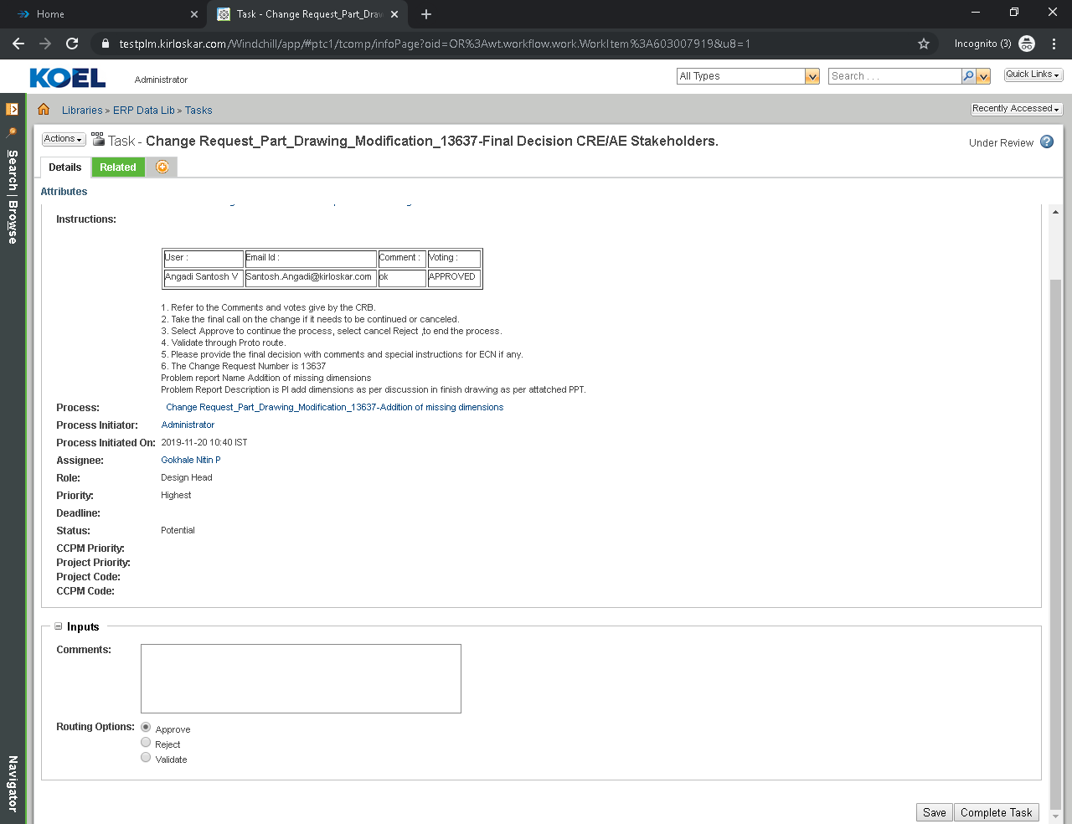
VP-CRE & AE-Review
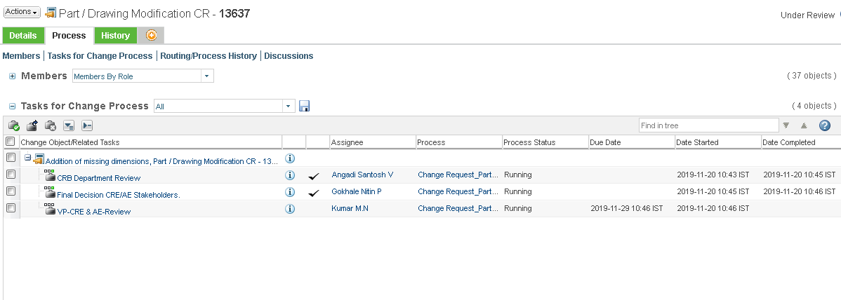
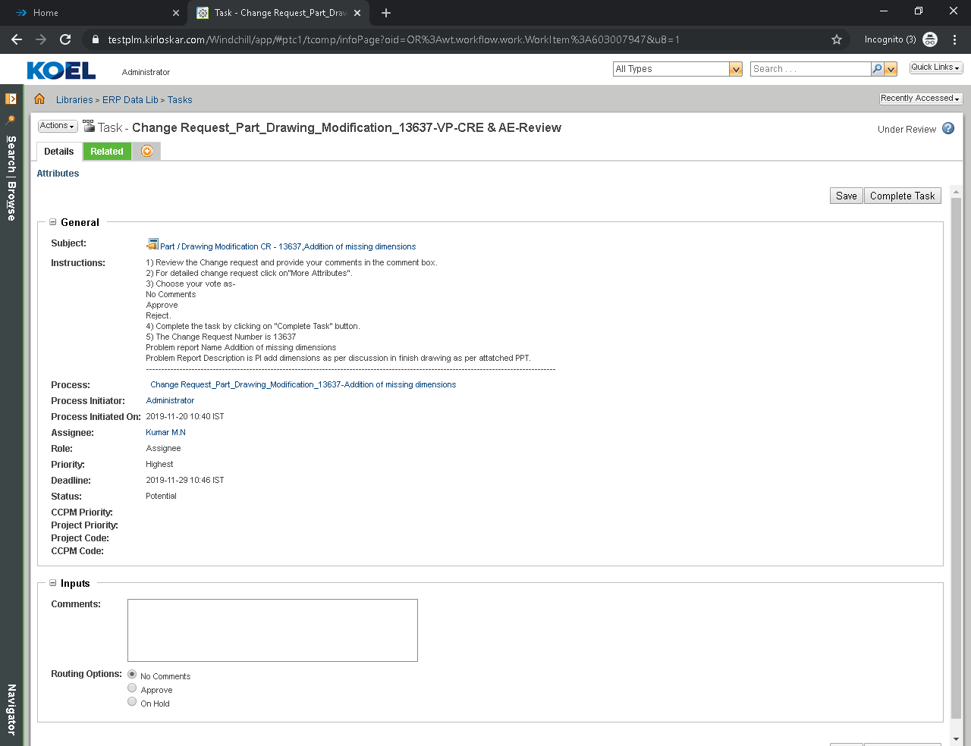

CPD Change Request Review
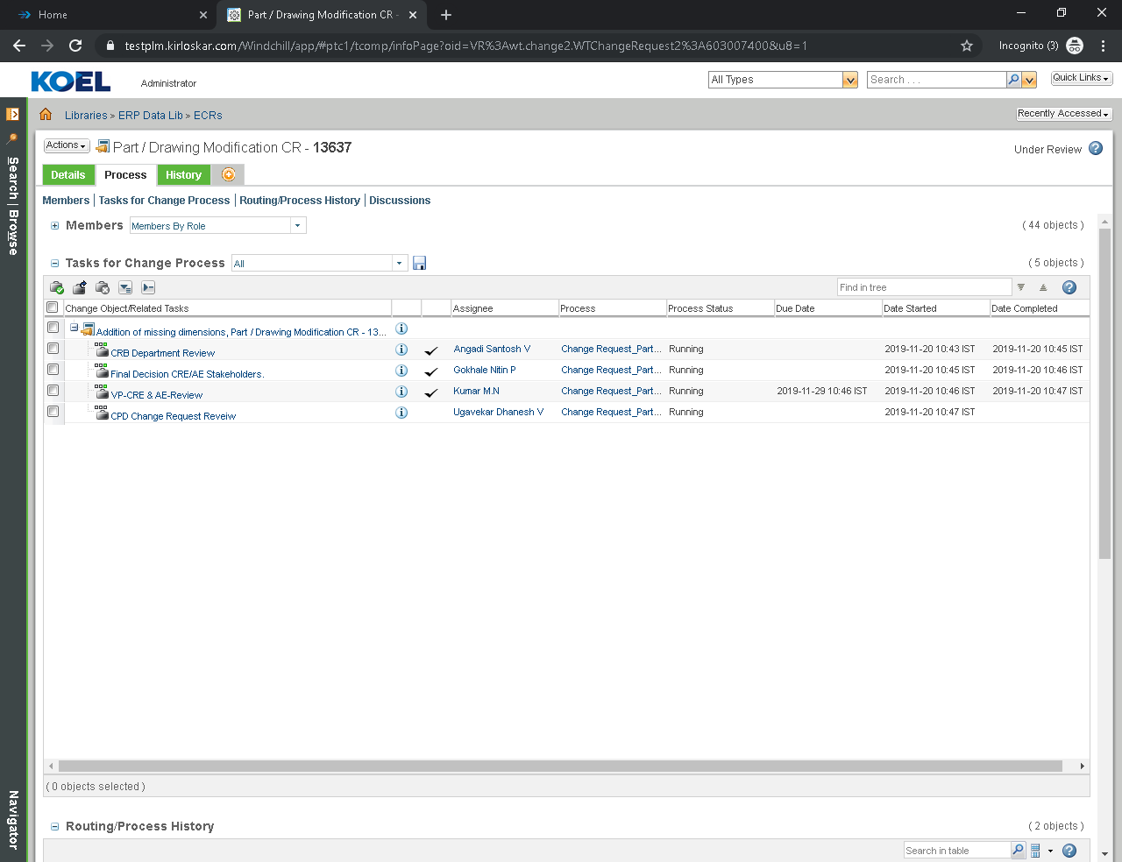
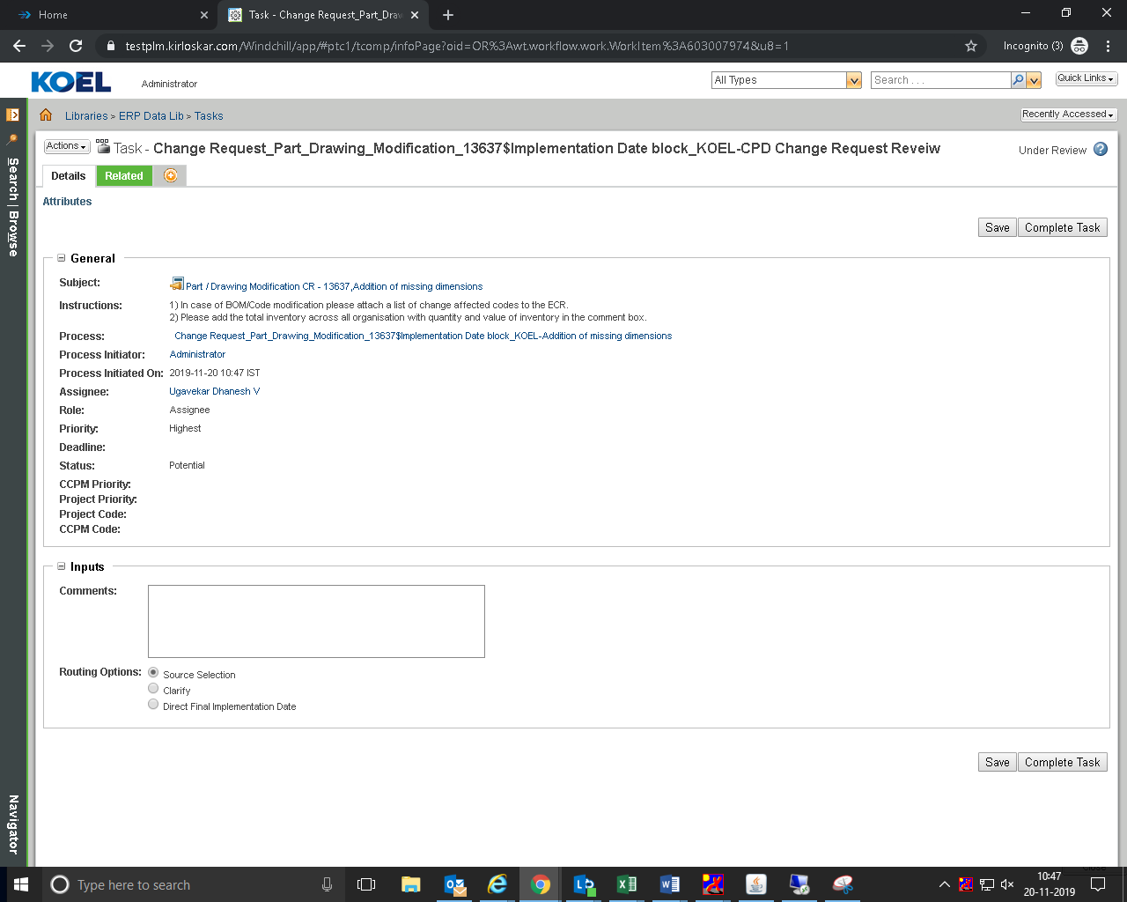
Select the source
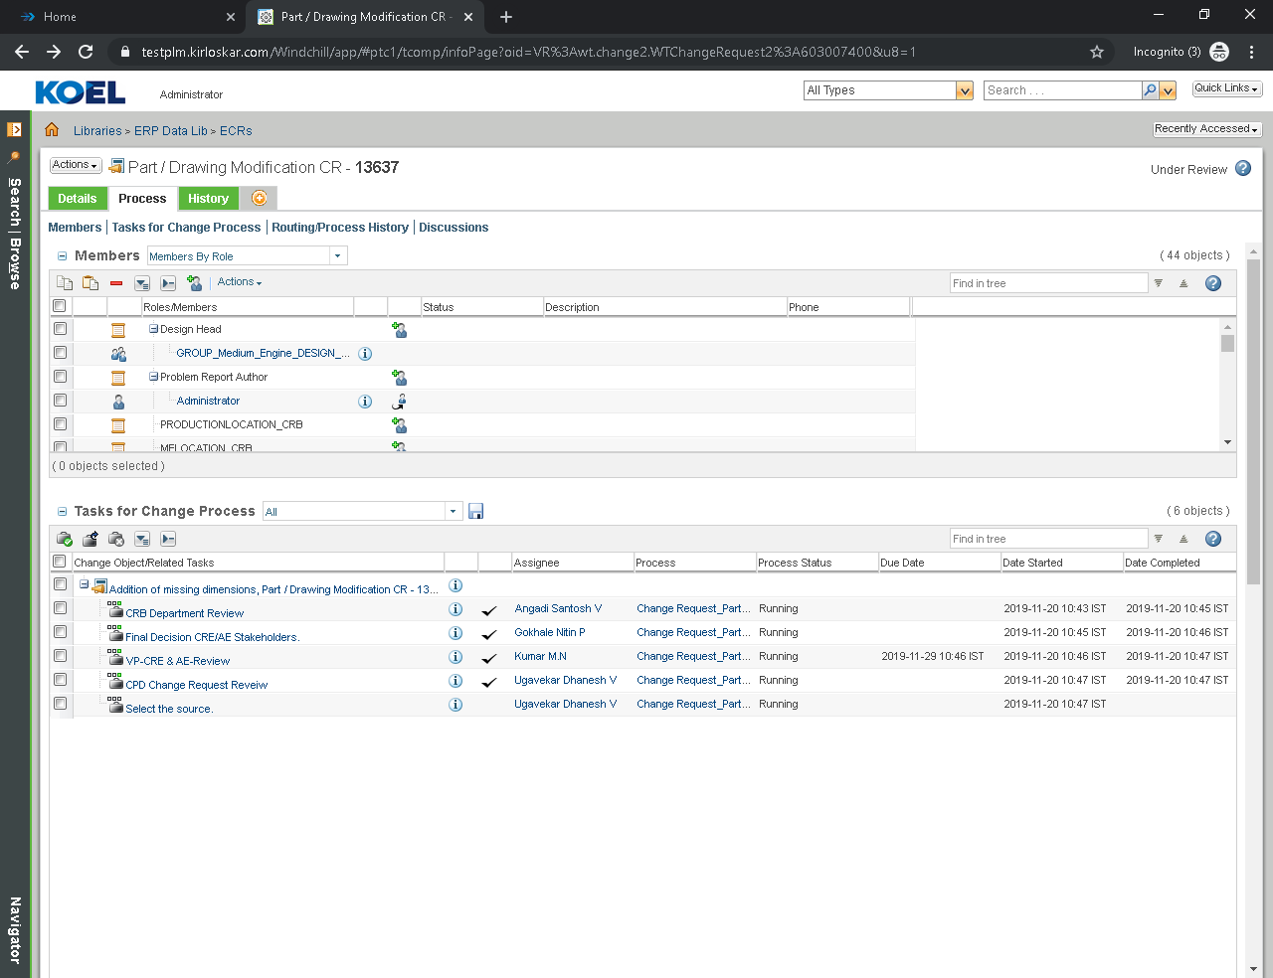

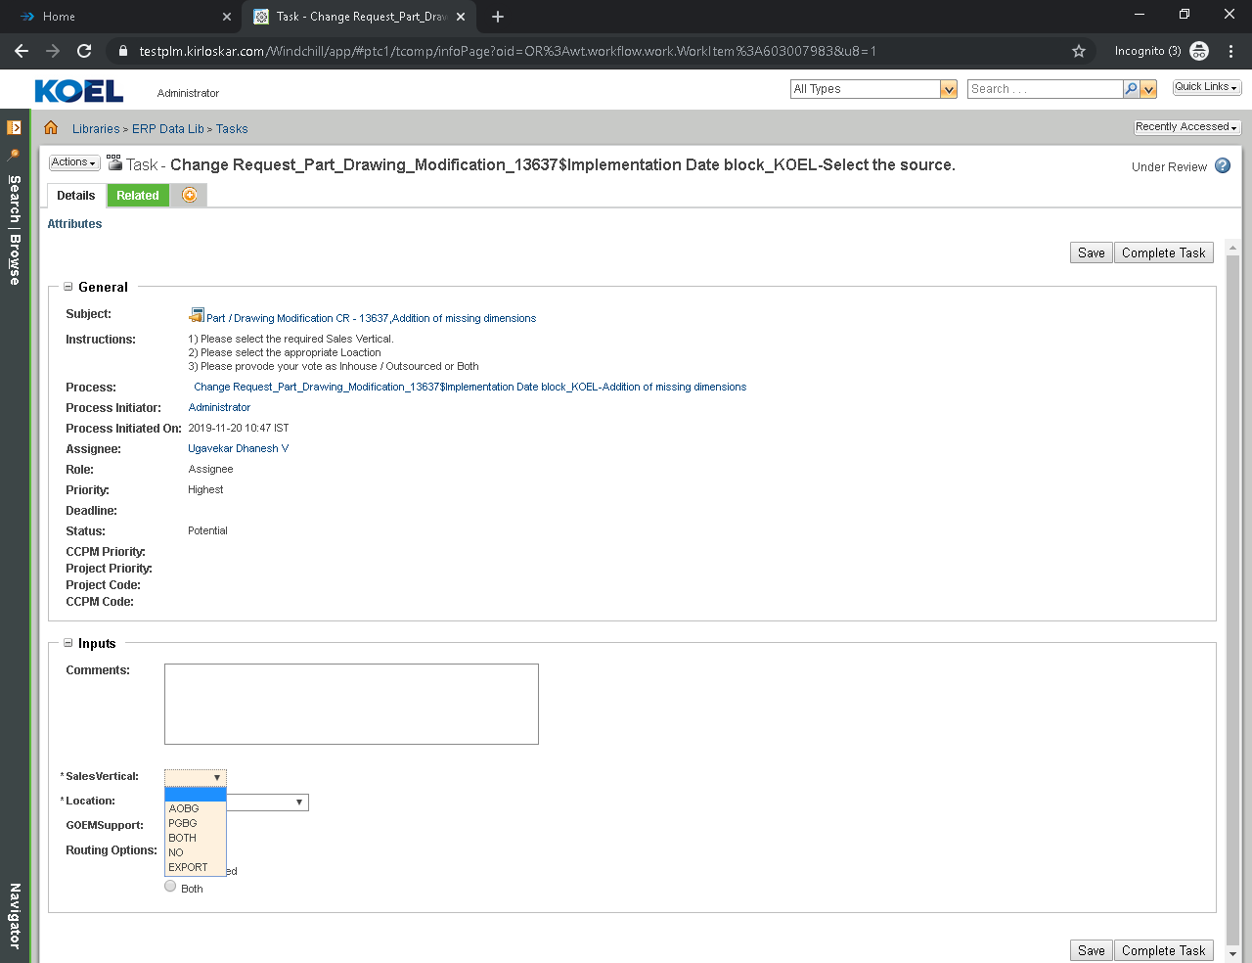
Provide the date required for implementation
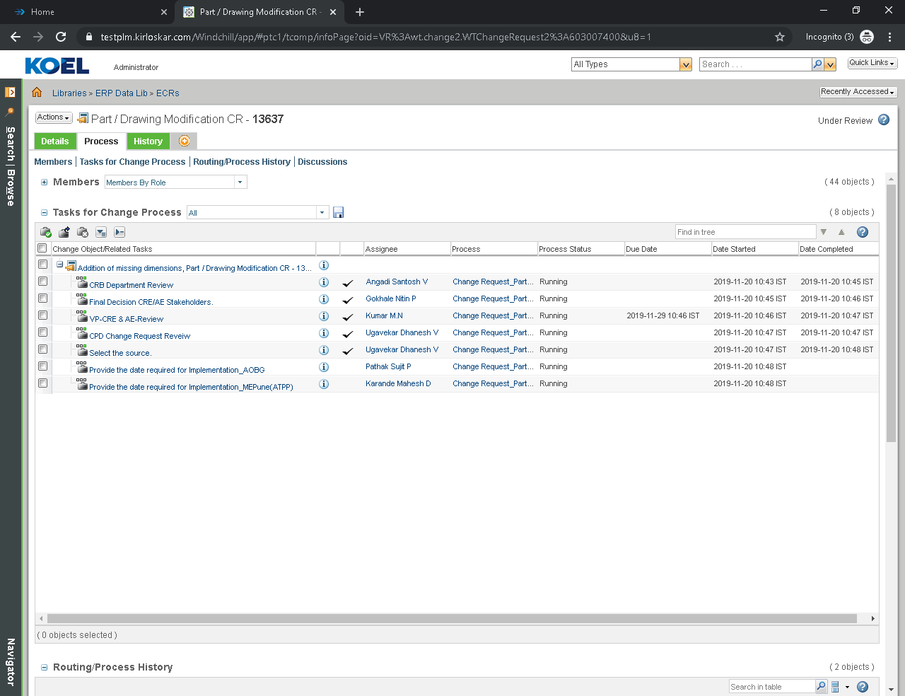
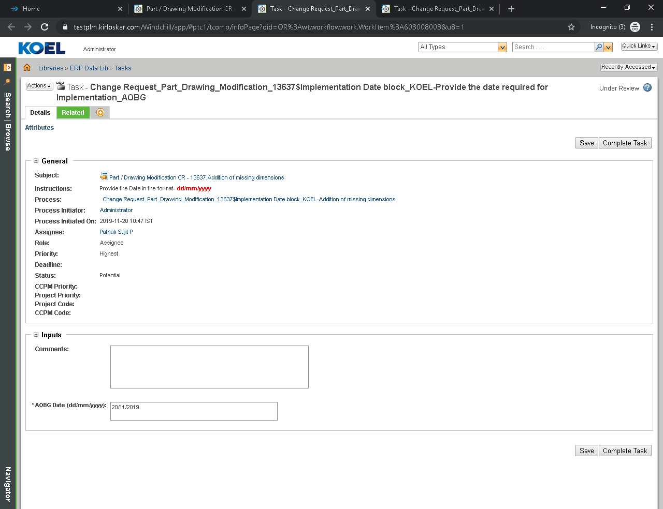
Provide the date required for implementation Sourcing and Click on Complete Task
Two Routing option: Continue and Assigned to Commodity Leader
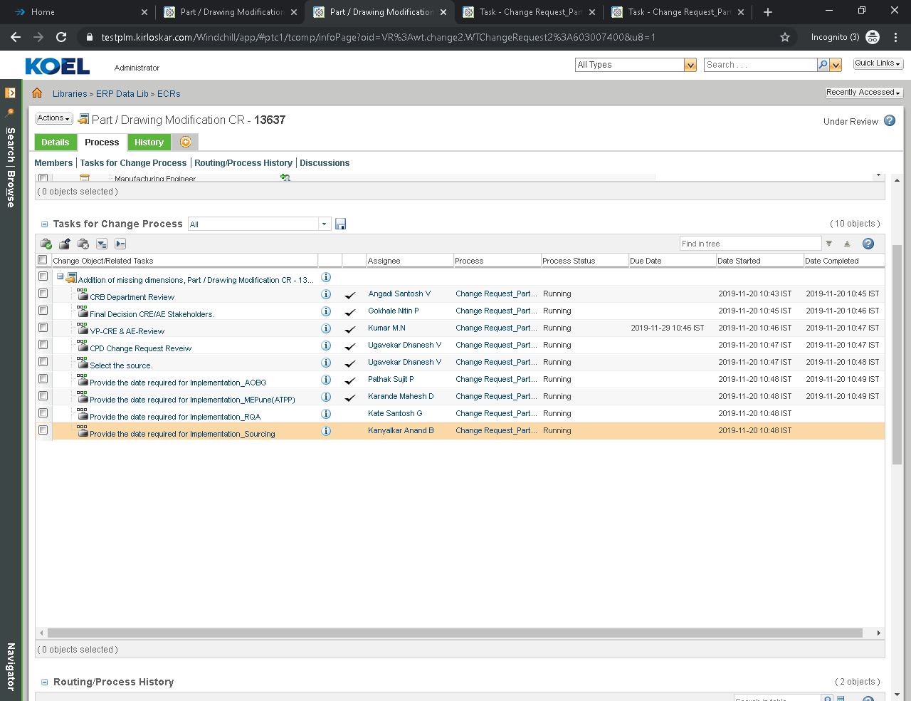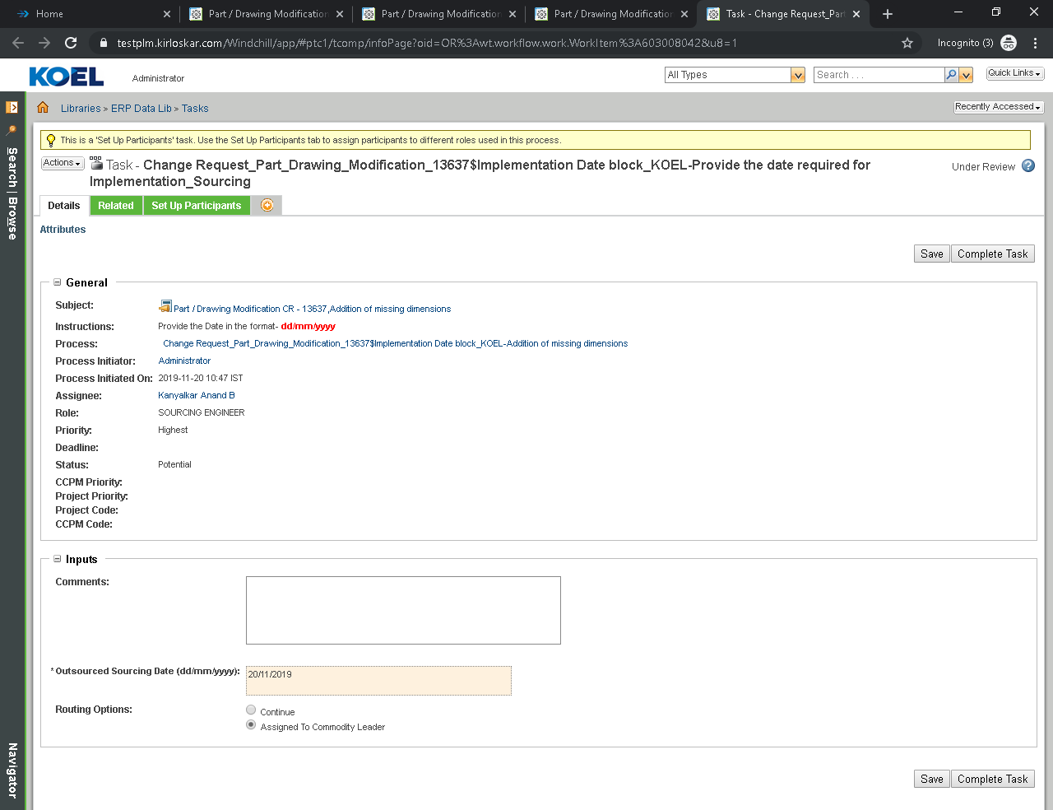
Select Setup Participant.
Select Engineer by clicking search button.
Add it to Participant list.
Click ok
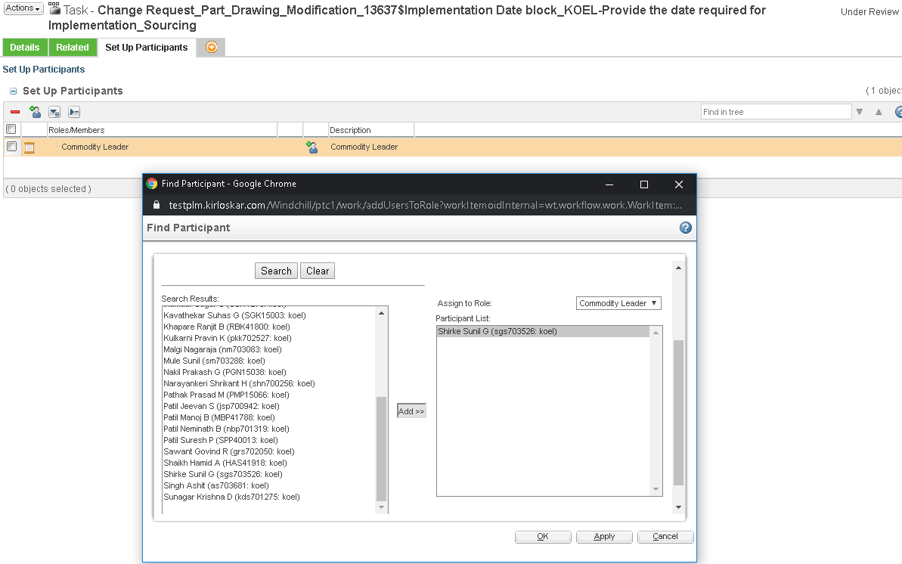
Now task (Provide the date required for implementation sourcing) is assigned to Commodity Leader in this case task is assigned to Shirke Sunil because in last task we select Shirke Sunil in Setup Participant
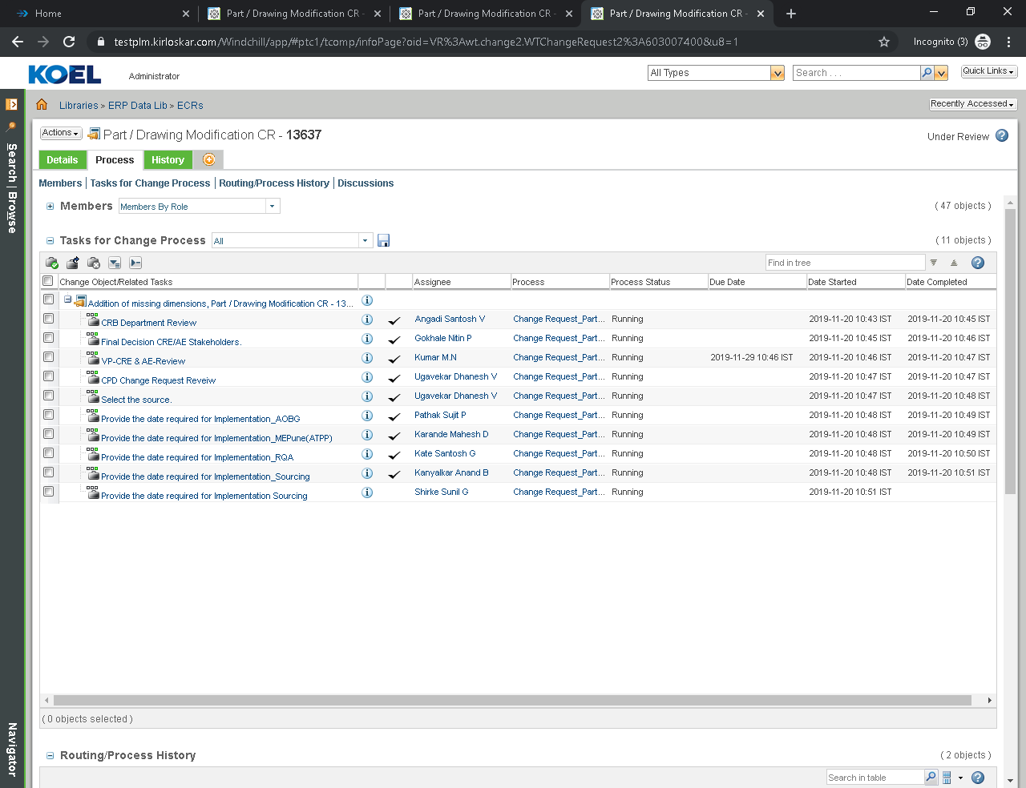

CPD Planned development date
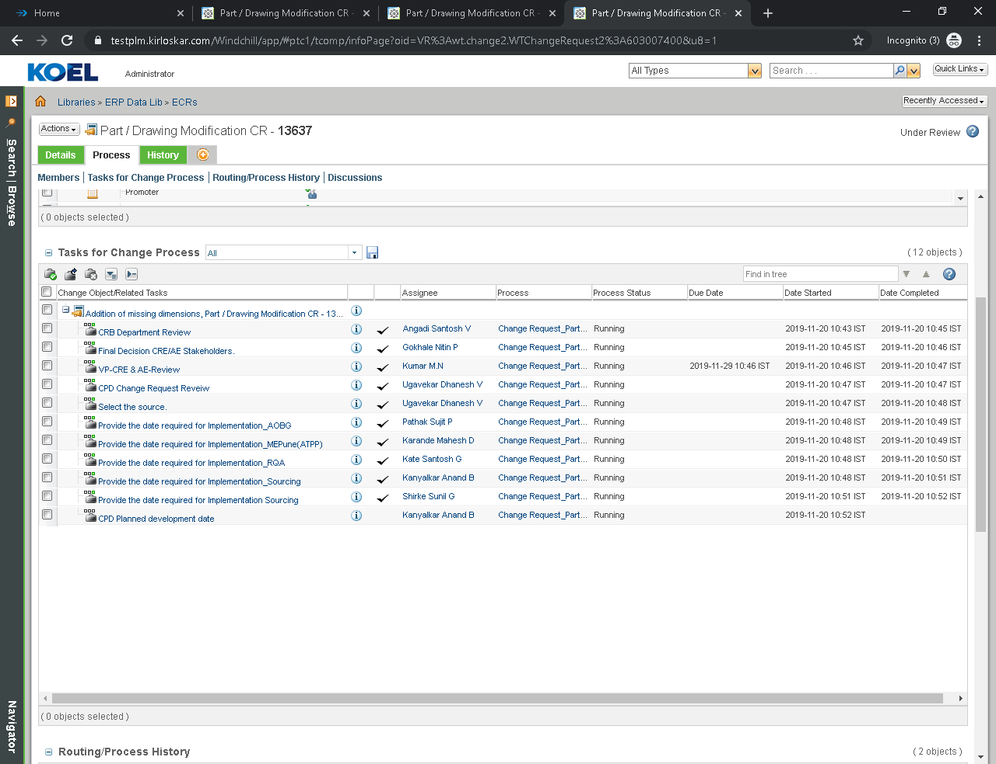
Click on Complete Task
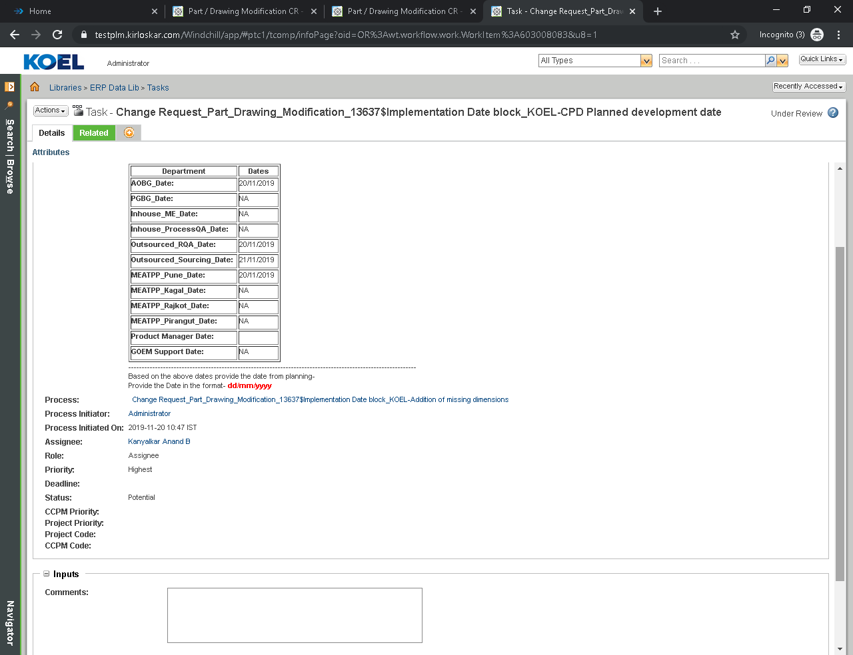
Provide the date requited for implementation Procurement
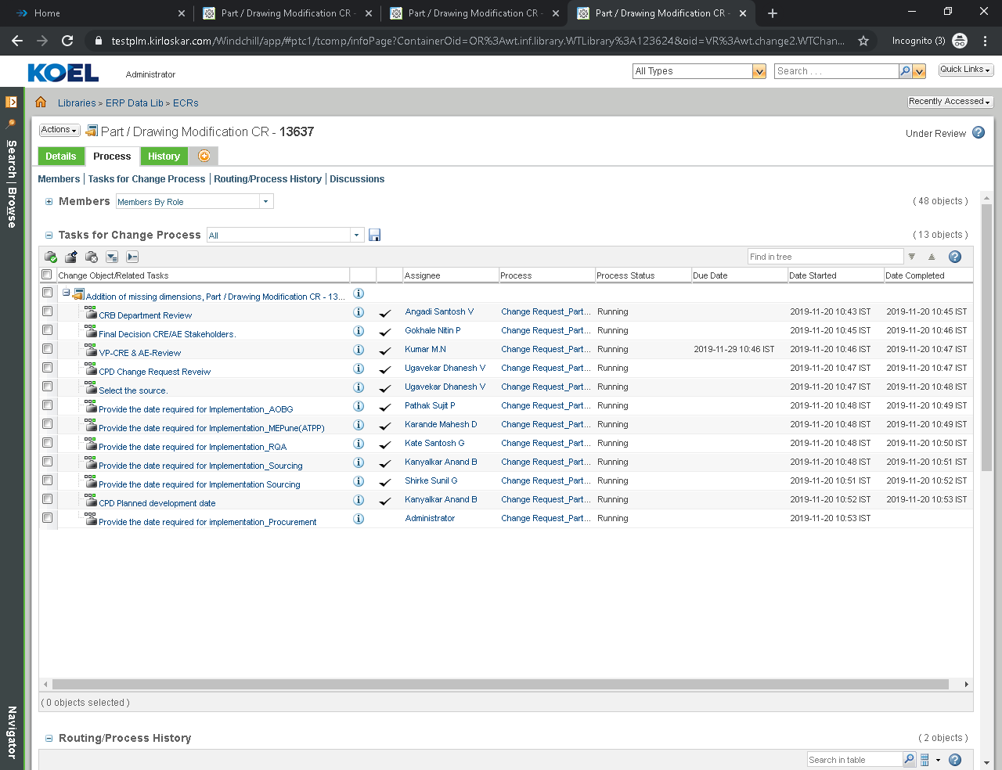

Provide Procurement Date
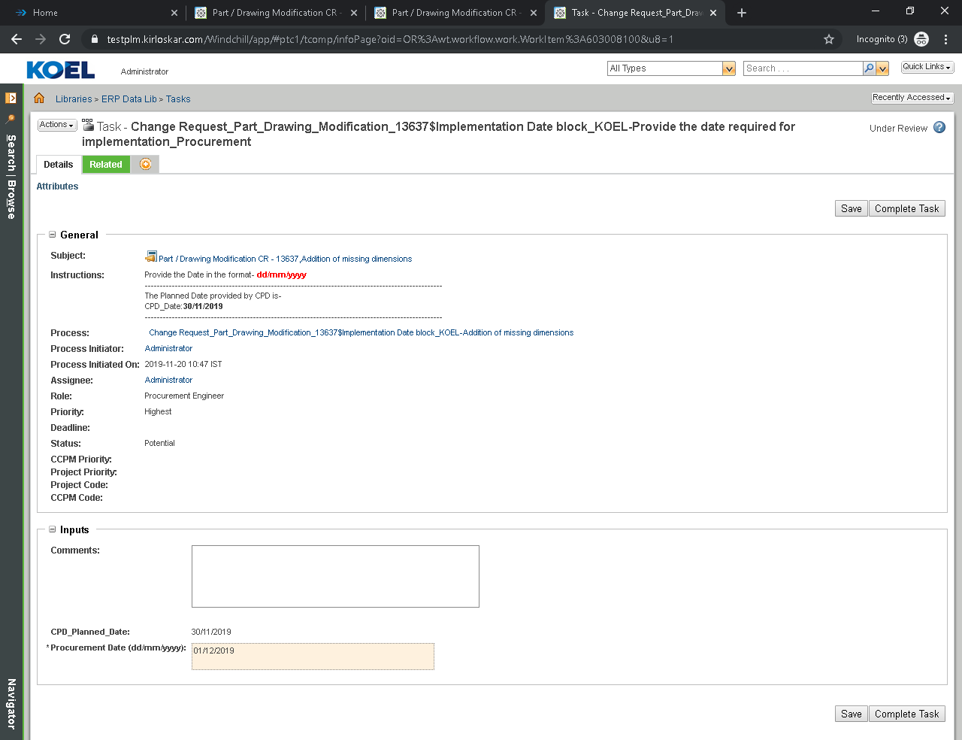

  - Engineering Change Notice Part/Drawing Modification
3.3.1 Engineering Change Notice Part/Drawing Modification Creation
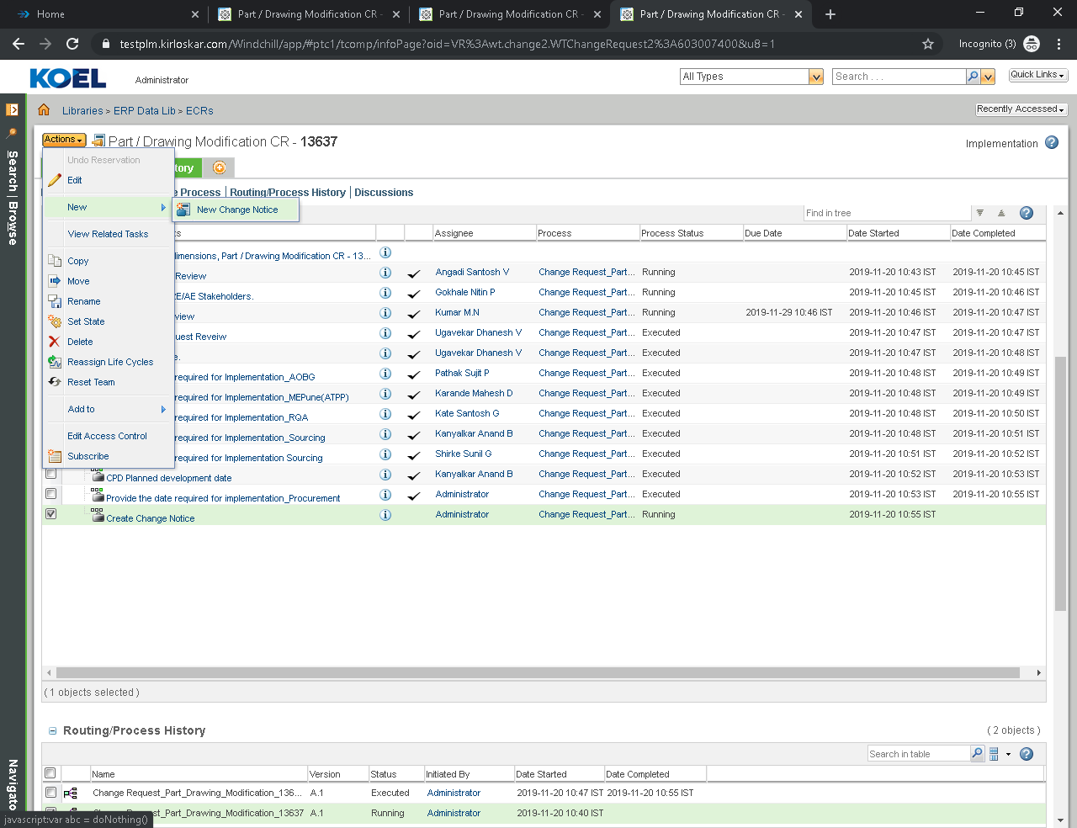
Set Attributes
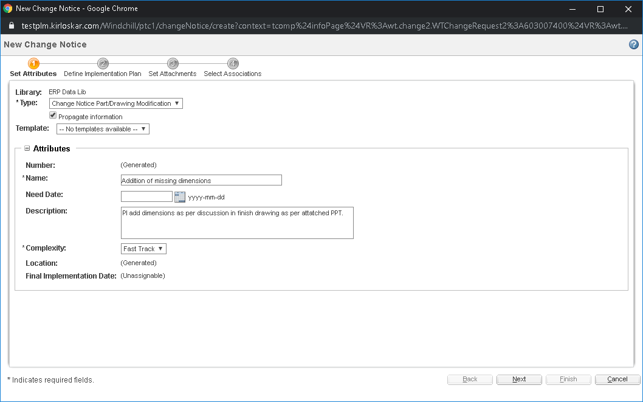
Define implementation Plan
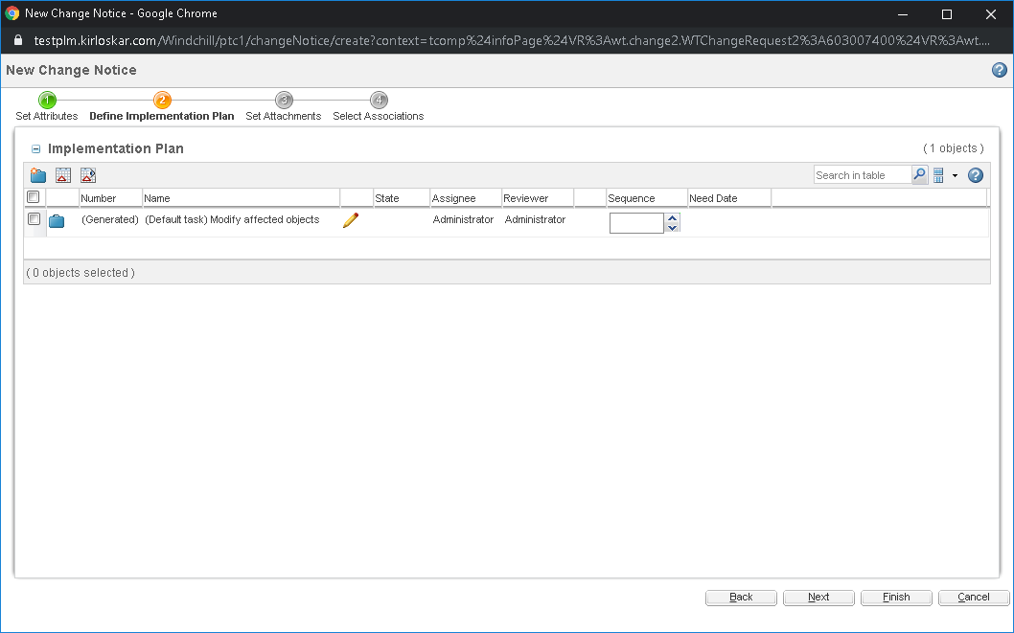
Set Attachments
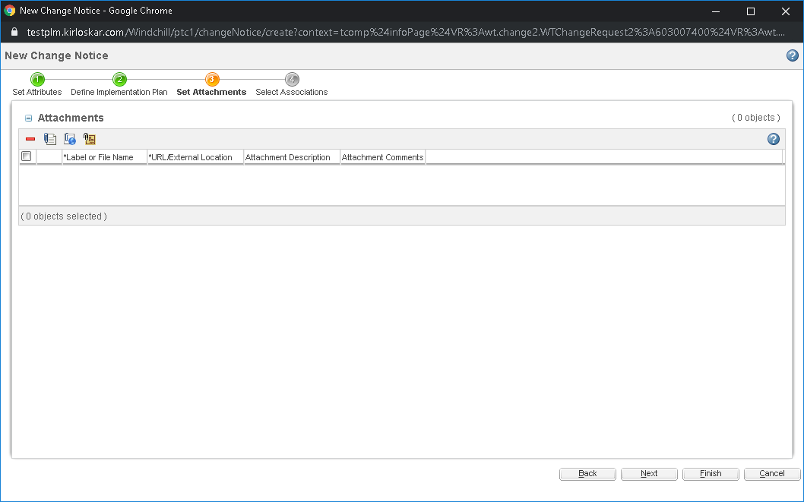
Set Associations
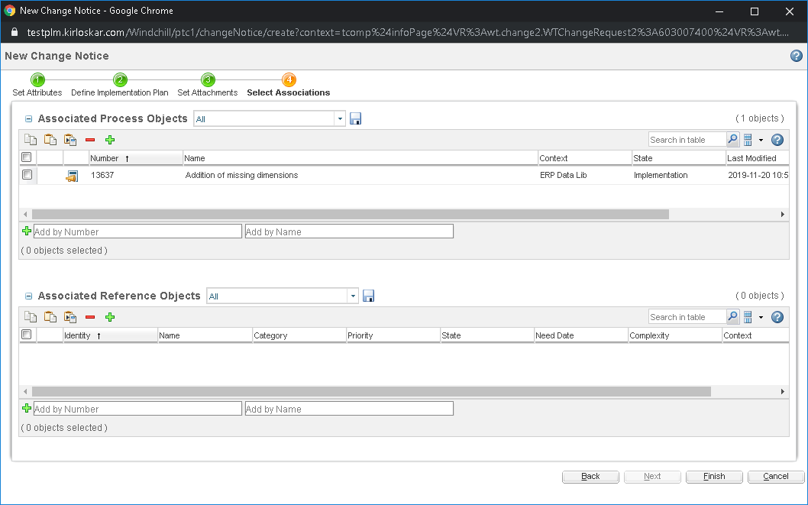
Click on Submit Now
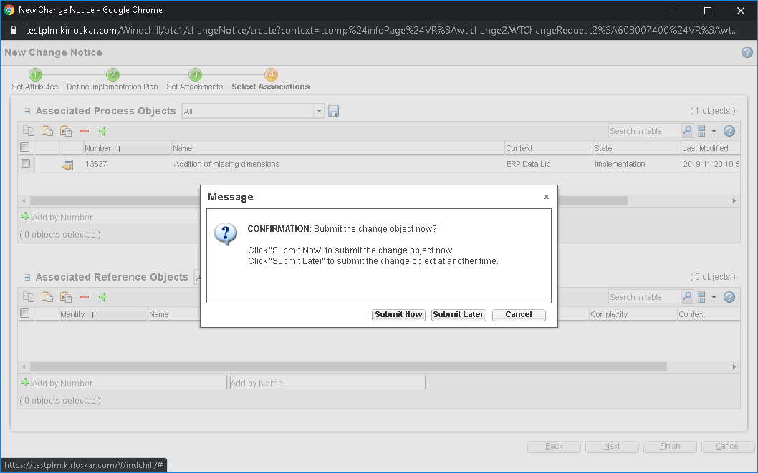
3.3.2 Engineering Change Notice Part/Drawing Modification Task

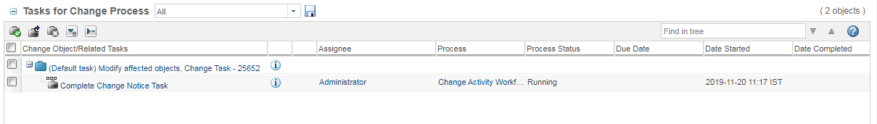

Click on Complete Task
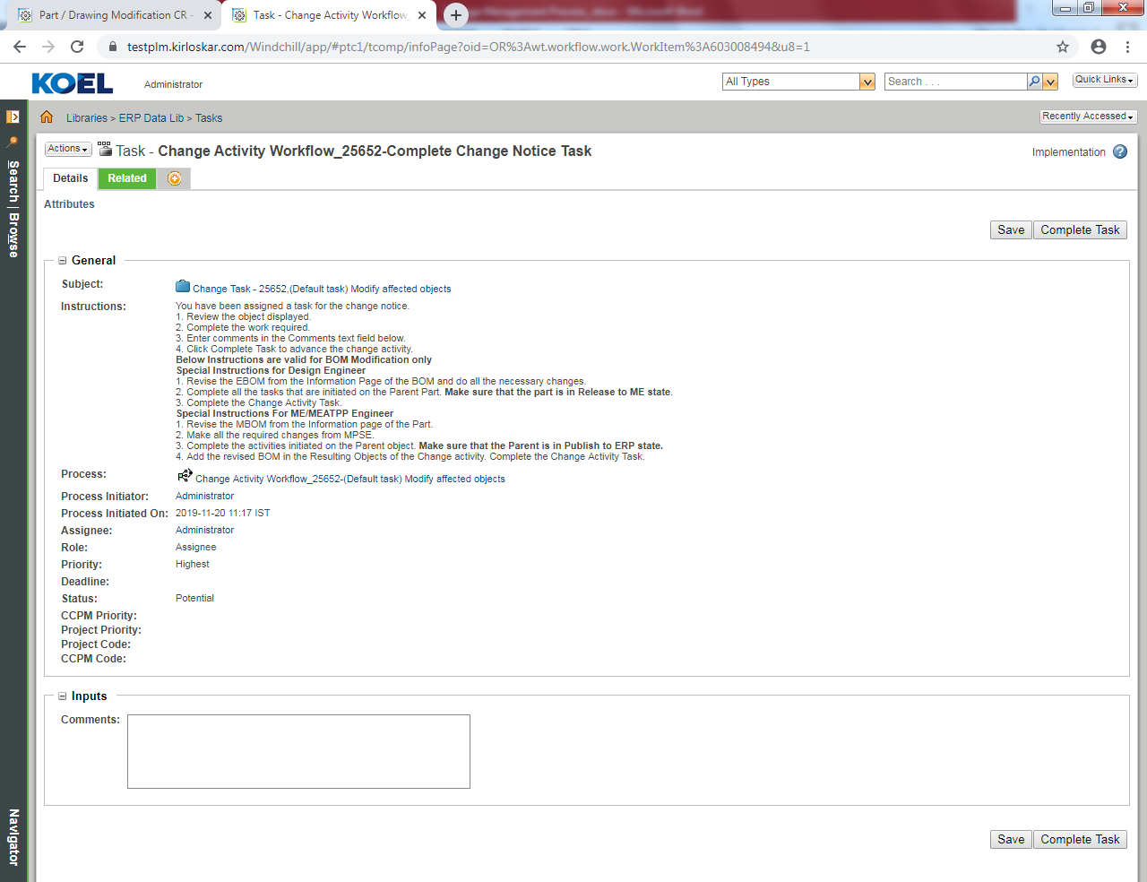

Proto Iteration
  - Problem Report Proto Iteration
4.1.1 Problem Report Proto Iteration Creation

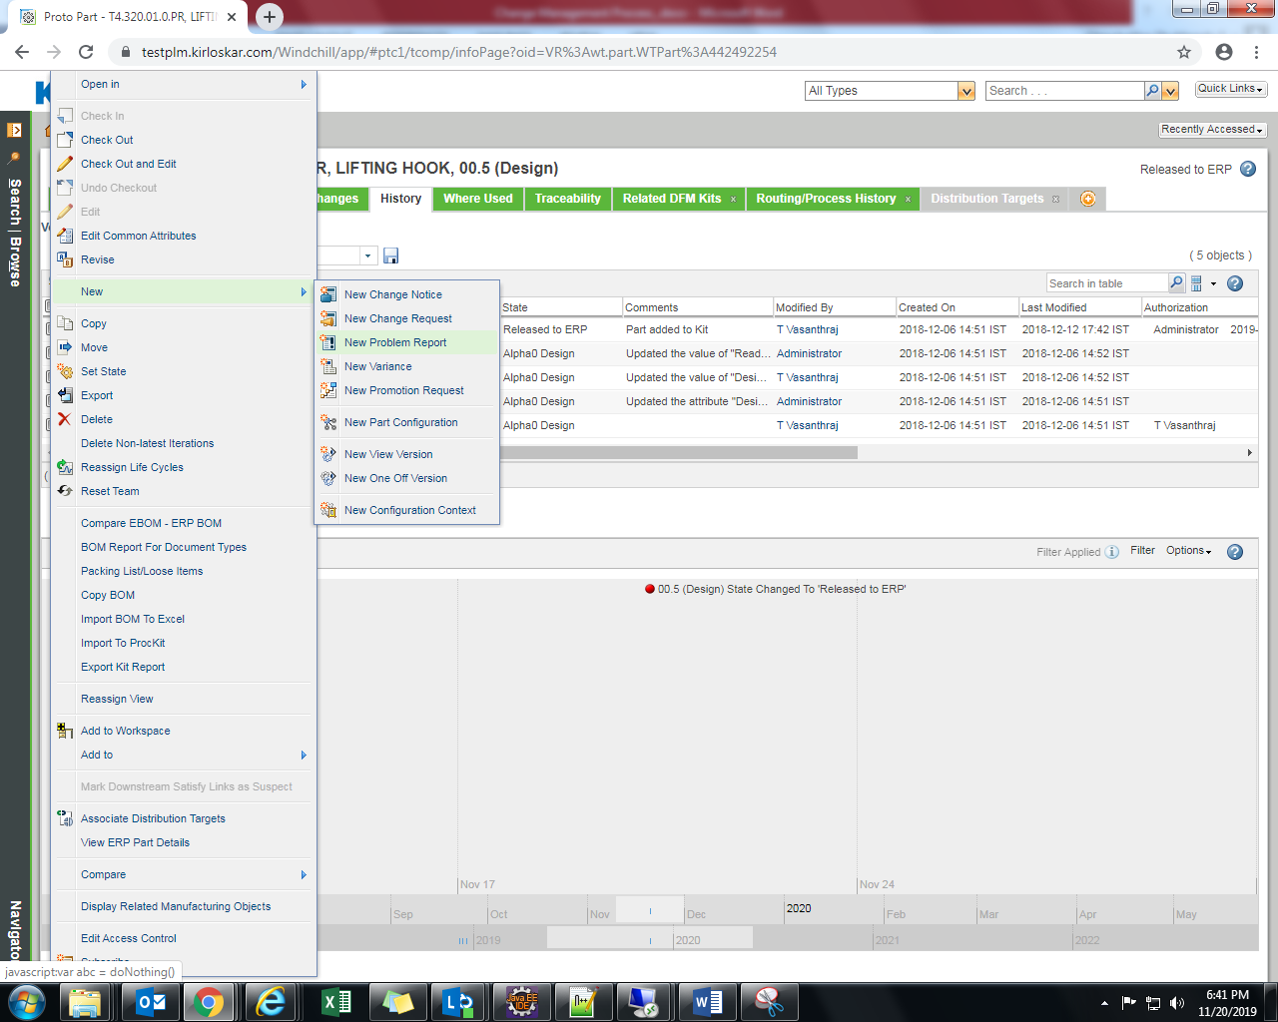

Set Attributes
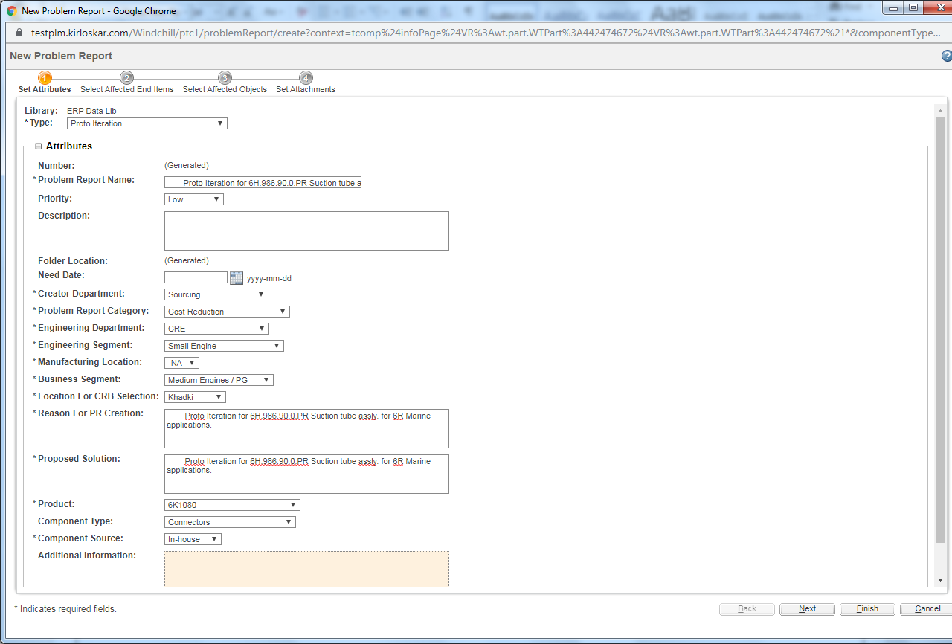
Select Affected End Items
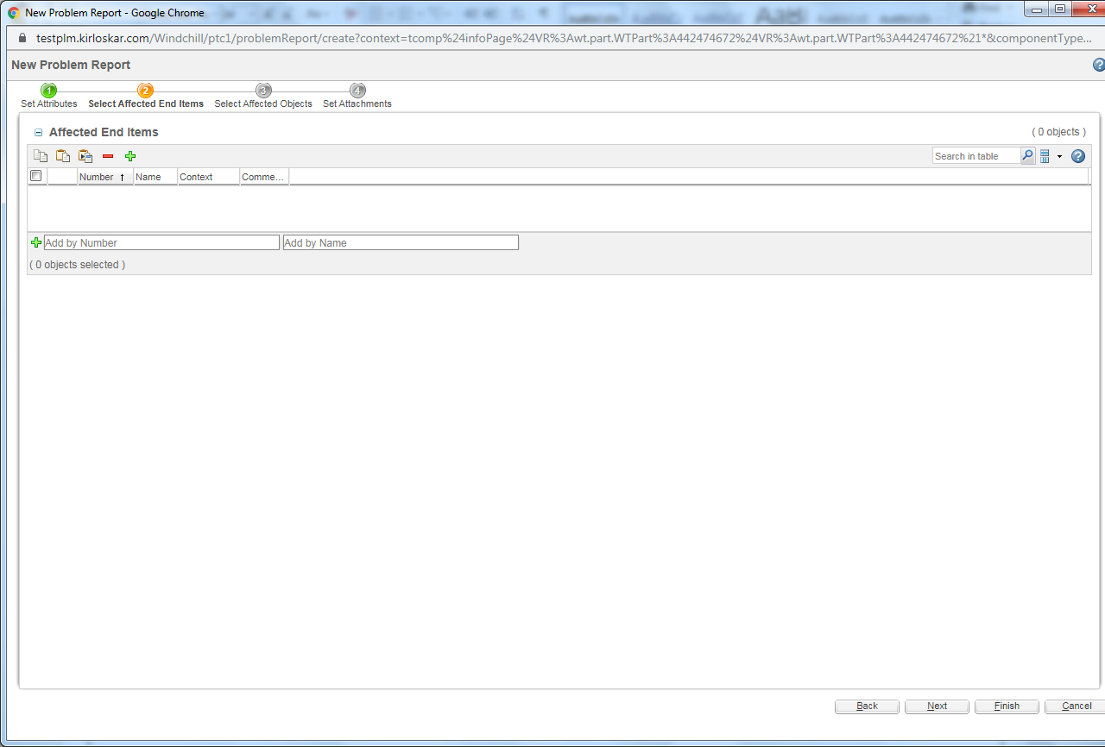
Select Affected Objects
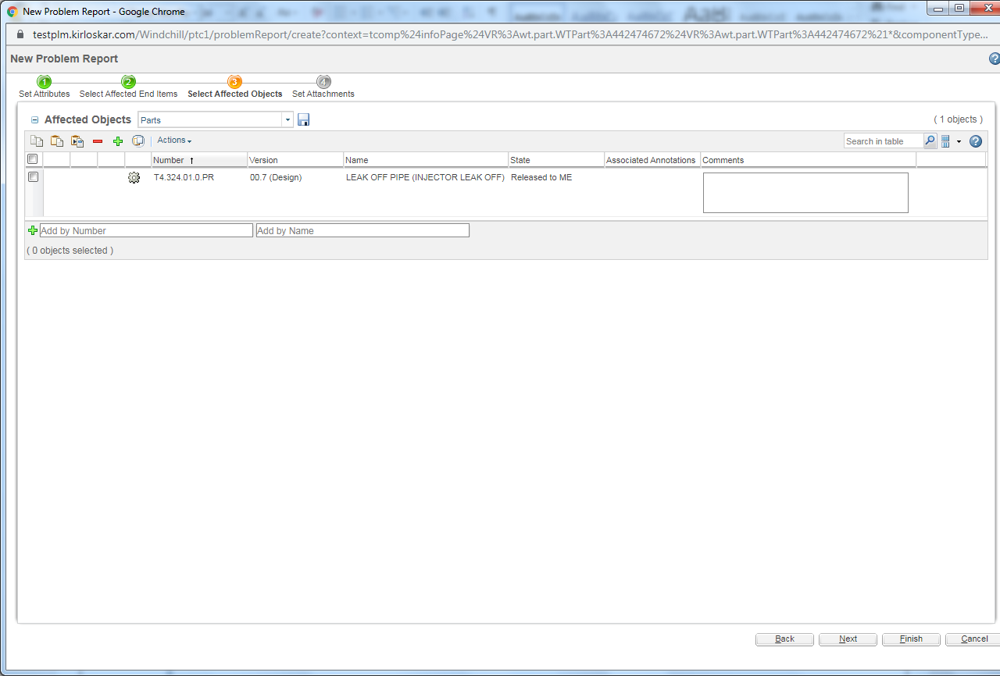

Set Attachments
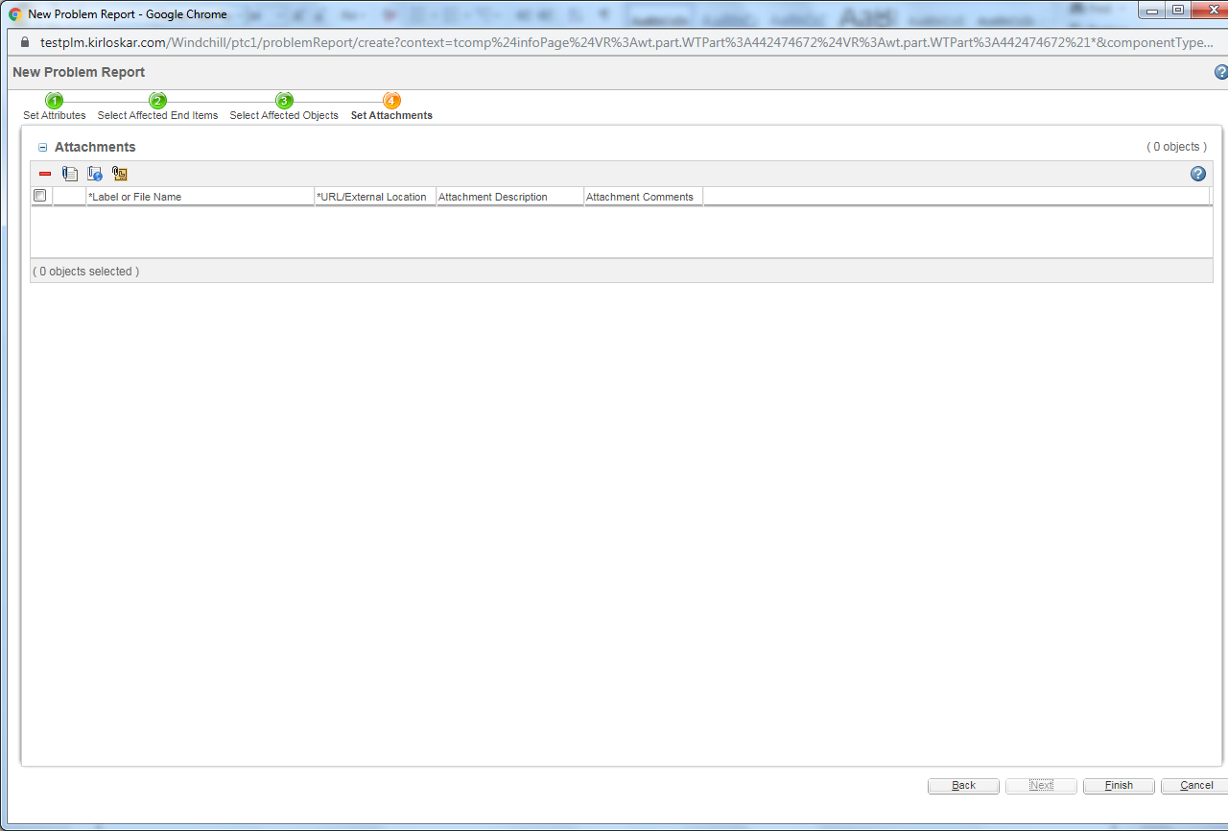
Select Submit Now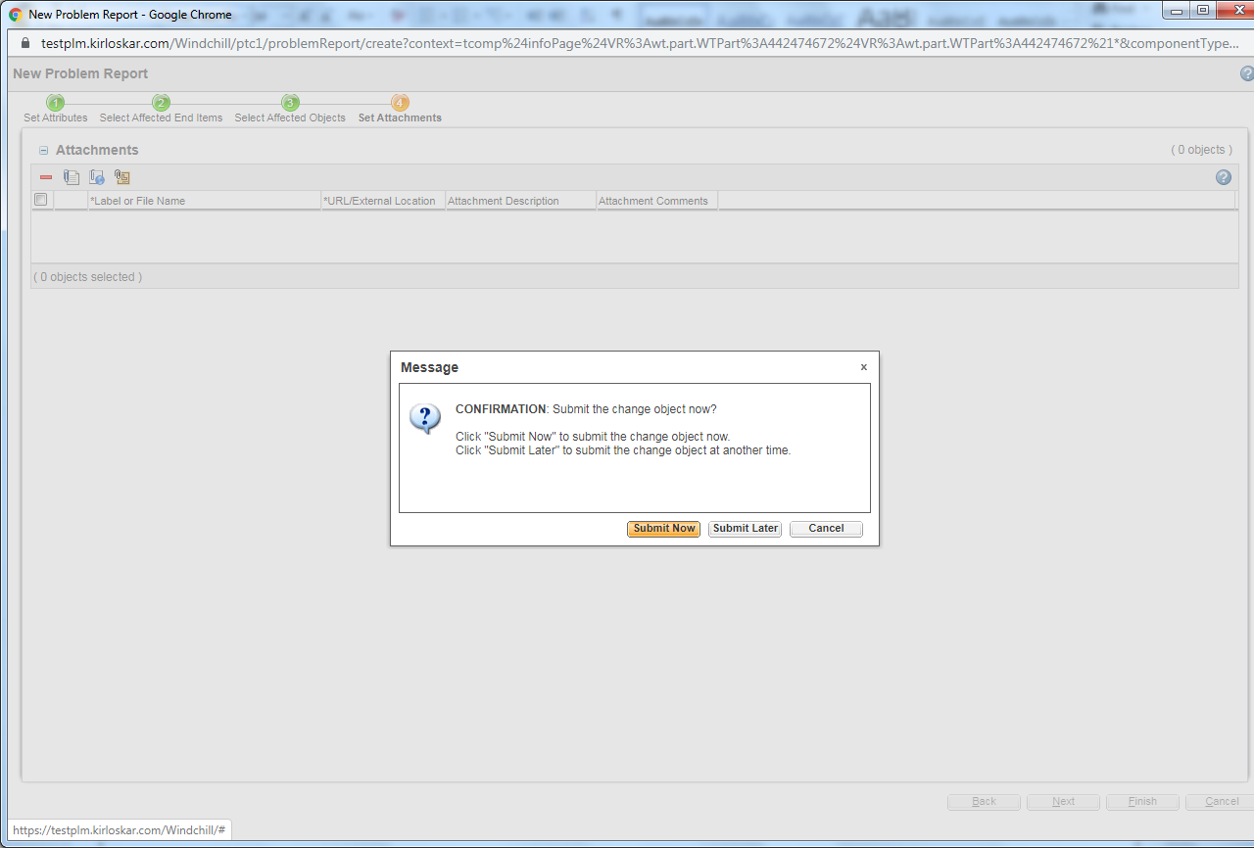
4.1.2 Problem Report Proto Iteration Task
Select Approver For Department Raising PR
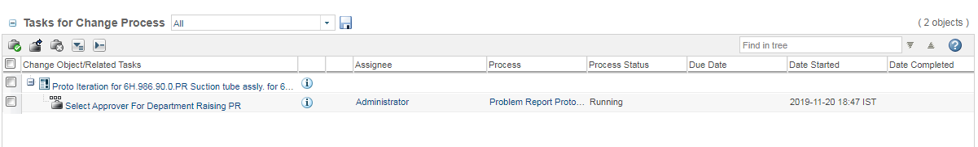

Click on Setup Participants
Select Department Head

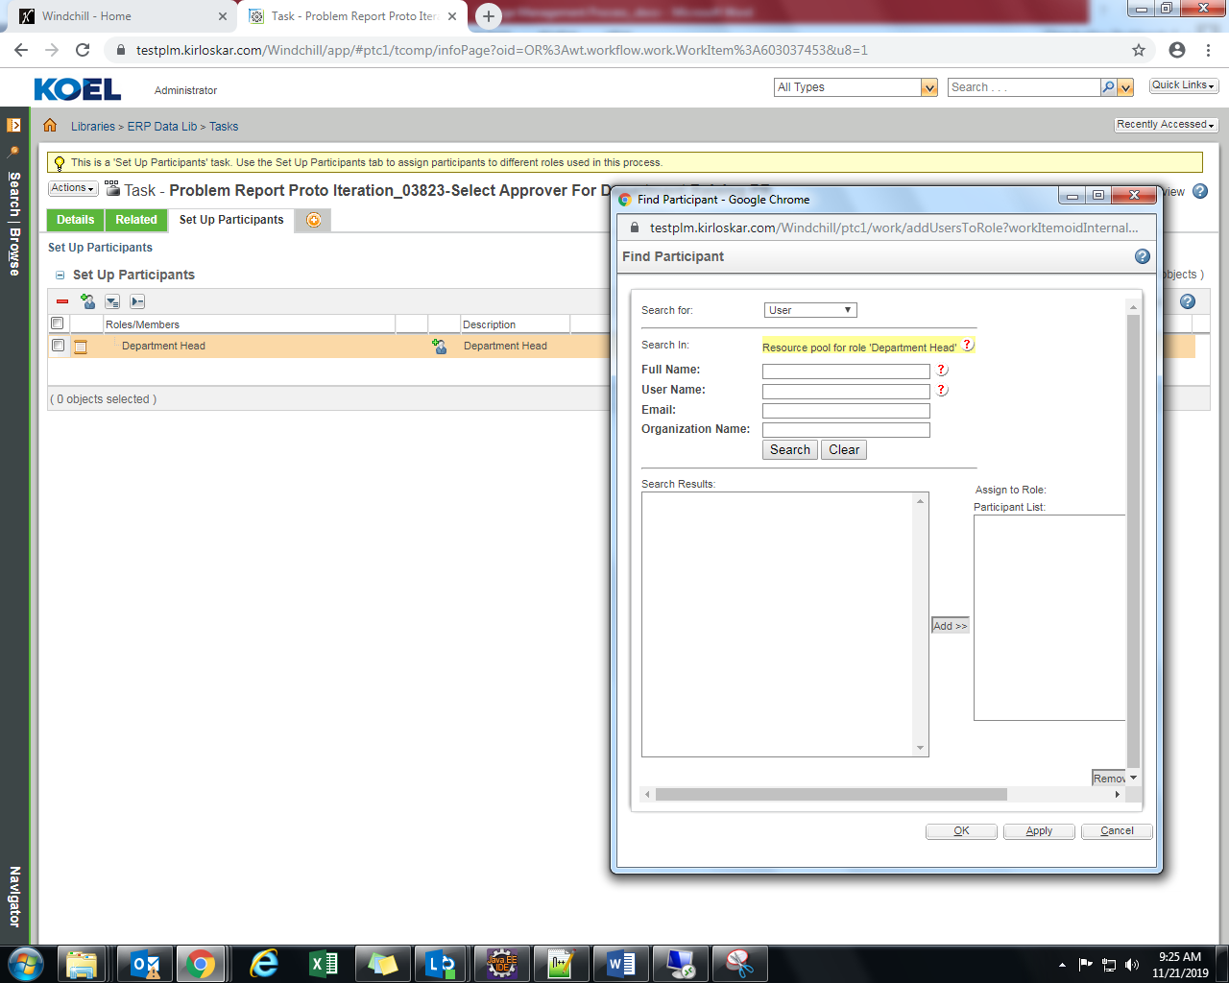
Select Complete Task
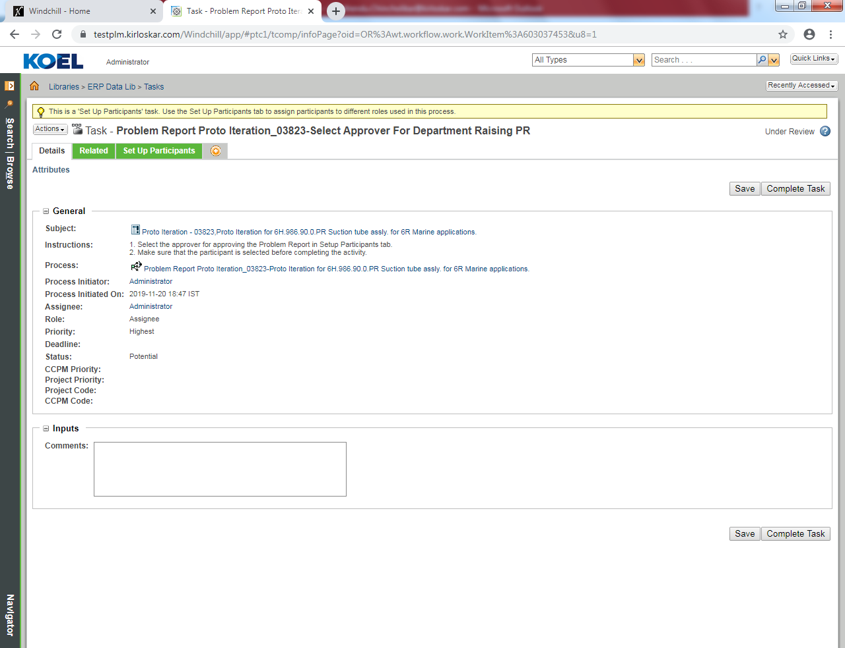

Review Problem Report
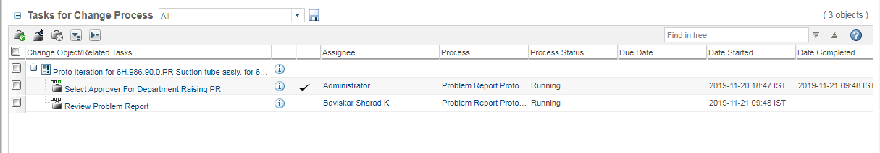
Three Routing options for Reviewer, Reviewer select appropriate option
Select Complete Task

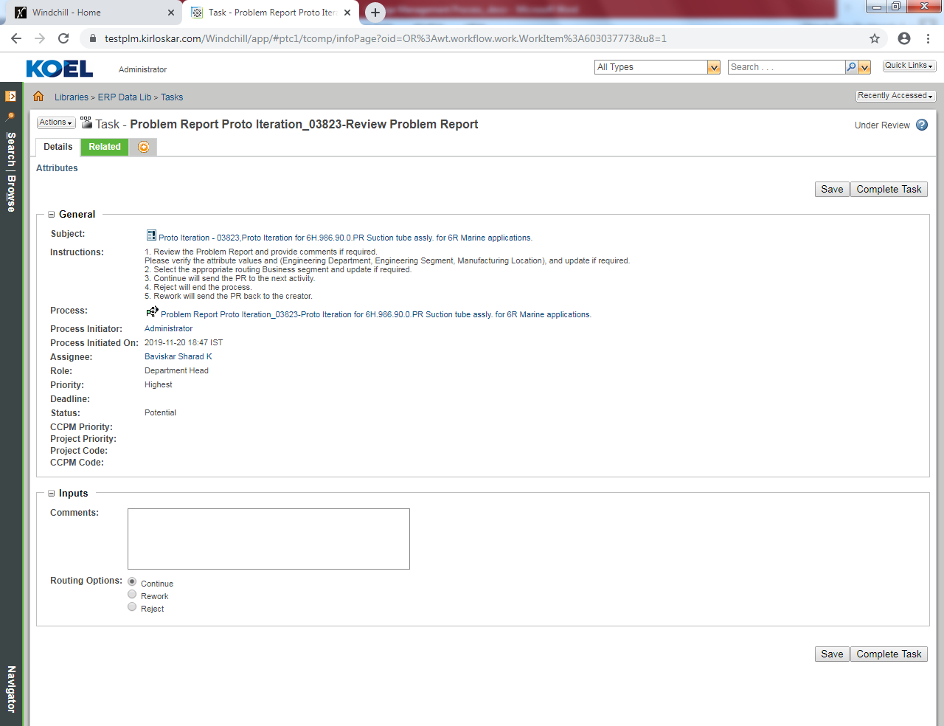
Assign Engineer and Department for comments
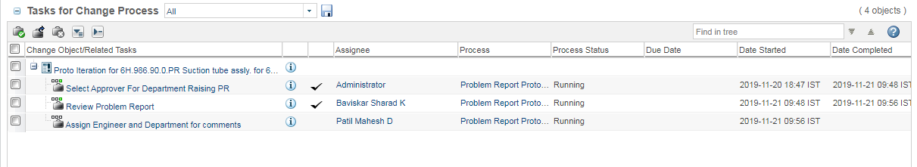

Select Setup participants
Select Design Engineer role

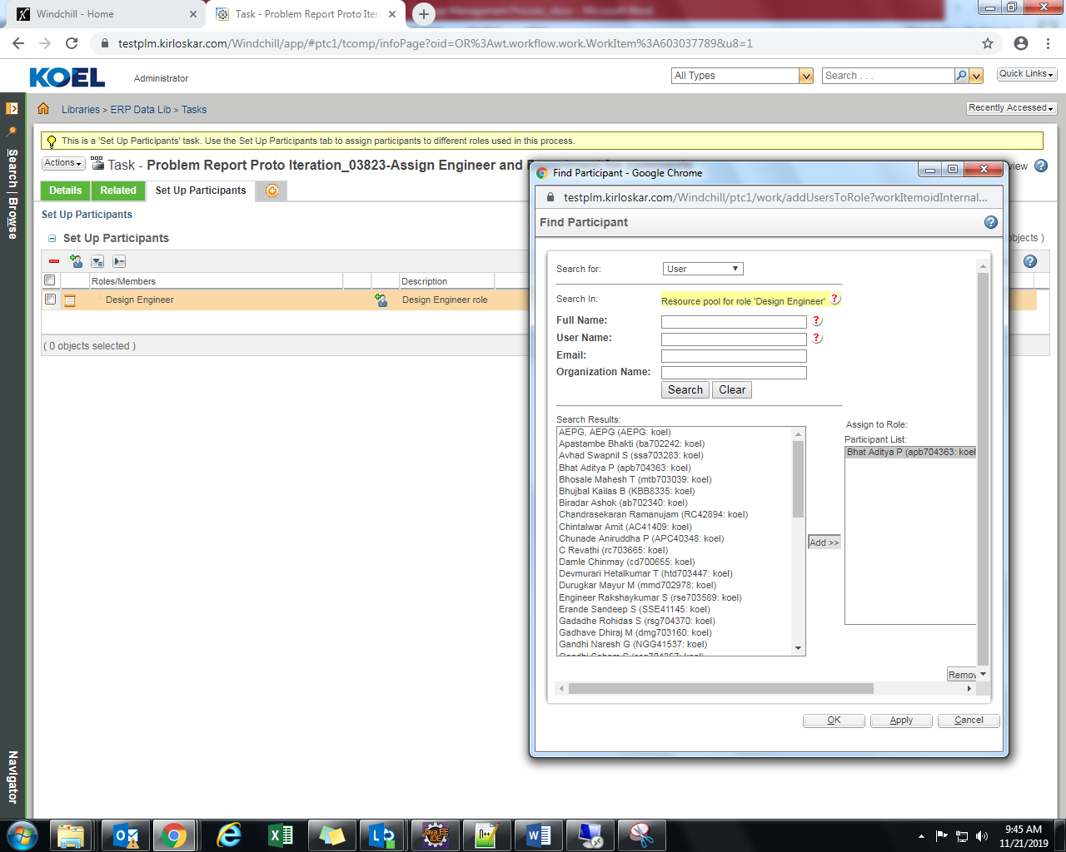
Select department review
Select Complete Task

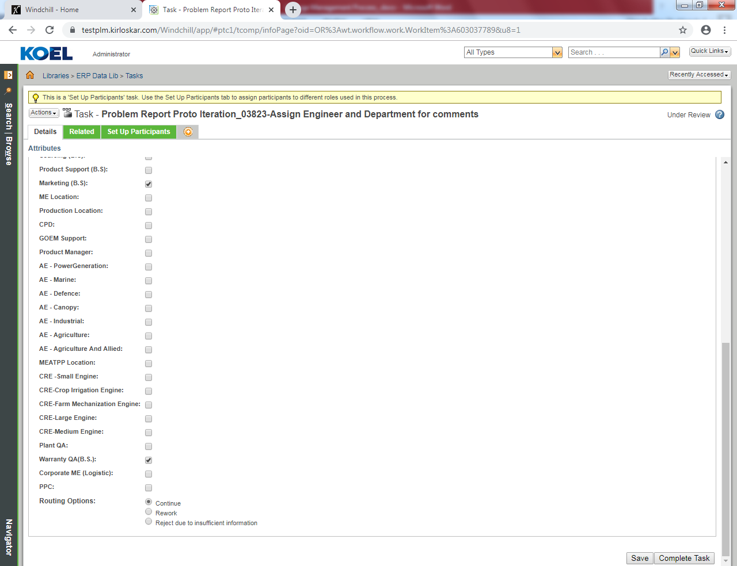

4.2 Engineering Change Request Proto Iteration
4.2.1 Engineering Change Request Proto Iteration Creation
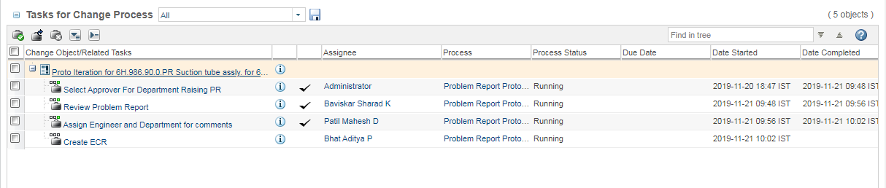
Action – New – New Change Request
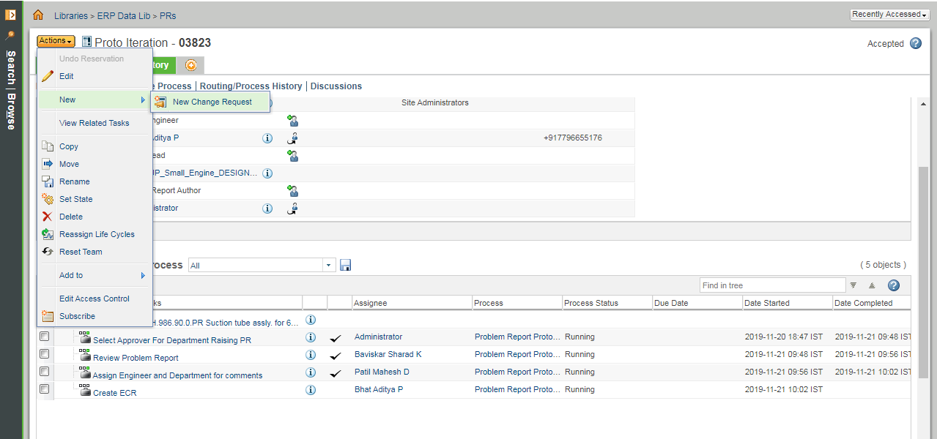

Check to Propagate information
Attributes are Auto populated and none of the IBAs are editable if CR is created against PR

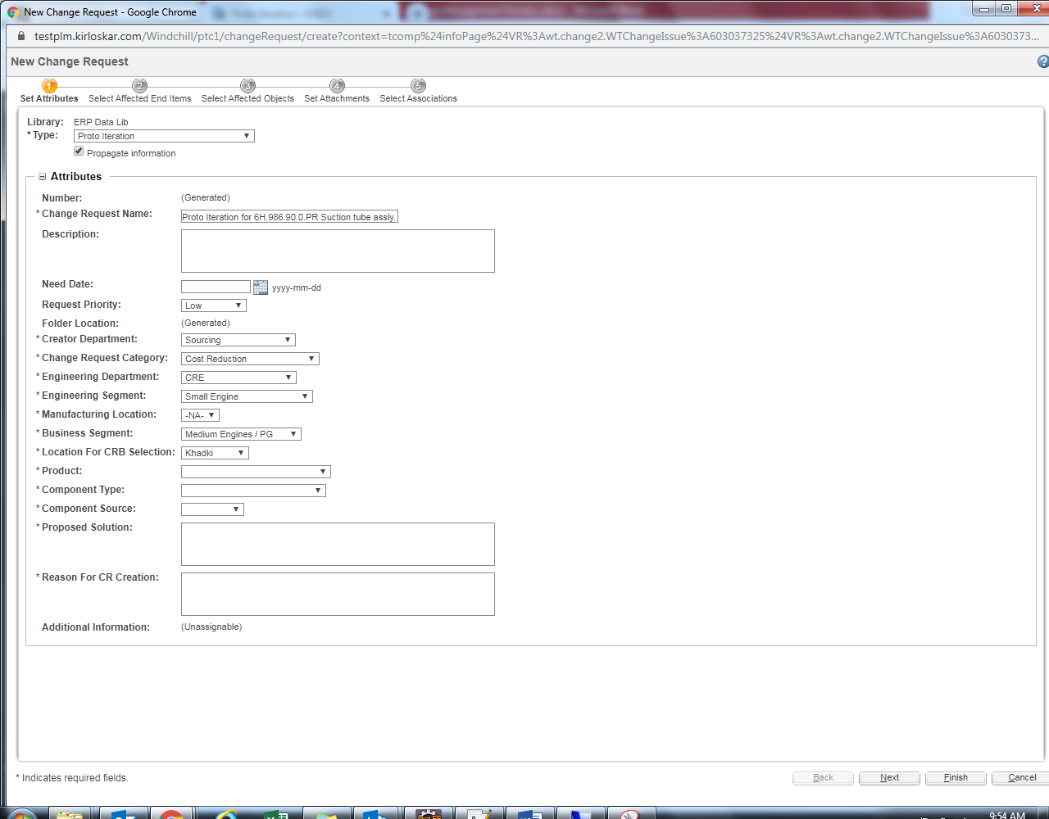
Select Affected End Items
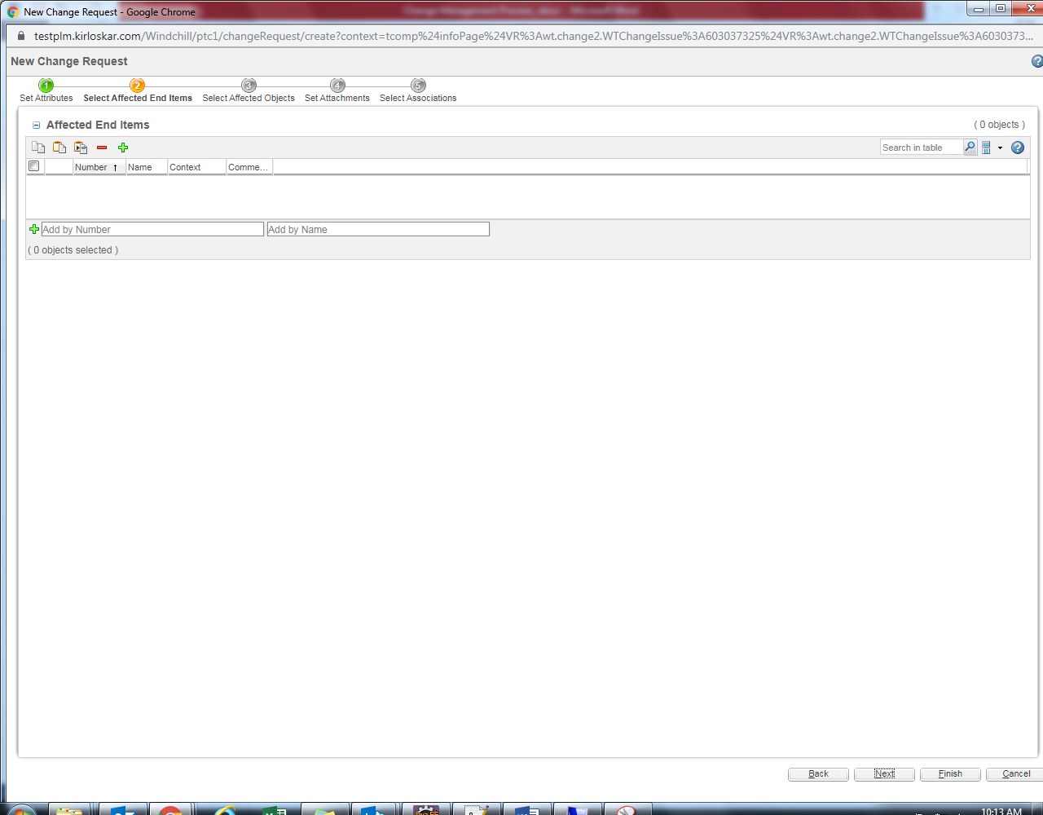
Select Affected Objects
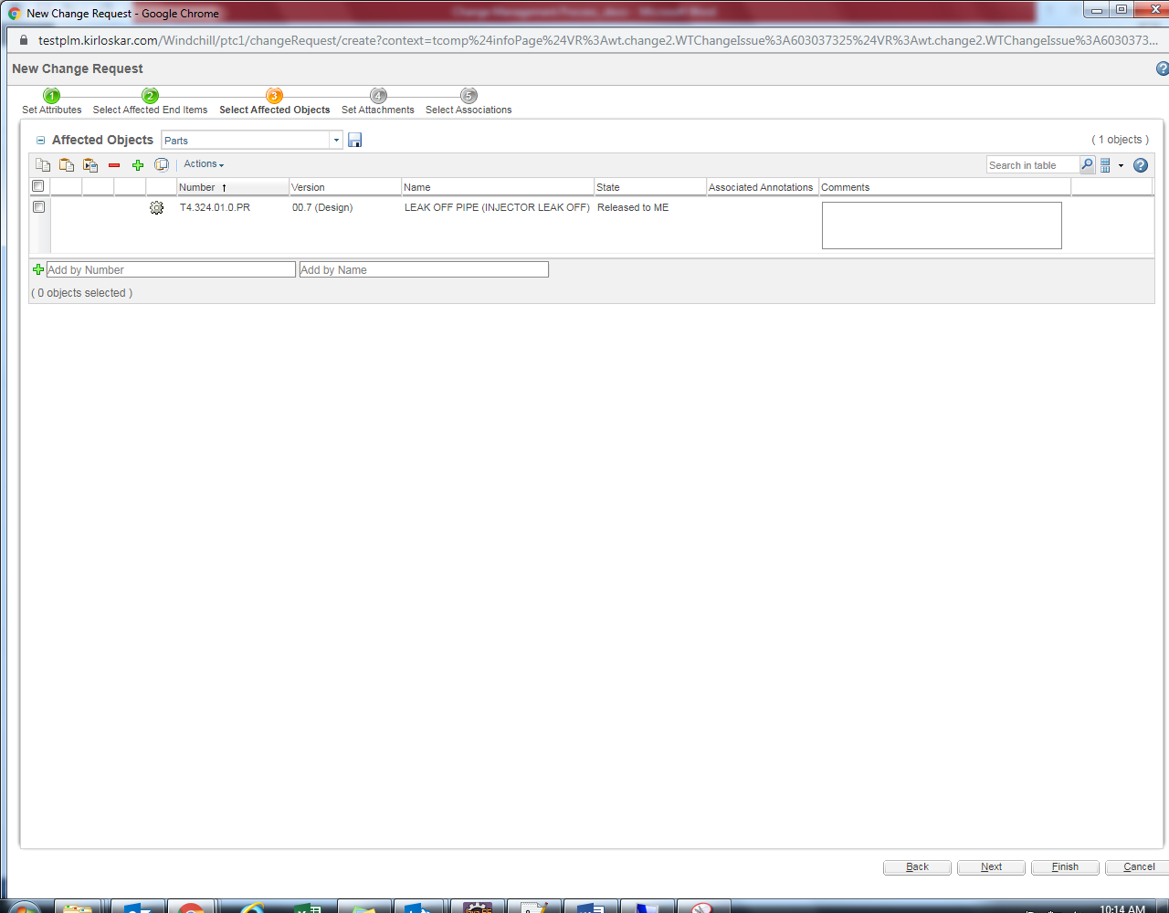
Set Attachments
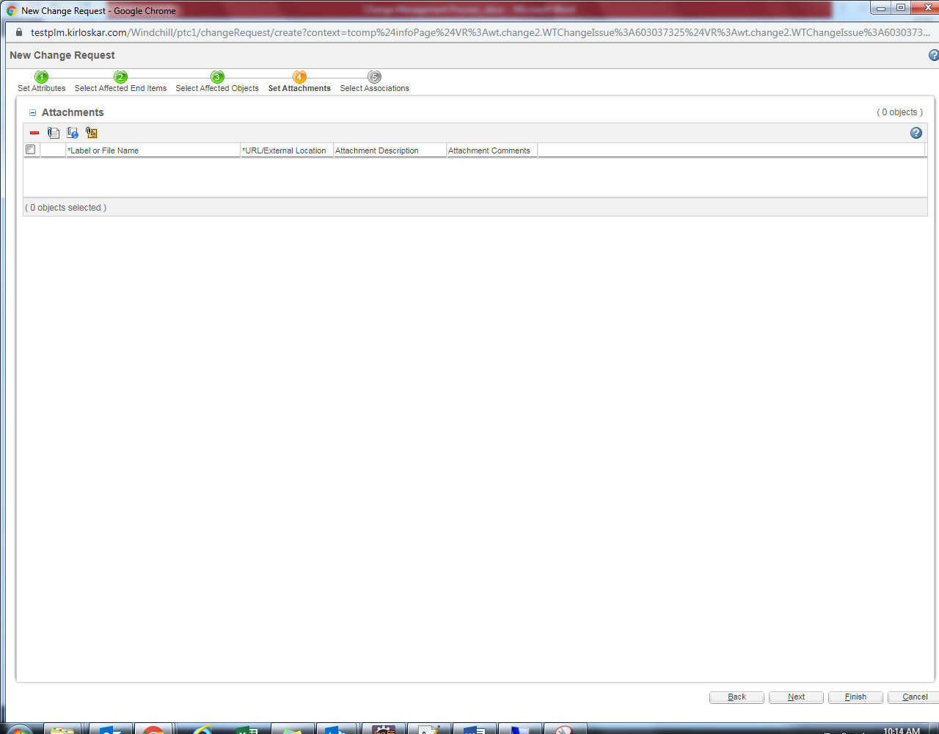

Select Associations – If Engineering Change Request is created based on Problem Report then it display Problem Report
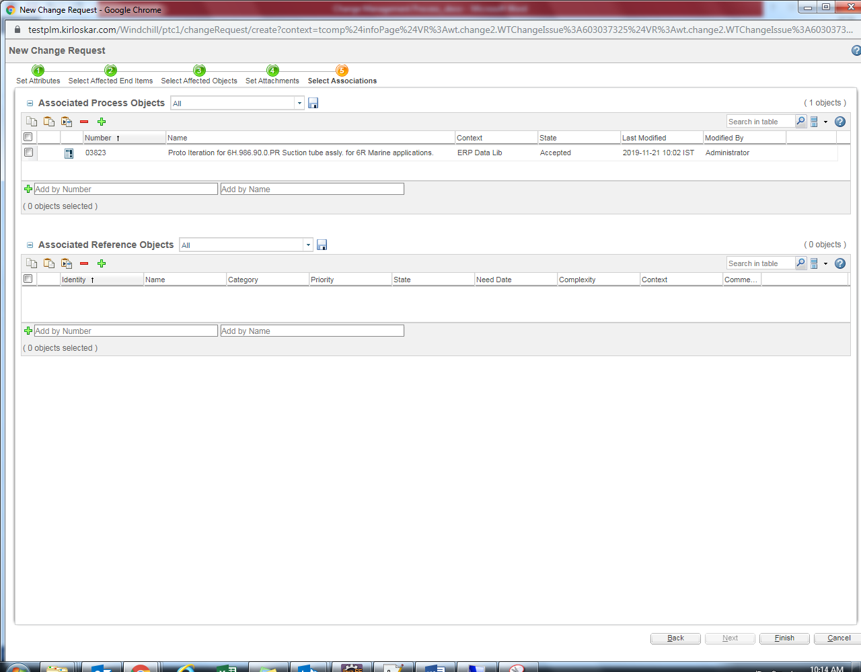
Select Submit Now
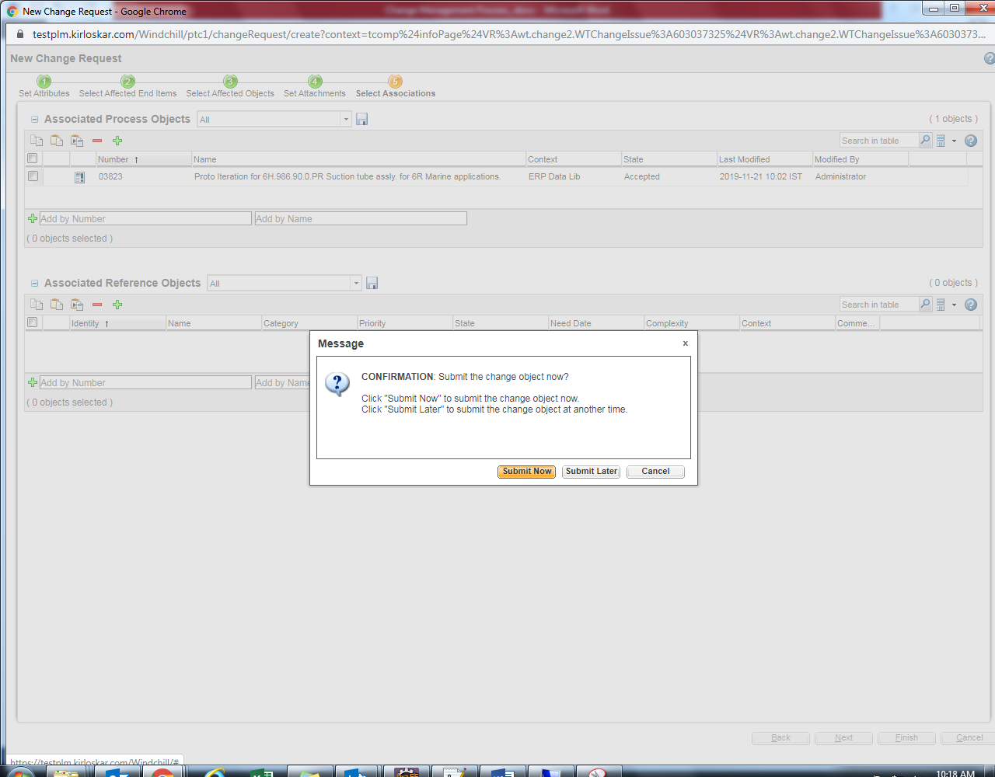
4.2.2 Engineering Change Request Proto Iteration Creation
Login as respective department reviewer according to selected category fields
Click on Home.
Select CRB Department Review from the list & fill the comment as required.
Click on Complete Task

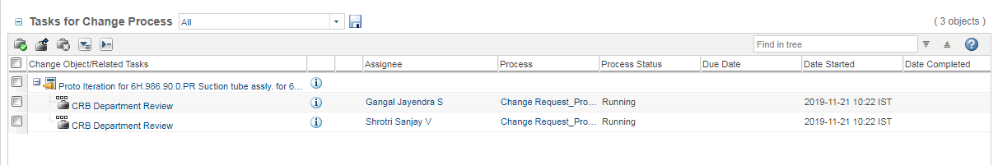
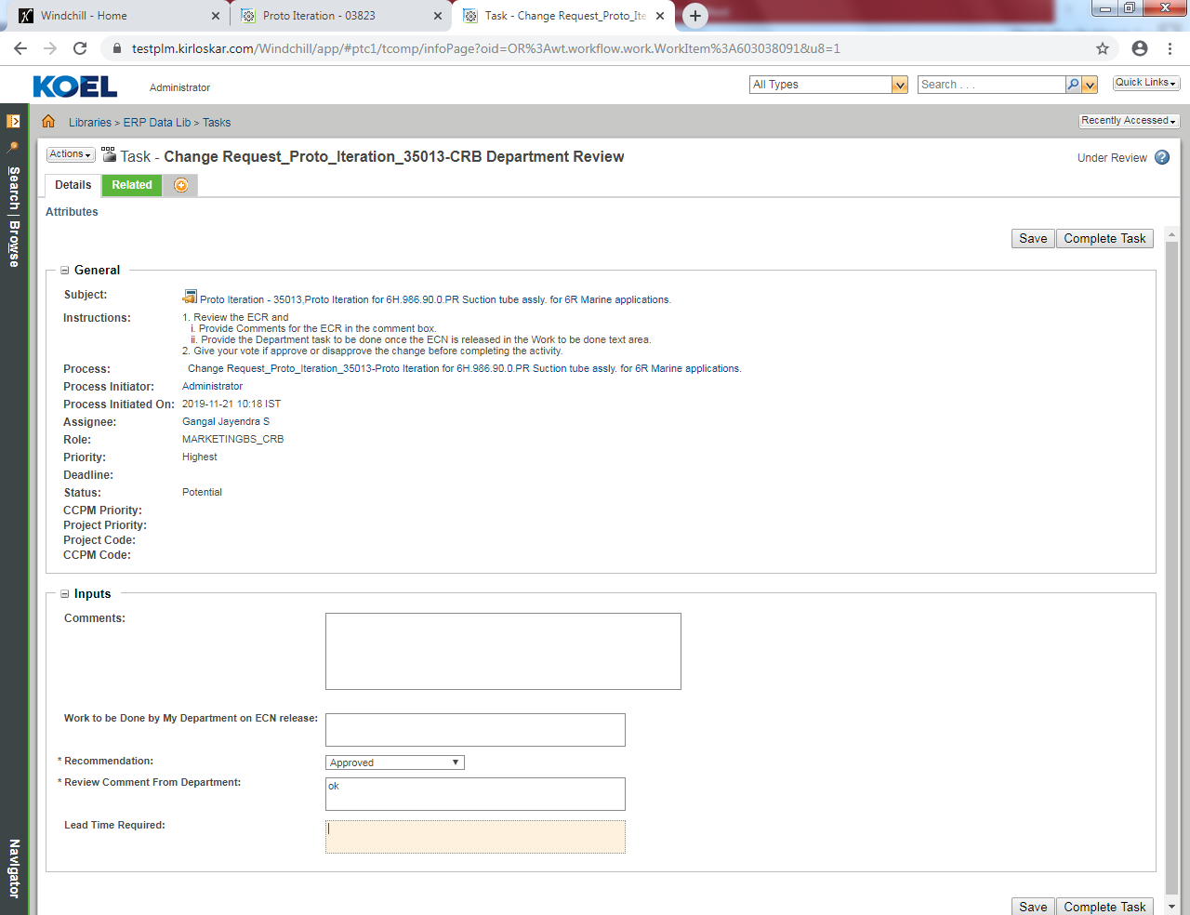
Final Decision CRE/AE Stakeholders
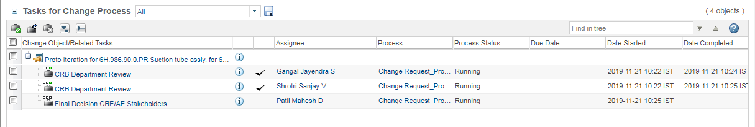

Approver either approve or reject
Select Complete Task
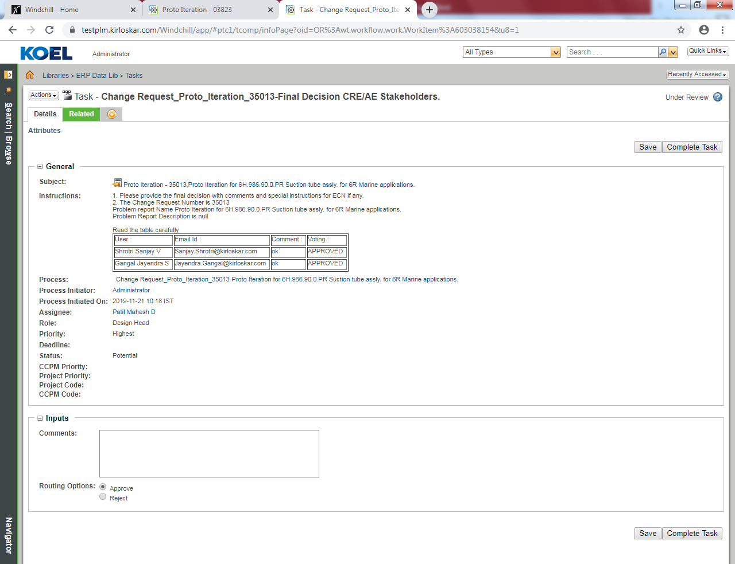
Send ECR for implementation Date Block. Click on Complete Task
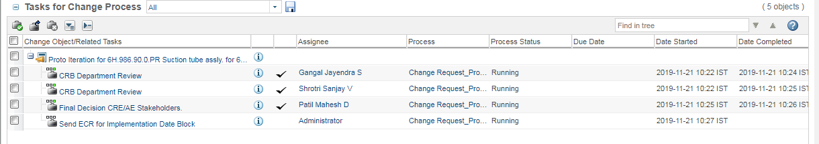
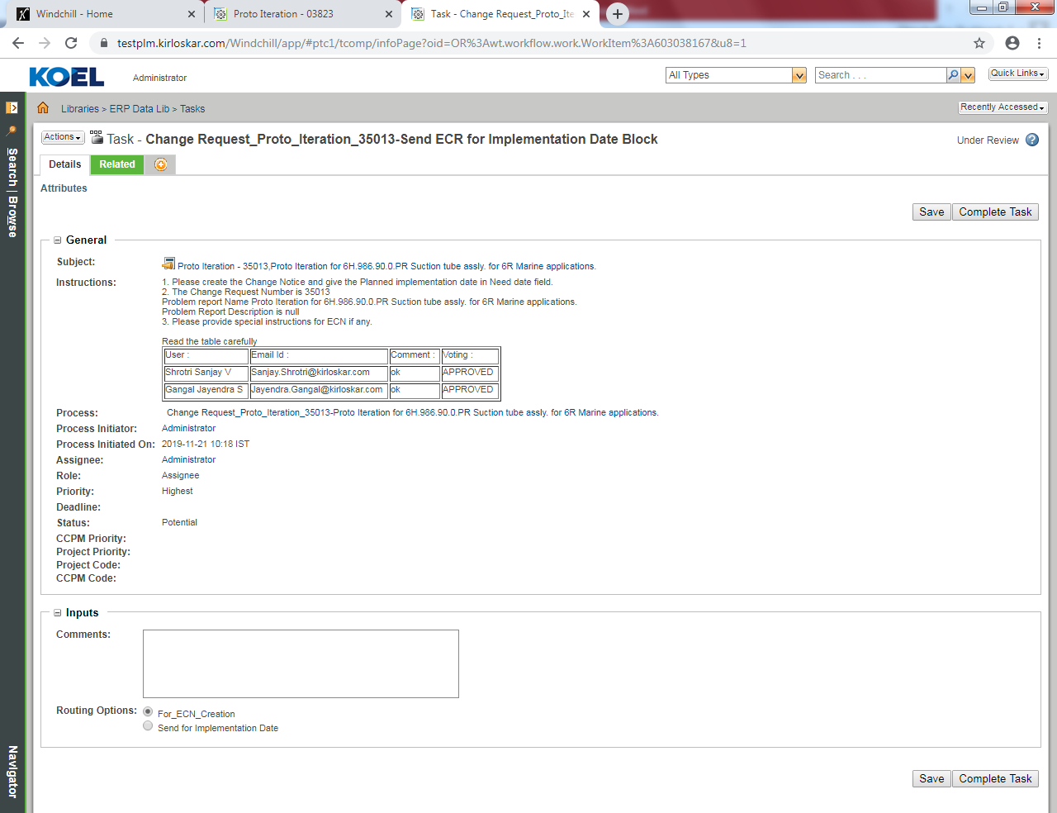

  - Engineering Change Notice Proto Iteration
4.3.1 Engineering Change Notice Proto Iteration Creation
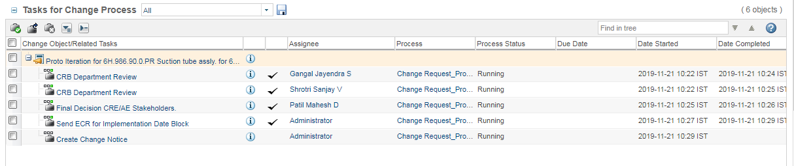
Action – New – New Change Notice
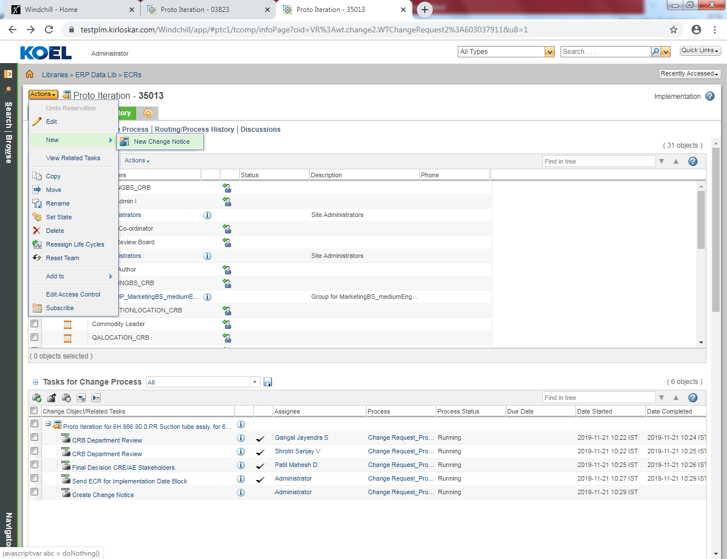
Select Change Notice Type
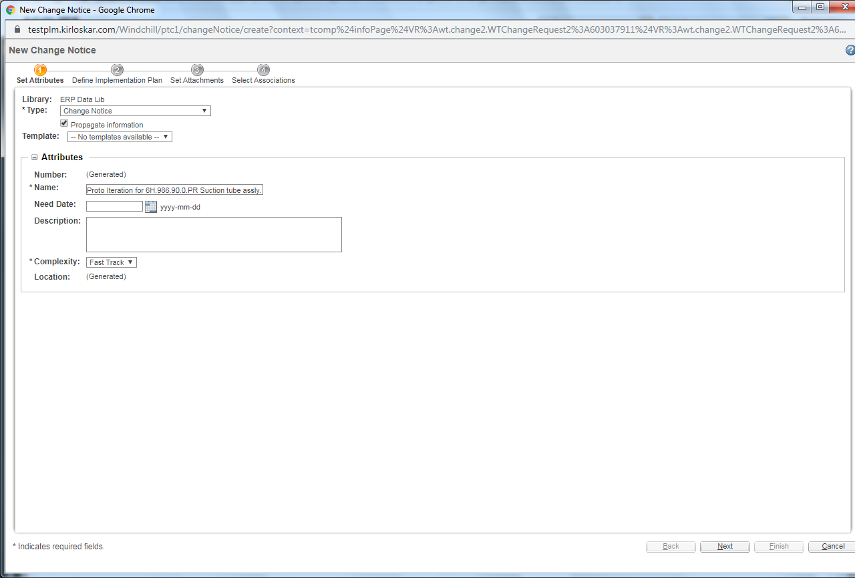
Define Implementation Plan
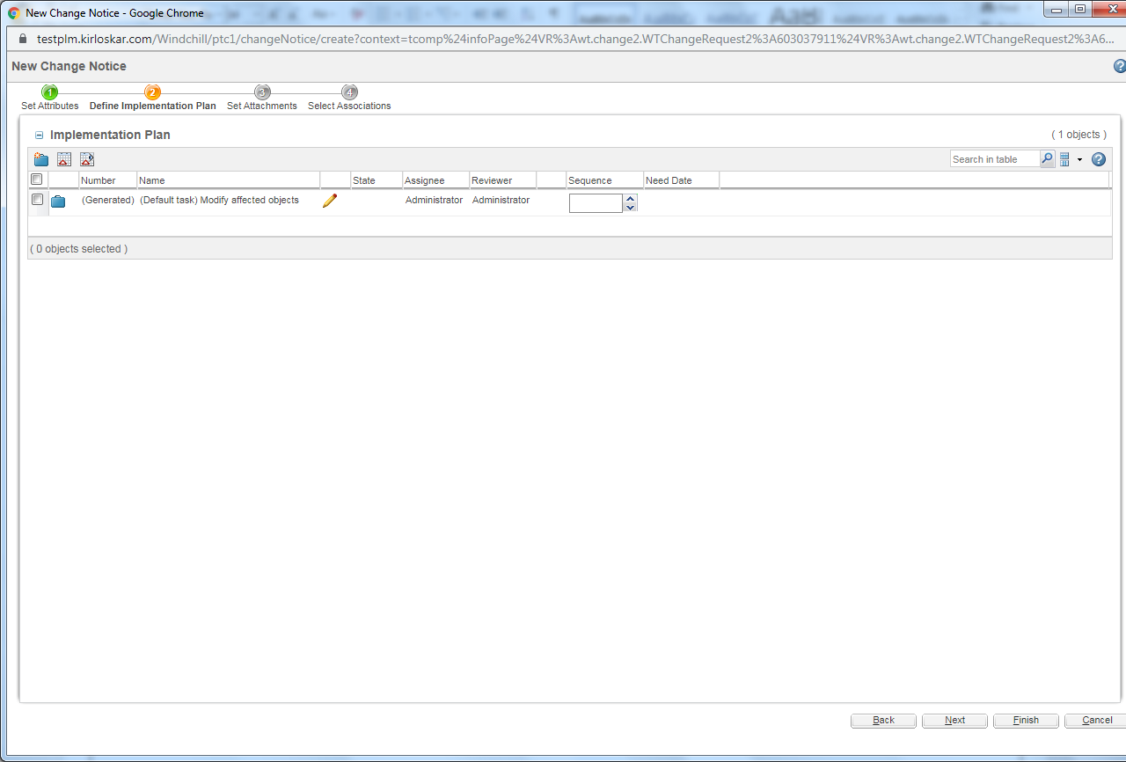

Set Attachments
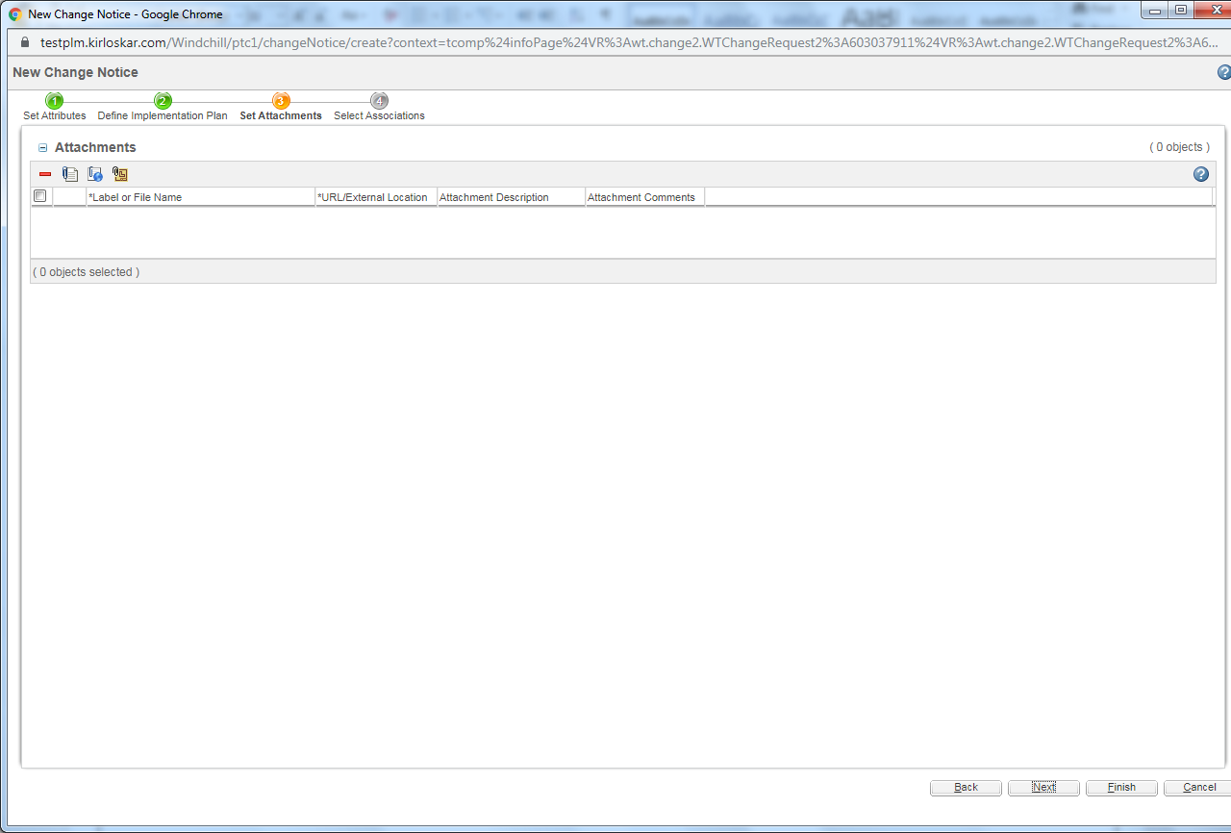
Select Associations
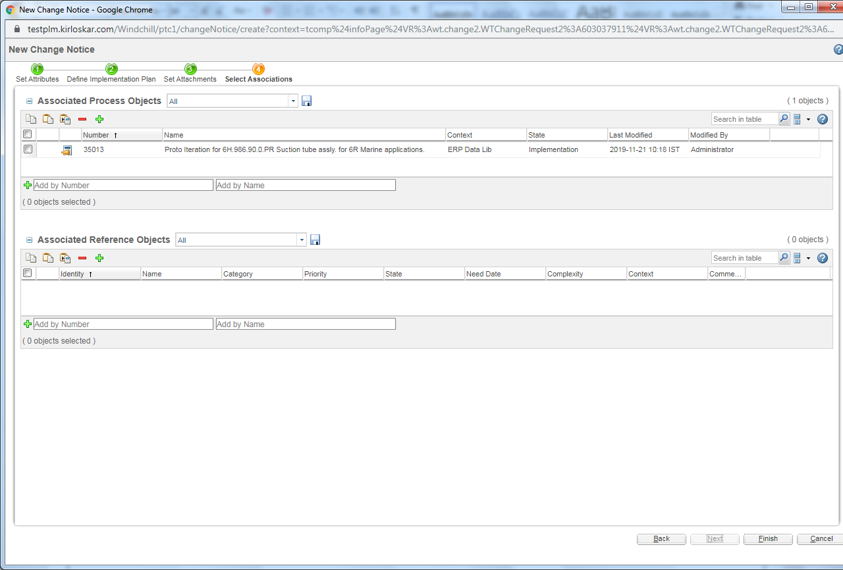
Select Submit Now
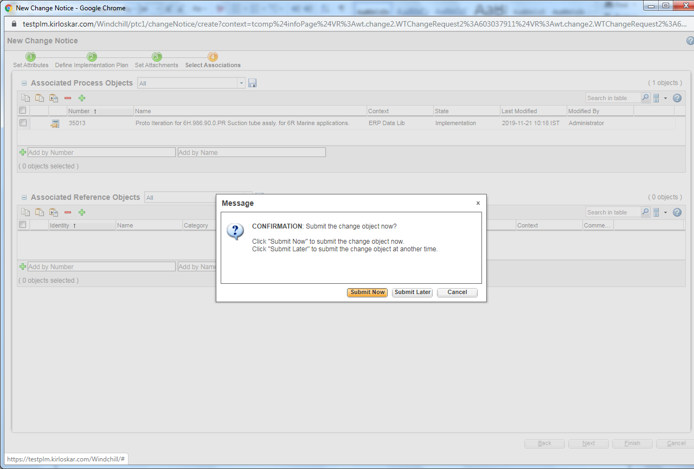
4.3.2 Engineering Change Notice Proto Iteration Creation
Complete Change Notice Task
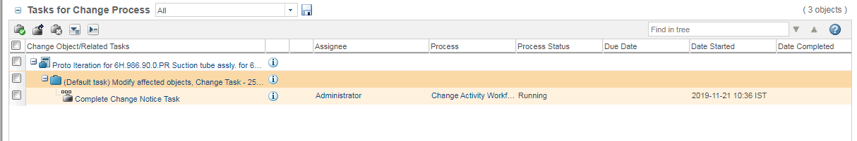
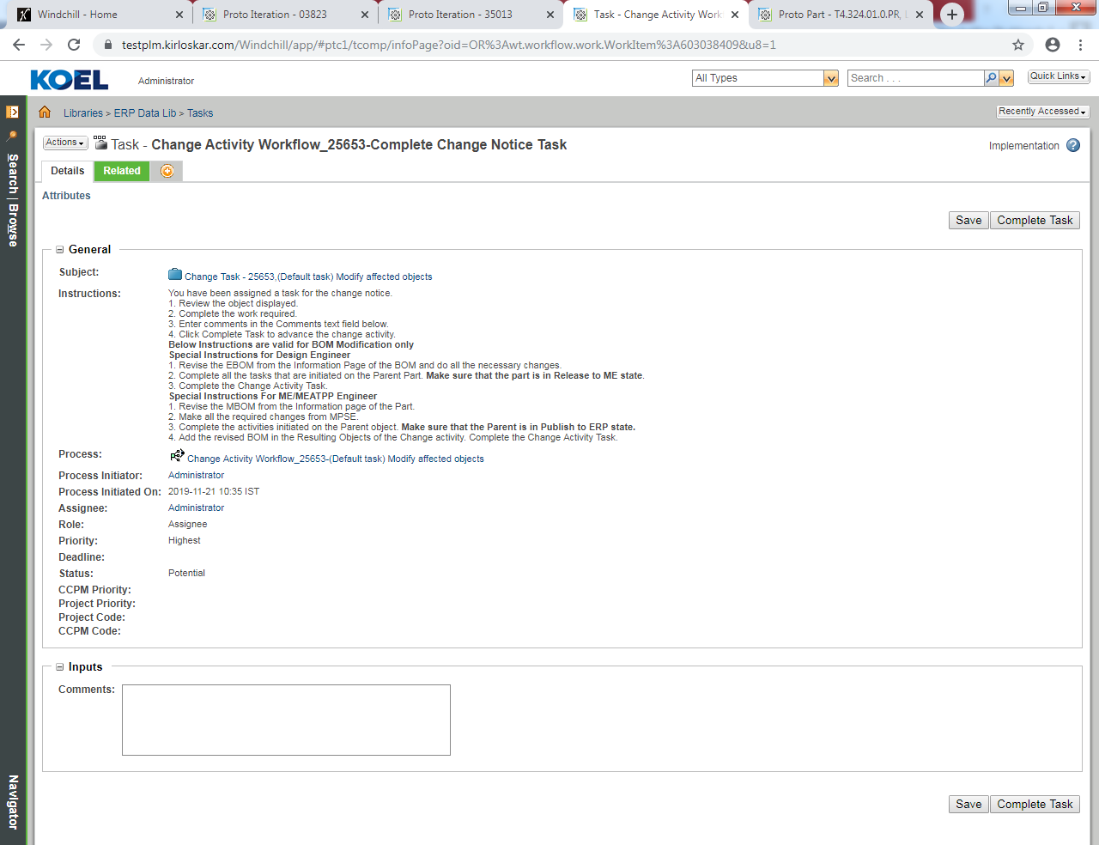
Release Modification Sheet

Set Attachments



